Variables of sustainable policy: the case of elaboration and implementation of the Estonian Forestry policy in 1995 – 2004, based on policy networks approach

By

Erik Sootla
Ph.D. student
Robert Schuman University of Strasbourg
Tallinn Pedagogical University

Georg Sootla
Professor of Public Policy
Tallinn Pedagogical University

Paper, presented at the 12th NISPAcee Annual conference,
12th –15th May 2004, Vilnius (Lithuania)

CONTENTS
1. Introduction. 3
1.1. Participation as a democratic norm and as core mechanism of the policy process 3
1.2. Networks as a variable of sustainability of the policy process 4
1.2.1. Governability 4
1.2.2. Consistency 5
1.2.3. Legitimacy 6
1.2.4. Networks 6
2. Developments in the Estonian forestry before the reform analysed through the prism of sustainability criteria 8
2.1. The Soviet period 8
2.2. Forestry sector after independence 9
2.3. Cabinet’s dynamic at the beginning of 1990-s 10
3. Basic premises of institutional reform of forestry 12
4. Developing forestry reform strategy: arenas and participants 15
4.1. Main decision-making arenas 16
4.1.1. Leading agency of Forestry reform 16
4.1.2. Expert groups at the EFDP 17
4.1.3. National working groups or steering working groups 17
4.1.4. Steering and/or Government Committee 20
4.1.5. Supplementary arenas and tools of network management 21
4.2. General configuration of the process of the Forestry policy development 22
5. Implementing Forestry reform: arenas and networks. 25
6. Conclusions: networks in ensuring sustainable forestry policy 27
References 29
ANNEXES 31

1. Introduction.

1.1. Participation as a democratic norm and as core mechanism of the policy process

What would the best policy in a certain sector be, if let to be decided by professionals of that sector? Is there any specific mechanism of policy-making that determines to which extent a policy is designed and implemented successfully?

Traditional single rational actor approach (Allison, 1971), – which is still the most widespread presumption in the analysis of specific policies – does not let much room for mechanisms of policy-making to be treated as variables of policy success. Because, according to this presumption, the correct plan/strategy and clear aims are variables that per se ensure the success. Mechanisms of policy-making would only harm the policy implementation through the resistance of different forces and constituents, who would not accept the declared policy aims. In this sense rational actor approach has to be considered as basically anti-participatory in relation to the policy process.

There is wide variety of new theories of the policy process that emerged after the need of policy analysis or policy failures came to the forefront as a practical policy problem in the mid 1960s (B. Radin, 2000 ) One part of them focuses on the elaboration of more sophisticated tools and methods of analysis and planning of outputs and outcomes of the policy. Another part focuses on the analysis of roles and activities of different actors in explaining the mechanisms of policy development. In this approach the borderline between policy elaboration and implementation tends to be blurred.

Earlier, conceptions of policy actors departed from the critique of basic premises of political science (pluralism), policy process (rational actor) and organisational theory (open systems’ theory) (Klijn, 1997). In these approaches such as corporatism, policy communities, sub-governments and others, actors are divided – as previously – into internal and external actors. Internal actors are official or institutional actors, like ministers, top civil servants, representatives of core interest groups etc., which concentrated in their hands the power and recourses to make or not to make decisions on certain issues. External actors are constituents, which are to different extent concerned or affected by certain policy and are invited by core actors into the policy-making process at different stages. There are different reasons for these invitations: from manipulating the public opinion and co-opting the most dissatisfied citizens groups, on the one hand, to the development of dialogue and ensuring citizen control, on the other (Taylor, 2003: 117).

Various explanatory paradigms of policy-making have been elaborated after the concept of modern governance became fashionable: policy networks (Rhodes, 1992), neo-administrative state (Durant, 2000), networked community governance (Stoker, 1991). These conceptions tried to avoid the hierarchical pattern of actors’ organisation in the policy process, because expected that the role of traditional policy-making core has considerably changed. The most radical versions suggest starting from implementation structures not only in the policy analysis but also in policy-making, because successful policy and its outcomes tend to be rather a reflection of interest and incentives of constituent and target groups, than intentions of policy-making politico-administrative core (Hjern, Hull, 1987; Bogason, 2000). As we shall see, Estonian Forestry policy development was largely a reflection of the backward mapping process (Elmore, 1979/80, Sabatier, 1997), in which parties involved formed network-type patterns where traditional policy core had no dominant role in the policy elaboration process and was not able to establish its dominance at the stage of implementation.

1.2. Networks as a variable of sustainability of the policy process

Two very fashionable concepts emerged in the framework of the governance paradigm: networks as a new form of organisation and sustainability as a new set of indicators of policy effectiveness. Unfortunately, both of them have serious methodological deficiencies that do not enable to consider them as a theoretical point of departure without falling into the normative overemphasis and tautology in defining variables*. We consider the wide involvement of various actors as a mechanism that could improve the quality of the policy program, of the effectiveness of its implementation and adaptability of the policy sector to contingencies and complex turbulent environments. I.e. we consider the contribution of networks to the sustainability of the policy process per se. Because this causal link could not be explained theoretically, we use the case study method to demonstrate what variables in this network type pattern play an independent role in determining sustainable policy outcomes. In the course of this study we would like to concretise also the indicators of sustainable development (Sootla, 2002 a, 2002 b).

We focus on the three core characteristic of sustainable policy-making as dependent variables: governability, consistency and legitimacy.

1.2.1. Governability

In the framework of traditional approach the governability was defined primarily as an ability of the government to impose losses on powerful actors in maintaining public interest in the policy process (Rockman, Weaver, 1993). Also, Lowi in his conception of policy types saw the interrelation between the depth of policy impact and the ability of government to impose its interests on political competition (Lowi, 1972). The conception of modern governance put the issue of governability into a different context, although does not deny the basic premises of the traditional definition. Governability in the framework of the system theory indicates the ability of actors of policy process to balance capacities (and resources) of actors and needs in qualitative changes. From the normative point of systems’ reproductions governability indicates the ability to focus on issues that most of all enable to increase the overall capacity of the societal system (not only some of its parts). So, the criteria of assessment are the overall gains, including, for instance, economy or losses of time and/or resource of citizens. This policy-making mechanism should be able to ensure that the realisation of one policy could not cause damages in other sectors or does not benefit some groups or sectors at the expense of the others. Here, the ability to balance out various actors and politics is a crucial indicator of sustainable policy.

The balance between capacities and needs could be achieved, first of all, between politicians and interests groups (constituencies), who over-emphasize, especially at the pre-electoral stage, the needs or demands of societal actors; whereas, civil servants and professionals over-emphasize the capacities’ dimensions (“Does it work?”), especially, if the satisfaction of needs presumes considerable reshape of their traditional working procedures (in case of officials) or their conceptual world (in case of experts).

1.2.2. Consistency

Consistency of the policy indicates the reasons, depth and frequency of revisions of adopted policies. Crucial, in this respect, is the question of the reasons of revisions or even terminations. One part of inconsistency is rooted in the technical professional dimension of the policy process: the strategy is professionally weak, and there some important unforeseen obstacles in its realisation were revealed. The other part of revisions is caused by frequent changes of coalitions, which are prone to revise previous strategies on the political ground. Here, the problem of consistency is rooted in the style of a coalition and overall policy-making.

The general issue in ensuring consistency is the sequence of elaboration and adoption of strategy and of appropriate legal acts. If the elaboration of policy strategy persists the elaboration of the law in time and space then the network like organisation of the policy-making and in-depth debates might ensure smooth professional and political input. If the legal act persist the strategy the policy-making arenas would be likely monopolised by lawyers or sectoral professionals.

Efficiency is not always equivalent to the sustainability and that in particular two ways. On the one hand, the absence of veto points and fast ratification of legislation has been the most important reason of its inconsistency. On the other hand, the passion of politicians to find unique and eternal solutions to problems does not result in the attitude to avoid changes in the policy programs even in the course of their implementation. On the contrary, intentionally planned changes and revisions, especially mechanisms of those changes that were encoded into the implementation stage, often assume to be the indicators of consistent policy.

1.2.3. Legitimacy

Formal support of certain policy decisions is the most superficial indicator of the legitimacy. In our framework of indicators of sustainability we consider legitimacy from the neo-institutionalist perspective as a phenomena of appropriateness or as taken for granted (Scott, 1995; March, Olsen,1995 ). I.e. legitimacy indicates that certain ways of actions and aims are understood in practice as best possible ways of conduct or purposes to be achieved. The legitimacy here is a rather good indicator of institutionalisation of policies. This indicator enables to assess the policy not from the viewpoint of rational purposefulness, but to assess whether and to what extent the ways the policy is formed and that basic presumptions the policy rely on correspond to the values, standards and customs that are accepted in society and in certain policy sector in particular. The legitimacy dimension of the sustainability is especially important for the analysis in sectors, which were highly institutionalised.

The more specific aspect of legitimacy is the ability of a policy to be targeted simultaneously to different stakeholders and constituents. From this point of view the involvement does not have a purpose to ensure informative or interests feedback. The sense and aim of involvement should be assessed form the viewpoint of whether and to what extent the policy becomes understandable to different participants and will be (!) interpreted similarly by them. Rational actor’s perspective presumes that constituents should understand the intentions of the policy-making core. The main tool for achieving this is the information of participants and stakeholders. From the sustainability perspective the policy should be simultaneously targeted to different constituents’ needs and visions about appropriateness. The more understandable is policy to different constituents and participants, the more adequately they interpret policy actions from the viewpoint of final outcomes and perspectives. In this way constituents can support and implement policies even, if at certain stages it could restrain their freedoms and differentiate from their immediate interests.

1.2.4. Networks

Policy networks are generally used as a metaphor that is rather used as a framework to be filled with different variables developed separately (Dowding, 1995). Estonian Forestry policy case in our interpretation is no different. Although the network approach is very attractive in that it serves as a solution to methodological dilemmas in many policy theories (Kickert et al., 1997), nevertheless, there is no clear link between the network structure and policy outcomes (Peters, 1998).

In our case we identify the policy network departing from its widest definition as a stable pattern of interdependency between autonomous and principally equal actors, and which is aimed at the self-investment in the policy process (policy formulation, policy implementation, policy strategy definition, definition of policy preferences) through collective process of resource exchange (Kickert et al., 1997).

Even with this normative definition it has been difficult to determine the exact location of the Estonian Forestry policy along the line of the basic classification of policy networks: i.e. issue networks versus policy communities (Marsh, 1998: 6-7). On one hand, the process was open and effectively included anyone, who manifested some interest (Estonian Forestry policy, 1997: 1); on the other, the decision-making capacity of stakeholders were substantial to the point, where the final draft of policy has been accepted almost without any substantial change. This has been a hybrid model, which could be explained by the transformation of the “government into governance” in process: the role of foreign experts definitely played the role of catalyst in introducing participation-based consultative decision-making style into the traditional rational actor central rule model of Estonian government. In fact, Guy Peters’s description of a structure, which could serve as an alternative to the networks, matches to the last detail, what has been the main stages and organization of the Forestry policy decision-making (Peters, 1998: 28). On the other hand, government’s role in the policy process has been rather formal, or at least post factum, when the policy already “took root” (Puustjärvi, Onemar, 1995: 4). En tout état de cause, the hybridization of the network in the case of Estonian Forestry calls for additional variables such as sustainability variables to be introduced.

2. Developments in the Estonian forestry before the reform analysed through the prism of sustainability criteria

2.1. The Soviet period

In the Soviet system Forest enterprises were similar to kolkhozes and sovhozes* - the main institutions of organisation of economic activity and social life in rural areas (municipality level was de facto absent.) Different from agriculture, forestry in Estonia did not have a considerable economic-political importance in comparison, for instance, to the neighbouring Karelia. But forests had a strategic importance. Estonia was an important frontier area of the SU, where strategic troops were located. It is similarly noteworthy that post-war resistance movement hid in forests, which in 1940s and even 50s were the battlefields of resistance. Forest managers, as well as forest protection serviceman, had the right to exert physical force comparable to police. They had uniforms and they were armed.

The only area where civilians could own and apply guns was hunting – an area, which represented a relatively popular recreation activity, especially for local, as well as national elites. Organisation of hunting and receptions for domestic and Moscow ‘boyars’ was one of arenas of policy-making concerning scarce recourses, investments, exceptional freedoms from central restrictions in the local economy. This made higher-based forestry enterprises and management politically very pronounced and powerful at the local level. Nevertheless, forestry and environment remained under subordination of domestic authorities.

In 60s and especially 70s local people intensively started building individual houses and summerhouses. Local forestry enterprises, where forests management and timber manufacturing were located, started to attract unplanned local resources and to develop the unofficial provision of round wood in exchange for political protection and other scarce services and goods. This made them powerful in the economic sense even in comparison to successful kolkhozes.

There was one very important specific of forestry companies in comparison to kolkhozes. State forestry system in Estonia emerged from the forestry system built up by the Baltic Germans before the Estonian independence of 1918. In the independent Estonia those forestlands were not privatised and a centralised state forestry system was established and managed. After the Estonian sovietization this state forest system has been adopted and did not crumble. At the same time, in the private lands that were subject to collectivisation forests management remained in the competence of kolkhozes as a secondary responsibility and has declined considerably. Organisational consistency was supplemented (Soviet administration considerably inherited German administrative practices) by consistency of forestry managers and employees.

Hence, one could imagine the political, economic and social position of forestry and forestry management in Estonia before the transition.

2.2. Forestry sector after independence

After the independence forestry remained politically rather an insensitive sector. The restoration of the land property right that was expropriated in 1940-s stimulated the creation of a large number of small landholders. A part of them became forest owners, who could gain some economic profit from the forestry. The centralised state forestry organisation started to crumble into autonomous forest management units, which were oriented to the new round-wood and timber market. True, as a consequence of the then fashionable libertarian ideology enterprises of forest industry – first of all wood mills – became subject to compulsory competition. But the main public resource – forest – remained in actual autonomous control of the local forest managers, whereas environmental issues, as well as market competition, were extremely weakly regulated. Centralized chains of command from the Ministry and Forestry Agency crumbled and started to rely largely on informal networks that were rather strong in the forestry.

This period (1993—1996) was later called “the golden age in the forestry”. Heads of public forests management units acquired wide discretion in cutting round-wood and selling wood ‘cut rights’ in forests to private companies. The scope of cutting was increasing extremely fast. On the one hand, a rather low level of planned production output during the Soviet time made cutting ecologically feasible. On the other hand, open markets provided forestry equipment and machines that were several times more productive. Different managers took different strategies in managing their units. Investments were made into equipment, facilities, offices, roads etc. Obviously some part of resources was deployed in private interests. Surprising as it may be, this almost anarchic situation that caused everywhere an extremely intensive corruption and de-institutionalisation did not result in the de-institutionalisation of the forestry. Foresters continued to follow – of course, each according to individual understanding – the perception of the forestry management as of a public resource. Meaningful ecological harm to forests – which becomes endemic in private forests – was not reported. Forestry units retained previous level of employment in context of overwhelming (some 30-40 % during three consecutive years) recession in the countryside in general.

The only meaningful negative outcome that assumed important was the distortion of the regional (Baltic and Scandinavian) round wood and timber markets. Presumably this was one of the reasons that triggered the reforms in the forestry sector. Soon the inflation that constituted the profit of the forestry sector, made the sector face some financial restraints and development deadlocks, because out-of-date organisation structures and management.

I.e. forestry was a rather well institutionalised sector throughout different political regimes. Strong values of forest management and life played an important role in ensuring the consistency of forestry as a sector of environmental reproduction. Among the new generation of local forest managers, who started to acquire modern knowledge in management and marketing, many were actually second, third or fourth generation foresters. Thus, the development perspectives of the forestry were also closely connected to social status and legitimacy at the local community. Although local forest managers acquired large autonomy, they were not very satisfied with the developments in the public forestry, in particular as an institution, and with enlarging violation of rules of environmental reproduction in private forestry, in general. The balance between the short-term interests of economic profit from cutting and of selling round wood, on the one hand, and long-term interests of reproduction of forests as of a public good still had a significant resource of balance in Estonia in the mid-1990s, when reforms started.

I.e. the entrance into the radical libertarian market environment did not considerably change the institutional identities. Presumably, the destructive developments in the private forestry and in agriculture strengthened these identities in the eve of radical reforms. In these conditions the top down reforms that were launched in other sectors were be impossible.

2.3. Cabinet’s dynamic at the beginning of 1990-s

In 1992 the first coalition took office after independence. This was a classical activist type of government (Sootla 2000, 2001), which puts emphasis on political coordination of decision-making and focuses primarily on politically sensitive and urgent policy issues. Forestry was not among these issues. The 1992 cabinet promoted collegial but top-down policy-making style, which did not let almost any possibility for wide involvement of constituencies and civil servants into the policy process. Thus, there were no preconditions for the reform of forestry in the first par of 1990s, although in 1993 the Forestry Act was adopted, which remained largely intact.

In 1995 a new coalition was formed between the Coalition party and several smaller rural parties. Ideological distance between them was not very sharp, but due to the high number of coalition partners the ends of spectrum created some considerable distance. Nevertheless, these parties had a strong element in common, which served as a unifying variable: they represented former Soviet urban and rural managers’ / employees’ interests. These were people, who have lost their status and/or wealth as a result of the radical market transition. The coalition promoted such values as reconciliation between parties of different spectrum ends, development of durable, consistent policy strategies and professinalisation of policy-making: at the government: seven out of 15 ministers of the 1997 coalition could be considered as non-political field professionals (Sootla et al., 2004). This institutional environment was extremely conducive to the formation of network type arrangements in the policy process. In the forestry sector the pattern of actors emerged largely during previous stages of the developments. The difficulty was to organize actors into an appropriate network for sustainable policy-making.

3. Basic premises of institutional reform of forestry

Our study has no specific interest in the conceptual scenarios and structural configurations of the forestry. Therefore, our description of the content of strategy related to the mechanisms of policy-making in forestry will be brief.

There were two agendas of the Forestry reform: institutional and economic agenda. In the institutional dimension the reform of forestry had to put an end to the situation, when (although main but only) one actor in the forestry sector was simultaneously representing the public authority (preparation and adoption of rules of forestry) and interests of the government as forest owner. On one hand, economic interests of owners could come into conflict with public interests of the government, which is expected to ensure the reproduction of forests and prepare space for public recreation activities. On the other hand, government as an owner could develop rules that would harm the interests of other producers in the forestry sector. I.e. the role of state as neutral regulatory agency in the forest markets as well in environment affairs should be increased after the conflict of interest will be abolished.

Economic agenda included more complicated questions. The first of them was the development of the balanced market with low transaction costs for producers. In the government sector this was expected to be achieved by the centralisation of marketing and by the creation – from the side of round-wood producers – of enough of strong subject, which could balance out strong and experienced companies, who mediated round-wood to direct producers, first of all, in Nordic countries. As the scope of Estonian round wood is several dozens times smaller than in the Nordic area this measure was directed primarily towards the equalisation of round-wood price.

The second aim was even more important because of its complexity. Small forest owners lacked almost any capacity in forest management and capacity of forests renewal after cutting. Their role in destabilizing round-wood market has been even more significant then in case of large producers and the state. Hence, the reform strategy presumed the delegation of the role of assistance to private foresters to the government agencies (State Forestry Board). Extension services were created at local administrations and were financed from the state budget. Even more important was the role of the government in developing cooperation within the group of private foresters, which would serve to balance out the pressure of radically-pragmatically oriented companies in favour of smaller, less experienced companies.

The reform of forestry was successful with the change in state forestry. In 1999 State Forest Management Organisation (SFMO) has been created, but its marketing structures were designed and activated already in 1997. Contract prices of round-wood and cutting licenses in forests became stable and closer to regional prices. Large lots enabled to cut and sell the round wood more efficiently. Reduction of workforce was very significant. The post of forestry guard was abolished and a number of forestry units in regions were reduced. Many activities that could have been done by small firms (cutting, maintenance of forests etc.) were contracted out.

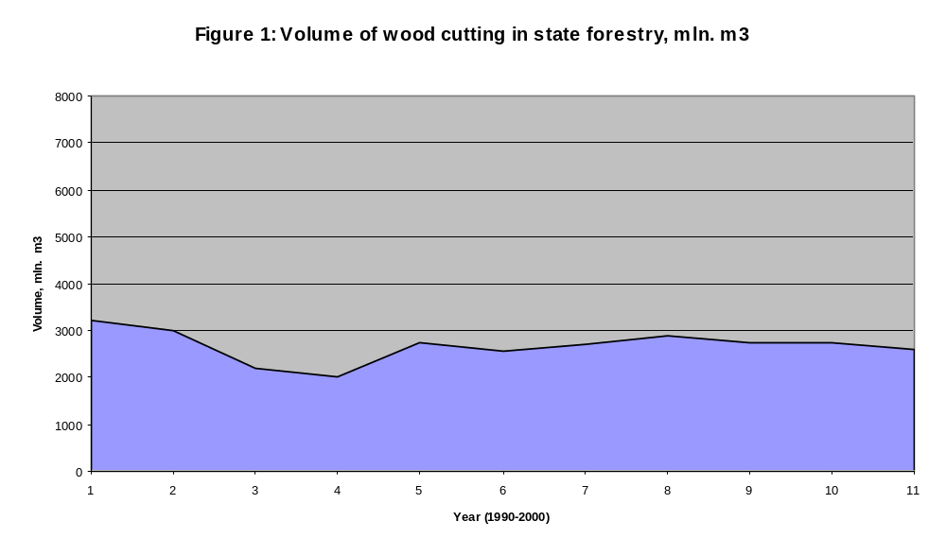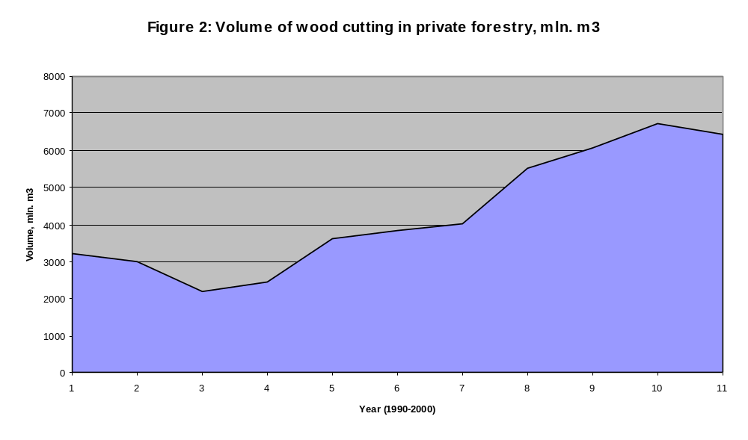

The reform was much less successful or even failed in what concerns the role of the government. Because of the domination by political aims the governance of forestry has been reorganised in a way that the state lost its ability to ensure the supervision over forests as of a public good. This role is still largely exercised by the SFMO. The government was unable to assist private foresters in the development of their capacity to manage forests and selling wood. Cases of illegal cut of wood are still frequent and its amounts are huge.

Table 1: Volumes of standing crop and timber thefts in the years 1999-2000:
 | 1999 |  | 2000
 | Quantity (m3) | Amount (million EEK) | Quantity (m3) | Amount (million EEK)
Timber | 6,990 | 2.6 | 4,750 | 2.6
Standing crop | 12,675 | 2.1 | 12,288 | 2.3
Source: SFMO development plan for years 2001-2003: 22

Private foresters largely neglect the priority of environmental reproduction of forests after cutting: private forests have during the 10 years lost a considerable proportion of their commercial value.

The development of forestry policy didn’t terminate with the establishment of the State Forest Management Centre (SFMC) and of local branches of the Forestry Agency, which ought to focus on the supervision over environmental dimensions of forestry as well as on the assistance of private forestry in transforming into economically and ecologically sustainable units. The latter represented the same kind or even a much less realistic myth than that of the rural transition as the development of family based large farming.

4. Developing forestry reform strategy: arenas and participants

In September 1995 a three-year Estonian Forestry Development Program (EFDP) was launched (Puustjärvi, 1998: 1). The Program was financed and main expert assistance provided by two ministries of Finland (Agriculture and Forestry and Foreign Affairs) and the Danish Ministry of Foreign Affairs (Puustjärvi, Onemar, 1996: 3; 1997: 5-6). 10 sub-programs were targeted mostly with environmental / technical aspects of forestry and forests. Three subprograms – policy development, forest administration and in private forestry, were directly targeted to the development of the Forestry Policy. Later also other public and private sponsors and assistance from Finland, Sweden and Denmark joined the program. The coordination of technical assistance from the Nordic side was contracted to the Finnish company Indufor Ltd. and was ensured by E. Puustjärvi (Puustjärvi, Onemar, 1996: 3; 1997: 5-6). Presumably, such foundation – like open assistance and financing mechanisms enabled attracting the necessary recourses in the course of strategy development that made EFDP especially sustainable.

Such overwhelming development program became possible, because of extensive foreign aid from neighbouring countries. They invested not only in terms of financial and expert resources, but also in terms of specific traditions of strategy development as part of the policy-making process in those countries. Policy transfer was a considerable variable that shaped the character of the Forestry policy-making process.

Firstly, the process was held relatively separately from the conventional administrative structures and routine of administrative practices: Finland in this respect differed because at the beginning of 1990 it abolishes independent administrative agencies. In Estonia such programs were also usually managed and financed separately. The question was, to what extent such kind of arrangements will be incorporated into the conventional chain of policy-making process of Estonian authorities. This depended largely on skills of EFDP leadership.

Initially the elaboration of the Forestry Policy was assigned to the Forestry Agency at the Ministry of Environment. This decision was later contested by several parties – Ministry of Agriculture, private forest owners’ organisations, forest industry (Puustjärvi, 1998: 4). At the same time the mechanisms of financing of the Program did not leave the main powers – powers to command resources – in the hand of the Director General of the Forestry Agency. As compromise the EDFP National Coordinator’s Office was established as an independent public body at the Ministry of Environment. The issue of neutrality was at the core of policy design also at latter stages of policy adoption (Ibid.).

Secondly, the elaboration of the strategy was expected to achieve aims that would be as rational and negotiated as possible. This presumed an extensive involvement of constituents and stakeholders through various decision-making arenas (Ibid.).

4.1. Main decision-making arenas

4.1.1. Leading agency of Forestry reform

The first discussion that was raised in relation to the planned reform was not about the institutional structure of the forestry sector, but it was a debate over the institutional structure of the reform management. Initial proposal to assign the central steering to the Forestry Agency at the Ministry of Environment were criticized by representatives of institutional and non-institutional actors: the Ministry of Agriculture, private forests owners, forestry industry (Puustjärvi, 1998: 1-2). Besides, the assignment of steering role to Forestry Agency was not possible because of project-based financing scheme that excludes financing via government agencies’ budgets. The issue of neutrality of the core coordinating body in a network building would be considered as a crucial point. Later it was revealed that this arrangement considerably increased the motivation of interest and stakeholder groups in participating at the network’s decision-making, prepared favourable premises for mutual trust between participants and, above all, made the policy proposals that come from working groups such as networks much more legitimate in the eyes of politicians and representatives of other institutional actors at the Steering Committee.

EFDP National Coordinator’s Office was an independent unit institutionally placed as part of an independent organisation of the Ministry of Environment – the Centre of Information and Economy of Forests (Puustjärvi, Onemar, 1996: 6). The only official link to the administration was the National Coordinator as the Director of that technical centre, being a part-time employee at the EFDP at the initial stage. Actually, this position of the director of the centre served as an official umbrella for the head of the Forestry reform coordinator, who was previously known as a leader of the pilot project on forestry management on one of Estonian island regions. Many ideas from this project were transferred into the Forestry policy.

The Coordinator’s Office played the crucial role in planning of and steering over the activities of the entire network, developing information channels and mediating feedback from stakeholder groups, controlling the scheduling of the work of experts at working groups, and integrating proposals from the working groups into the coherent policy document. The Coordinator’s Office acted also as a policy-making capacity builder in order to boost the efficiency of the network that, as we shall soon witness, was rather low (Puustjärvi, 1998: 6).

We should not overestimate, however, administrative/ steering monopoly of this Office. The head of the Office was not formally subordinated – as weren’t many experts and participants of the EFDP – to the Forestry Agency. A close relation developed between the two institutions in coordination of visions and actions, especially in the initial stage of organization and triggering of the policy process.

4.1.2. Expert groups at the EFDP

Expert groups at the EFDP were formally part of working groups. But it included those experts, who were staff members of the EFDP or civil servants and professionals from public agencies of the Estonian forestry participating on a voluntary basis. The latter came from different public organisations, from contracted public or private organisations and from the Forestry Agency. Expert groups were formed according to the main guidelines of the Program and were more closely connected and subordinated to the EFDP as the program for technical assistance, which, among others, was aimed at the elaboration of the Estonian Forestry Development Plan. The aim of the EFDP in this aspect was “to build up the local capacity to carry out similar exercises in the future” (Puustjärvi, Onemar, 1996: 4). Working groups functioned on a permanent basis and work at the groups was partly compensated. In 1997 the Estonian staff input was already 67 person/month (Kallas et al., 1997). But experts coming from the Forestry Agency and other forestry organisations were not formally assigned as part time experts from their main work. Thus, members of expert groups had no formal subordination before their home organisations in respects of their functions at the Program, although informal connections with their home institutions remained important. There were ten of them. The main aim of those groups was to organise a systematic analytical work in certain sectors or dimensions of the forestry and to work out conceptual solutions for the Forestry policy. In those areas, which were closely linked to the Forestry policy, the preparation of background analysis was more successful. More technical working groups need more time for analysis and less pressures to contribute to the policy development by deadlines. But these groups did not work less intensively because they prepared analytical materials for the Development program.

4.1.3. National working groups or steering working groups

These groups were formed to test policy proposals elaborated by experts at stakeholders’ and constituents’ meeting. National working or steering groups involved members on the formal basis from the Ministries, government agencies, institutes and universities and other public organisations (Puustjärvi, Onemar, 1996: 6). Besides, representatives of seven different stakeholder unions were involved alongside with the Estonian Green Movement and Estonian Nature Fund (Puustjärvi 1998: 9). The initial aim of such extended working groups’ meeting has been “the introduction of a participatory decision-making process” (Puustjärvi, Onemar, 1996: 4). From the outset this has also been considered as “a prerequisite for successful and effective implementation of the future Forest Policy”, because “it is largely accepted by those who are affected by it, and that it receives full support from decision-makers” (Ibid.). Unlike members of the expert core, these extended working groups didn’t have a formal link to the EFDP as a technical assistance program. Nevertheless, extended working groups were actually binding links between this technical assistance (foreign aid program) and the conventional policy-making process (see Figure 3).

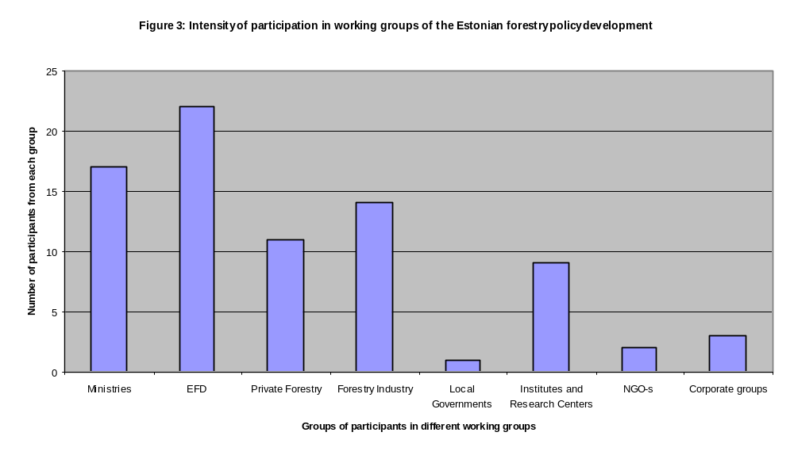
Source: Draft Terms of Reference, Estonian Forestry Development Program 1995-1998.

It was indicative that representatives of ministries considered these working groups as traditional “talks’ chambers” and, initially, at the stage of formulation of basic presumptions of the Forestry Policy, didn’t actively participate in working groups’ meetings.

Such behaviour of officials in the proceedings of the preparatory inter-ministerial working groups has been rather characteristic, when the policy-making process was build up on the bureaucratic subsystem of policy advice. As a result, such groups soon faded and turned into simple bureaucratic units of policy advice to the top officials or ministers. After the presentation of a proposal to the “higher” politico-administrative level the new mechanisms of coordination and political input started to function. This mutually unconnected multilevel coordination and input system would cause considerable discrepancies of strategies, because different layers of professional and political output could not fit one with another.

EFDP was able to avoid such arrangement of unconnected interest of potential stakeholders, but it presumed a supplementary effort to trigger the interests of neighbouring ministries and politicians.

There also was another side of the coin of consensus-based decision-making that was intentionally introduced at that level. Extended working groups involved organised groups and their representatives. Even at that level of representation efficiency of stakeholders’ input was low, especially at first stages, which caused the pessimistic attitude of ministerial representatives (Puustjärvi, 1998: 6). The development of collective decision-making skills and culture was one of the key activities of the EFDP’s leading managers. The National Coordinator’s Office worked out several tools that assisted the development of the policy-making capacity of participants. The Office experts worked out guidelines for the working procedures of the working groups to increase the overall effectiveness of the meetings. To avoid spontaneous discussions and unnecessary topics each working group had to develop a clear agenda and a list of problems that should find a clear answer at the proceedings of a working group (Puustjärvi, 1998: 6). The Office organised training on methods of managing the working groups. These measures and accumulated experience reduced the significance of emotions in discussions and disabled to some extent the potential of the negative sum game.

At the outset of the process the leadership of the EFDP were aware that extended working groups had widely the effect of “the therapeutic democracy” (Chandler, 2000). Until the Forestry policy there was practically no experience and skills of the democratic policy-making process in Estonia. At the same time the dominance of sector and parochial group identities did not allow to find a common language and cooperative disposition of participants from different organisations and groups. Discussions in working groups were, first of all, targeted to the development of such a common language and such dispositions. This purpose was soon achieved.

It is not accidental that we emphasize the role of the working groups as a link between different policy-making arenas. On one hand, the discussion of proposals prepared by experts was directed by participating experts to the framework that enabled stakeholders to rely on rational arguments. The more rational arguments were involved, the less active but more constructive was the contribution of group representatives. Initially, working groups’ participants coming to the network to present their particularist interests, soon started to deliberate in terms of the overall optimality of policy proposals. The role of working groups in the networking process (as opposed to simple gathering together) between different stakeholders and constituents was gradually achieved.

On the other hand, connection to the Steering Committee played its crucial role, but it was undermined by the delay in the establishment of the Committee. Working groups were made policy advice by the steering groups more legitimate, which, in turn, facilitated the political confirmation of policy proposals. However, the feedback from the political Steering committee was equally important, because members of the working groups wanted to get some confirmation to the significance of their involvement in shaping the outcome of the policy process. This aspect of recognition of the significance of input by stakeholders is an especially important parameter of the network-based decision-making. Frequently, the absence of such recognition in the framework of the bureaucratic policy-making (which results from the mutually unconnected multilevel coordination) can hinder the formation of the policy ownership among civil servants.

Nevertheless, final proposals approved by the extended working groups with wide involvement of organised interests appeared to be a rather legitimate source of authority for politicians at the Steering Committee during the deliberation of the core propositions of the Forestry Policy.

4.1.4. Steering and/or Government Committee

It was common at the beginning of 1990s, but unusual for the end of the same decade that such programs as the EFDP had a Steering Committee did not include the representatives of the government. The program was launched and acted in its first year without any political steering and/or without any clear policy directives from the government. “[…] the establishment of the Steering Committee was delayed until the first draft of Forest Policy has become available” (Puustjärvi, 1998: 7). This is the second peculiarity of political steering of the Forestry policy.

At the first meeting with the Program officials the politicians expressed dissatisfaction, because expected to have the right to issue basic policy directives for the experts. However, politicians’ discontent was not fair, because the Minister of Environment was a former forestry sector specialist (former director of the Forestry Vocational Training Centre) and was perfectly informed about the activities of the EFDP. Presumably, politicians were not so optimistic about the effectiveness of the EFDP.

In spring, when the formulation of the Forestry policy entered into its final stage, the EFDP experts and the National Coordinator’s Office became concerned that the lack of interest on part of the government and the Minister might hinder the planned schedule of the policy development. One of the reasons for such a gap between the policy development program and the political leadership initiative has been the unusual organisation of the policy process, where ministerial apparatus was almost completely external to the process and the Minister didn’t feel enough responsible for for the development in a sector, which didn’t have a unit of policy advice established at the ministry and which was formally assigned to the independent Forestry Agency.

The National Coordinator’s Office started to lobby the process at the Environmental commission of the Parliament, where Cabinet members were frequent guests. Steering Committee was brought back and during a limited period (May–November 1996) it presented the final draft proposal of the Forestry policy to the Cabinet. The role of the Steering Committee as an arena was not so pronounced as of that of other inter-ministerial commissions, although the draft proposal was discussed and revised several times at the Steering Committee.

Steering working groups created departing from the consensual basis already tentatively legitimised and ensured professional support to the majority of proposals that had far-reaching political and institutional consequences. It was not so easy to oppose proposals that were supported by important groups and organisations. The same applied later to parliamentary debates. The parliamentary commission was involved – at least in the part relating to the feedback – into the elaboration of the Forestry policy at earlier stages. When draft proposal from the government reached the Parliament, they were criticized by certain interest groups, primarily by the Farmers’ interest organisations (Kallas 1997: 1). The current coalition was characterised by a relatively autonomous stance in relation to the Parliament. Government proposals were rather frequently considerably revised and contested by Parliament’s commissions and even at plenary sessions. The pressures from interest groups on a relatively open Parliament commission triggered a new round of debates. But the Parliament soon reached an almost a unanimous decision (only 2 votes were cast against the policy).

After the adoption of the Forestry policy the Steering Committee ceased to summon, although the elaboration of the Forestry Development Program continued with the creation of the SFMO. The National Coordination of the EFDP was put in charge of the SFMO in the beginning of 1997, which strongly undermined the coordination capacity of the EFDP. This new structure of the division of labour and of the coordinative capacity stimulated the confusion among different interests groups and other parties in relation to the status and responsibilities of the Program (Puustjärvi, 1998). The confusion was caused also because of the delay of administrative reorganisation of the Forestry Agency (and of the Environmental administration in general), which was launched only in September 1997 (Kallas, 1997). The third development of erosion of the effective policy implementation was the delay of the revision and adoption of the Forestry Law (Puustjärvi, Onemar, 1997: 8). This delay was caused by technical as well as by political reasons. But the main reason of the delay was the over-bureaucratisation of the policy-making process. The preparation of proposals to the revision of the law (actually it was an entirely new document) was assigned to the Ministry of Environment and the commission was chaired by an advisor to the minister. The intensity of work as well as involvement decreased dramatically. The main obstacle was a dispute with the Ministry of Justice over the status of the new SFMO. After the achievement of agreement with the Ministry of Justice the Ministry of Finances started to contest the status of the SFMO. (Un)fortunately, the veto right of those two ministries was abolished by that time and the law has been passed putting aside the issue of consent of the Ministry of Finances.

In sum, after the gradual dissolution of the network of the Forestry policy the process of policy development and implementation faced serious difficulties in comparison to the policy process based on a network arrangement, which, on the contrary, is traditionally expected to be more time-consuming and containing numerous obstacles in the form of veto points.

4.1.5. Supplementary arenas and tools of network management

There were two other large constituents, who were not integrated enough into the elaboration of policy proposals on forestry. One of them – private forestry owners – was rather poorly organized and whose participation was ensured by largely unrepresentative tip organizations, which were expressing either highly politicised or highly particular corporatist interests (Puustjärvi, 1995: 5, 1998: 6; Puustjärvi, Onemar, 1996: 5). The representation and articulation of private forest owners’ interests, although highly emphasized by the government itself, remained the most problematic issue of the Forestry policy at the stage of formulation as well as implementation. A survey has been conducted, which served to substitute direct participation of private owners and to establish a more or less reliable general image of the position of the private owners concerning different aspects of the Forestry policy (Puustjärvi, 1998: 1, 6; Puustjärvi, Onemar, 1996: 5). Thus, the conclusion could be that interests should be promoted directly by constituencies / stakeholders instead of delegating it to third, hardly legitimate representatives.

The second group consisted of employees of the forestry sector – forestry managers and workers as well as officials from the regional offices. Formally they were all involved through their peak organisation: Association of District Foresters and other union-like organisms. Actually, local forest managers, who were formally subordinated to the Forestry Agency, exerted considerable power and possessed substantial material / fiscal resources in the period, when the reform initiatives were launched. The discourse with that target group, which was not directly involved into the visible policy-making process, should have been organized into an independent arena of policy formulation and later – of policy implementation. Unlike the established arenas, the discourse between the EFDP key leaders and experts was held either in ad hoc national and regional seminars and meetings or during regular, traditional events of the forestry sector: the Day of Foresters, regular meetings with heads of forestry management units etc. During three years the frequency of such kind of meetings was meaningful. In these years the culture of the discourse has been developed that continued to progress already at the SFMO. In order to speed up the exchange of information a special gazette of the EFDP was printed: in two years of the EFDP there were 12 issues (Puustjärvi, 1998: 1).

4.2. General configuration of the process of the Forestry policy development

The scheme of the development of the Estonian forestry policy strongly contradicted the conventional sequence of the policy process. Nevertheless, we witnessed this un-linear structure of the process to enable the creation of supplementary recourses to the sustainability of the policy.

Table 2: Stages and duration of various stages of Forestry policy
Stage | Beginning | Termination | Duration (month)
1. Preparing policy proposal | Sept. 1995 | May 1996 | 9 month
2. Making policy decisions  - At steering (inter-ministerial) committee  - At the Cabinet  Total | May 1996  November 1996 | November 1996  March 1997 | 6  5  11 month
3. Legitimising policy | March 1997 | June 1997 | 4 month
4. Forest Sector Development Plan 1997 – 2001 (Implementation strategy) | Early Spring 1996 | March 1997 | 12 month
5. Preparation and adoption of the Forestry Law | July 1997 | December 1998 | 17 month
4. Creation of SMFO  - Creation of the first draft  - Creation of central and regional offices  - SFMO legally in force |  | Oct.- Dec. 1997  January 1999  February 1999

Firstly we witnessed that technically more complex and professionally more extensive tasks were fulfilled relatively easily. Political legitimation of the Forestry policy took 15 month, whereas its implementation took the same 15 month. At the same time the political stage of the policy elaboration was assessed as a relatively successful.

We witnessed many difficulties in the revision of the Forestry Law, which has largely been caused by the bureaucratisation of this policy development. According to our evidence the final consent at the cabinet was largely the result of the EFDP leadership’s unofficial lobby. Besides, many of the statements of the Forestry policy as of an official act inhibited the new provisions into the law that would reverse the whole process of re-organisation of forestry in Estonia.

Most importantly, we witnessed that many implementation activities were triggered by the time, when the adoption of the Forestry policy became more or less ensured. The Forestry policy was adopted in June of 1997. Before that (in March 1997) the ‘Forest Sector Development Plan for 1997 – 2001’ – otherwise considered as an implementation strategy – was completed and the creation of the SFMO was already half-accomplished. The Forestry Law was adopted less than a month before the beginning of the first financial year of the SFMO as an integrated organisation.

Hence, the network organisation of the policy development, in which the elaboration of policy precedes the creation of a formal-normative framework, contains some extensive supplementary possibilities to fasten the process of policy development and to make it more sustainable. In network arrangements conflicting interest groups as well as sector and professional egoism of government agencies would be substantially balanced out to successfully pass the dead-ends of the policy process. This confirmed also in the course of the subsequent development.

5. Implementing Forestry reform: arenas and networks.

Soon after the SFMC started its operations and completed its organisational integration (Sootla, Kadakmaa, 2001) the new minimal winning coalition (Laver, Schofield, 1991) with a large ideological distance took office. Ministerial autonomy at that Cabinet was considerable. The Minister of Environment came from what appeared to be a libertarian party (Reform party) and, obviously, was the promoter of interests of the forestry business. However, soon the Minister, absolutely independently from the Cabinet PA reform strategy, started to reform the environmental sector and attempted to redesign the previously well-tuned institutional roles in the forestry sector (this a independent policy-making initiative was thoroughly discussed at the Government commission for PA reforms). All field services of the Ministry of Environment, except for inspections, were merged into one Environment service, in which major part of the capacity was provided by the former Department of Environment that was detached from the County government level with its right to command regional resources of the Environment Foundations (the latter was obviously the political aim of the reform). Concentration of government roles in Environment protection at the regional level was an urgent task. Government role in extension of private forestry and in safeguarding forests have become very weak after the reform.

Nevertheless, the main aim of that reorganisation was the centralisation of resources to the disposal of the Minister. Formerly, the control over resources was considerably constrained by the bureaucratic hierarchy and by the status of an independent agency. The Forestry Agency was abolished and re-organised into a policy advice unit at the Ministry. This reorganisation was accomplished parallel to the implementation of the Forestry policy becoming a high priority. Obviously, the political leadership was not interested in the implementation of the adopted Forestry policy. Regional services became directly subordinated to the chancellor of Environment, who was politically affiliated to the Minister’s party#. The Public Environment Foundation was soon reorganised into a private-law organisation, in which supervision over resources was ensured by the political supervisory council.

In relation to the forestry the political career minister (previously the Minister of Finances and Economics) had a special concern. He offered a qualitatively different model of the Forestry sector. (See:..)

The Forestry policy departed from the premise that the government was not able to ensure or guarantee public interests in the management of public forests. This aim was planned to be achieved through private-public partnership in the forest renewal. Besides, state-managed forestry enabled to spread considerable risks from the temporarily recessed forestry regions and to make some considerable investments into forests that were externalised from the environmental management system, because they were located in the zones of previously extensive Soviet military activity, i.e. frontier defence zones that extended up to 40 km from the costal line. I.e. the environmental dimension of the forestry expanded rapidly during the transition toward a new model of forestry.

The new plan presumed the restriction of the role of the SFMO in forestry management to the environmental renewal works and protection of forestry resources that ought to be financed from the state budget. Those works were supposed to be financed from taxes of private companies, which – according to the new institutional configuration of the forestry sector -- had to take over all forest cutting and marketing tasks at the government-owned forests. What was the most impressive fact is that the Minister appealed to the Soviet time forestry managers and ‘Greens’ in order to assist in restraining the role of the SFMC in the Forest management. This plan was promoted, by the way, in the period, when forest resource in private forests approached to ecological limits after a 5-year extensive cut resulting from very liberal rules.

Why was it necessary to describe the background of this innovation so extensively? Because it was targeted and backed up by the interests of two main actors of the forestry, which were balanced out during the network -based elaboration of the forestry policy. One of them, the forestry industry intended to enhance its role in the round-wood and forest management markets. Another actor with opposite interests became an ally of the business interests. The Estonian Fund for Nature expected that the restriction of the SFMO role would enable better achievement of public or government roles in the forestry and, first of all, in ensuring the environmental reproduction of forests. Nevertheless, all other major actors would loose from that model of forestry management, first of all, because of the loss of control over the returns from the forest management activity.

The network of major actors of forestry policy that formed in 1996—1998 was enough strong to resist to those plans, although political pressures on them were extremely intensive and enduring. The policy network was so balanced that other participants, even from the private sector, and – what was more important – heads of the recently reformed forestry units (who lost their financial independence in the course of the reform) did not support this pressure on the leadership of the SFMO.

6. Conclusions: networks in ensuring sustainable forestry policy

Policy development in the forestry sector has been an edifying case of a network-based decision-making, which ensured the sustainability of the Forestry policy in its major dimensions.

Differently from other sectors, where reforms were carried out through the decentralisation and privatisations, the reform in the forestry sector promoted aims of centralisation, economy of scale and collective identities. The Forestry reform did not follow the overall tendency. Returns from the forestry management were considered as means of ensuring sustainable forestry in Estonian state forests (Sootla, Kadakmaa, 2001). Because reform was backed and resulted in strengthening values that formed the basis of institutional strength of the forestry during turbulent time. At the same time we should not underestimate the role of the transfer of major values of consensual decision-making style by sponsors and experts from Nordic countries.

In our analysis we witnessed different mechanisms and ends of balances, which the network-based policy-making arrangements ensured. These balances ensured, first of all, the optimal equilibrium of forestry needs and capacities during the planning and implementation of the Forestry policy. Radical reform in the majority of sectors was carried out under the priority of interests of capital accumulation, whereas losses were by imposed on constituent groups. This is a rather usual to unbalanced systems of governance (Viteritti, 1997). In the forestry sector the gains and losses from crisis and radical reform of forestry were spread more or less equally among different stakeholders and constituent groups. This ensured an unusually strong support of groups and constituents to the main reform policy, although losses of all were considerable (for instance, the number of state forestry units decreased by three times; the number of employees was reduced by 2,5 times). At the same time the government itself was the weakest link in the chain of institutional arrangements, what has been damaging to the forestry development outside the state forestry sector.

The consistency of policy was also largely ensured by the network arrangement, which provided the domination of consensual decisions. Although some political players intended to reverse the achieved consensus, the possibilities of revision of policy have been severely limited. At the same time, in making final decisions, especially in case of the status of the SFMO, the transition specific, which cannot enable the introduction of most optimal solutions, was frequently the main argument. The Forestry policy and Development Plan contained several propositions that will be revised as soon as forestry and Estonian society have reached certain point of maturity. First of all, the Forestry policy presumes a gradual reliance of private law forms on forestry management.

Networks also enabled to reach decisions that were based on their appropriateness, i.e. decisions were accepted by members of the network, because they were clear to stakeholders and constituents, even if they might have contradict their particular interests. The focus of attention on the elaboration of the Forestry policy and on its adoption as a binging law played a considerable role. Consequently, the Forestry Law might have a law regulatory capacity because of the highly institutionalised normative values. Thus, we could witness how smoothly the new institution building started, although the formal Law was not yet passed.

Hence, we were able to identify some immanent properties of networks that could be considered as the independent variables of institutional organisation of the policy-making in modern society.

References

- Allison, G.T. (1971) Essence of Decision: Explaining the Cuban Missile Crisis, Little, Brown, Boston, MA.
- Bogason P. (2000) Public Policy and Local Governance. Institutions in Postmodern Society, Edward Elgar;
- Chandler D. (2000) Active citizens and the therapeutic state: the role of democratic participation in local government reform, Policy and Politics, 29 (1): 3-14;
- Dowding K. (1995) The Civil Service: Theory and Practice in British Politics, Routledge;
- Durant R. (2000) Towards the polity centered theory of administrative reform, Journal of Public Administration Research and Theory (1);
- Elmore R. (1979/1980) ‘Backward Mapping: Implementation research and Policy Decisions’, Political Science Quarterly, vol. 94(4);
- Hjern B., Hull C. (1987) Helping Small Firms Grow: An Implementation approach, Croom Helm;
- Kallas A., Puustjärvi E. (1997) Progress report for the year 1997 (draft manuscript), Estonian Forestry Development Programme 1995-1998;
- Kickert W.J.M., Klijn E-H., Koppenjan J.F.M. (eds.) (1997) Managing complex networks: strategies for the public sector, Sage;
- Klijn E-H. (1997) ‘Policy network and network management: a state of the art’, in W.J.M. Kickert, E-H. Klijn, J.F.M. Koppenjan (eds.), Managing complex networks: strategies for the public sector, Sage;
- Laver M., Schofield N. (1991) Multiparty Government: the Politics and Coalition in Europe, Open University Press;
- Lowi, T. (1972) ‘Four Systems of Policy, Politics, and Choice.’ Public Administration Review, Vol. 32, July/August, pp. 298-310;
- March, J.G. and Olsen, J.P. (1995) Democratic Governance, Free Press, New York;
- Marsh D. (ed.) (1998) Comparing policy networks: Public Policy and Management, Open University Press;
- Peters G.B. (1998) Policy networks: myth, metaphor or reality?, in D. Marsh (ed.), Comparing policy networks: Public Policy and Management, Open University Press;
- Puustjärvi E. (1995) Formulation of National Forest Policy and Coordination of technical assistance in the forestry sector, Draft work plan, Estonian Forestry Development Programme 1995-1998;
- Puustjärvi E. (1998) Evaluation on Formulation of Public Sector Policies Case-study: Estonian Forest Sector, unpublished paper;
- Puustjärvi E., Onemar A. (1996) Progress Report for the year 1995, Estonian Forestry Development Programme 1995-1998;
- Puustjärvi E., Onemar A. (1997) Progress Report for the year 1996, Estonian Forestry Development Programme 1995-1998;
- Radin B. ( )
- Rhodes R.A.W., Marsh, D. (eds.) (1992) Policy Networks in British Government, Clarendon Press, Oxford;
- Rockman B. A., Weaver K.R. (eds.) (1993) Do institutions matter? Government capabilities in the United States and abroad, Brookings Institution;
- Sabatier P. (1997) ‘The Need for Better Theories’, in Theories of the Policy Process, Westerview Press;
- Scott R.W. (1995) Institutions and Organizations: Foundations for Organizational Science, Sage;
- Sootla, G. Kasemets, K. and Velthut, A. (2000) Balancing policy-making in the 'centre of government': the Estonian example. Paper, presented at the ECPR 28th Joint session of Workshops, Copenhagen, 14-19 April, 2000;
- Sootla G. (2001) ‘Evolution of Roles of Politicians and Civil Servants During the Post-communist Transition in Estonia’, in T. Verheyen (ed.) Politico Administrative Relations. Who rules?, NISPAcee;
- Sootla G. (2002a) Indicators and mechanisms of sustainable government – Estonian Human Development Report (in Estonian), Tallinn;
- Sootla G. (2002b) ‘Development of governance structures from the sustainability perspective in Estonia in 1990-s’, in RIO + 10, Tallinn;
- Sootla G., Sootla E., Velthut A. (2004) The role of Prime Minister’s Office in coordinating Cabinet policy-making in Central European countries. Paper, presented at the 32nd ECPR Joint Session of Workshops, 13th-18th April 2004, Uppsala, Sweden;
- Sootla G., Kadakmaa H. (2001) Evolution of Administrative Capacity of Estonian Public Administration in the course of Reforms in 1990-s - Estonian Human Development Report, Tallinn;
- Stoker G. (1991) The politics of local government, Macmillan;
- Taylor M. (2003) Public Policy in the Community, Palgrave Macmillan.
- Viteritti J.P. (1990) ‘Public organization environments: Constituents, Clients and Urban Governance’, Administration and Society, 21(4): 425-452;

Normative acts:

- Draft Terms of reference, Estonian Forestry Development Programme, 1995;
- Estonian Forestry Policy, 1997;
- SFMO Development Programme, 1996;

ANNEXES

Annex A: Process of elaboration of the Forest Policy

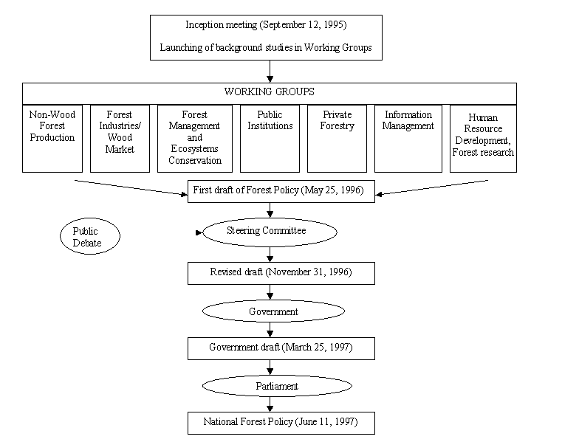 Source: Puustjärvi, 1998.

* Networks approach has been heavily criticized because it could not be used analytically as an independent variable, as it is still defined via other concepts and variables (Dowding, March). The concept of sustainability is still heavily inclined towards the normative ecologism (Sootla, 2001), although its roots in the system analysis enable to interpret it as a set of indicators for the identification of systemic mechanisms and outcomes of policy (Sootla, 2002).
* Colhoz – collective agricultural farm; Sovhoz – state farm.
# Interestingly the Chancellor becomes soon main opponent of Minister in issues of Forestry policy. Because his reliance of bureaucratic neutrality many pressures to foresters were balanced and did not result in the revision of basic premises of Forestry Policy.

