NISPAcee Conference

Implementation of
New Regionalism in the CEECs

Zoltan Balogh

Vilnius 13 – 15 May 2004

Abstract

The theoretical basis of the paper is the work of Jörgen Gren’s „New Regionalism in the EU” and Gregorz Gorzelak’s „The Regional Dimension of Transformation in Central Europe”. The starting point of my paper is the transformation of the CEECs from socialist economic and political system to capitalist one. The main features of this process are summarized by Gorzelak as a restructuring process, but nothing different that happened in the 1970s in the capitalist countries.
The analysis is concentrated on that how to recover the dangerous effects of a state-directed sectoral planning, which missed the principle of coherency and the implementation to different featured regions. This effect is the problematic of core and periphery, the difference between the core area of the Central-European boomerang and the periphery of the „dead east” (as the area called by Gorzelak). Instead of handling the problems of the „dead east”, Gorzelak suggests a policy which is prospective, integrated, internationally and efficiency oriented, regionally targeted.
The work of Gren stresses the importance of creating regions after the new external effects caused in the postfordist area. The five new elements of regionalism are the erosion of national authorities by globalization forces, the region as an agent and lobbyist of the European stage, the influence of supra-national structural policies, the growth of regional consciousness, the influence of cross-border cooperation. Gren analyzes these elements by three case studies.

Sweden – as the last case study of Gren – has got a unitary state form, like all the CEECs. The single intermediate sub-national level is common in the CEECs (except Poland which has a two-level intermediate system). Sweden is a country from the last enlargement round, facing with the territorial reform just in the last decade, after a state-directed planning system. Many different trials, pilot programmes, regional cooperations, searching for the best solution for reaching the goal: the new regionalism.
On the other side the CEECs. Countries in my case studies (Hungary, Slovakia, Slovenia) have three different approach to territorial public administration reform, but all of them can be characterized by a top-down based regional policy. Discussions are based on EU initiatives, NUTS classification, but not in the ways mentioned in the Swedish case, not by a bottom-up approach. The question of financial and institutional independence, to achieve the regional economic entity, mentioned by Gorzelak, is out of scope. The delineation of borders does not mean anything without a content, there is no need to think about the right place of regional self-government in the NUTS classification, if there is not a clear legal and identical basis for existing.

Is it possible to implement the Swedish way of regionalism and experiences? Which way of cooperation would be a possible and realistic way of new regionalism in the CEECs? Is it a reality to gain some years in lagging behind by implementing international experiences in regionalism, or the still existing peripherial regions will be bi-peripherial regions, not just in the pure economic indicators, but in the social patterns of regionalism as well?

Under the experiences from the case studies, the paper evaluates the Swedish trials in regionalism and give some suggestions, what should be the major steps on the way to new regionalism in the CEECs. As a major goal it makes the first step to define Gren’s New Regionalism approach in the CEECs context.

Contents

1. Introduction 4
2. EU regionalism and ways of regional structures 4
2.1. The role of the regions in the EU 4
2.2. Ways of regional structures 5
3. The process of transformation 6
4. Defining New Economy 7
5. The Concept of New Regionalism 7
Case study 1: Sweden 8
6. Regionalization efforts in the CEECs 9
Case study 2: Hungary 10
Case study 3: Slovakia 11
7. Implementation possibilities of New Regionalism in the CEECs 11

References 13

Figures 14
Figure 1.: The Central European ’boomerang’ - a concentration of transformation processes 14
Figure 2.: Space economy of New Europe 15
Figure 3: Economic trends of recultivation 16
Figure 4: Regional typologies for Poland, Hungary and the Czech Republic over 1990-2000 17

Chapter 1. Introduction

The fall of Berlin wall was a symbol of the fall of the socialist regimes not just in East-Germany, but in all countries of the region. The European Union as a democracy based international community became the symbol and vision of a new life for the people of these countries. As the membership got into the focus, and the elements of each EU policies became known for the citizens, all these beliefs and symbols got darker. Coming to the stage from the shadow the EU regional policy and the regionalization in general had a great debate in each Central and Eastern European country (CEECs). Losing the symbols, the exaggerated enthusiasm became an afraid of the unknown. Understanding and creating national regional policy as a tool against regional disparities is the real side of visions.

Chapter 2. EU regionalism and ways of regional structures

2.1. The role of the regions in the EU

The process of EU regionalism could be divided into two parts for the study of European regionalization (Illes 2001):
- The role of the regions in the decision making system of the EU
- The regions, as the subjects of the EU cohesion and structural policy
In this chapter I try to summarize the regionalism under this theory.
Although the European Union bases on the common decisions of the member states, but the latest treaties and processes of the EU tried to give more rights to the different institutes.
From this aspect the Maastricht Treaty established the consultating body of the Committee of Regions. Besides it the lands of federalist states (like Austria, Germany, Spain) got the right of representation of their interests, and determined the principle of subsidiarity, but it is still not clear, there are many controversial understanding of it.
The position of the regions changed from all aspects. If we have a look from the federalist representation right, there is not a further interest for the leader European regions to support the need for power of the other small regions. The CoR's role is not the same than the declaration, there is no decision making right and the rights of opinion can not be used in all cases.
The cohesion and strustural policies of the EU were based on the national governments until 1988. The introduced Nomenclature de unites statistiques territoriales (NUTS) was the first step to create a unified system for a real EU regional policy (The regions 2001). It has got five levels:
- NUTS I: in general it is usually one member state's total area
- NUTS II: the so called "region", the supplement of structural policy connected to this level
- NUTS III: in most cases the existing public administration system of the member states
- NUTS IV: small statistical territorial units, in many cases it is not possible to identify them with a national territorial level
- NUTS V: the local government's level
The process of enlargement raised many questions to the regional structure. Most of them are connected to the lag of the Central and Eastern European countries in many fields of economy:
- the present structural and cohesion funds of Agenda 2000 for the current regions will not be needed after 2006 ;
- under-developed regional structure of joining countries;
- all the regions of enlarging countries will be entitled to structural and cohesion funds (number of current supported regions: 53 from 202, the number of newly eligible regions is 54!).
All this current problems are created a specific requirement list for countries of enlarging process. The organizing of regions is a need because of the statistical system and the goals of Maastricht, which supported the regions as the subjects of structural funds.
But the EU emphasis in many cases that it would trust more in centralized system, not in territorial public administration system. In the following I will present two countries from the CEEs. These two case studies will strengthen the anxiety of the EU, because they will show the lacks of the enlarging countries' public administration and county development structures.

2.2. Ways of regional structures

The EU does not give a model for the countries how to create regional structures. They have got high intervals for each NUTS level, but in the reality the current territorial system has not got any correlation between the area, population and the number of territorial units.

Table 1. The NUTS-classsification of current member states in the European Union
Country | NUTS I |  |  | NUTS II
 | Number | Area | Population | Number | Population | Area
Austria | 3 | 27951 | 2686 | 9 | 9317 | 895
Belgium | 3 | 10171 | 3386 | 11 | 2774 | 923
Denmark | 1 | 43077 | 5262 | 1 | 43077 | 5262
United Kingdom | 12 | 20407 | 4899 | 37 | 6260 | 1503
Finland | 2 | 169094 | 2563 | 6 | 56355 | 854
France | 9 | 71389 | 6486 | 26 | 24712 | 2250
Greece | 4 | 32986 | 2619 | 13 | 10150 | 806
Netherlands | 4 | 10466 | 3881 | 12 | 3489 | 1294
Ireland | 1 | 70284 | 3634 | 2 | 35142 | 1817
Luxemburg | 1 | 2586 | 416 | 1 | 2586 | 416
Germany | 16 | 22315 | 5119 | 38 | 8480 | 1945
Italy | 11 | 27387 | 5314 | 20 | 15063 | 2923
Portugal | 3 | 30796 | 3309 | 7 | 13198 | 1418
Spain | 7 | 72112 | 5667 | 18 | 28043 | 2204
Sweden | 1 | 440945 | 8841 | 8 | 55118 | 1105
TOTAL – EU | 78 | 70129 | 4272 | 209 | 20918 | 1707
Source: Eurostat News Release No. 11/99. 9 February, 1999.

That is why in this case the EU can not require anything, only that to create a more decentralized territorial system to ensure the democracy in this young capitalist countries.
As we have seen in the lack of rules the fastest way to create an own territorial system is to implement the experiences of other member states with the same public administration traditions. The basic constitutional territorial modells are the next ones:
- Unitary states: in general one level territorial system with centralized executive power, based on self-governments of counties
- Federalist states: the leading countries of the continent, more-level territorial structure, with a high independence of the lands/regions
- We should talk about a special group of countries which has not got a territorial self-government system, the regions/counties are directed by state administrative units (like Greece, Finland, Luxemburg). Until 2001 Slovakia was in this group as well.
As the majority of the new-coming EU member states have a unitary state form during the regionalization process the best models could be the unitary states such as Sweden, Portugal, Greece, Finland. As these countries joined the European Union during the last enlarging rounds, the experiences of them on the field of regionalization and regional policy could be the most useful. In the following after examing the new trends in regionalization (the concept of New Regionalism) i try to evaluate the regionalization process of Hungary and Slovakia based on the Swedish experiences. The similar public administration traditions (all of them are unitary states – see Table 1.) and political backgrounds (Sweden joined the EU in 1995 in the last enlarging round, which is the closest time to the 2004 enlarging round) justify the involvement of the selected countries in this comparison, although they are on different level of public administration development and regionalization process.

Table 2. The NUTS system of the countries involved in comparison
 | NUTS I |  |  | NUTS II |  |  | NUTS III |  | NUTS IV |  |  | NUTS V
Country |  | Area | Number | Area | Number | Area |  | Number |  | Area | Number |  | Area | Number
Sweden |  | Land | 1 | Riks-omraden | 8 | Lan |  | 21 |  | - | - |  | Kom-muner | 289
Hungary |  | Ország | 1 | Régió | 7 | Megye, főváros |  | 19+1 |  | Kis-térség | 150 |  | Tele-pülés | 3135
Slovakia |  | Stat | 1 | Region | 4 | Kraj |  | 8 |  | Okres | 79 |  | Obec | 2800
Source: Commitee of the Regions: Regional and Local Government in the European Union p.219., Hajdú, Zoltán: The Public Administration Geography of Hungary p.281., Consultation with Milan Bucek, EUBA, Slovakia

Chapter 3. The process of transformation

Grzegorz Gorzelak (1996) summarizes the process of transformation in the CEECs from socialist economic and political system into a capitalist one interestingly. Focusing on Poland, but having a wider scope on each countries of the area, he believes the transformation to be a restructuring process, but nothing different that happenned in the '70s in the capitalist countries. It is just a way of the postfordist restructuring in a 20-30 years time lag.
The question is that how to recover from the dangerous effects of a state-directed sectoral planning, which missed the principle of coherency and the implementation to different featured regions. That is obvious that "all four countries (Czech Republic, Hungary, Poland, Slovakia) have their unquestionable leaders of transformation, which have already demonstrated the highest potential for restructuring and a great capability for adoptation to new conditions. These are their greatest agglomerations. ... We have sketched in this way the core of Central Europe: 'the Central European boomerang' delimited by the following centres: Gdansk-Poznan-Wroclaw-Prague-Brno-Bratislava/Vienna-Budapest." (Gorzelak 1996 p.127. - see Figure 1.)
On the other side "Central Europe has a very clearly marked periphery. It extends from the north eastern corner of Poland to the south eastern part of Hungary, with extension westwards to the eastern part of the Slovak-Hungarian border." The main features of this periphery after Gorzelak are the following:
- transformation processes are slow
- the level of education is low
- do not attract the attention of foreign investors
- these areas cannot expect to receive inducement for transformation and recovery from their neighbours on the other side of the border (Lithuania, Belorussia, Ukraine)
Based on these facts Gorzelak states that: "It is therefore very likely that the eastern wall will become the 'the dead end of Central Europe." (Gorzelak 1996 p.129.)
Connecting to the core-periphery problemacy Sokol (2001) argues the existence of the core, he suggests to handle Central Europe as a periphery of the New Europe (see Figure 2.). „The last decade has also seen significant divergence within Eastern Europe itself.” By delimitating the geographical areas of different peripherial levels Sokol says „a small number of Central European economies (Slovenia, the Czech Republic, Slovakia, Hungary and Poland) appear to be performing much better than the others. However a closer look at the figures reveals that even these countries have been struggling to recover their 1989 GDP levels, let alone converge towards the EU average.” (Sokol 2001 p.647.)
This notice of Sokol is important to understand productivity development in the CEECs. Janossy’s theory on economic trends of recultivation (1966) was applied for economies after the Second World War struggling in a similar situation than the countries of transformation in the 90’s. The outstanding productivity growth rates are valid just on a short-run till the economy catch up with the normal line of the economic trend (see Figure 3.). That was the reason for the success of the socialist countries in the 50’s and a reason for fast development of the CEECs in the 90’s.
Completing these ideas Downes (1996 p.258-259.) says "the reasons for certain regions becoming innovative while others move towards crisis are rooted to a great extent in the nature and structure of the regions itself. A number of factors affect the ability to individual regions to adapt to new economic conditions. These include:
- The regions’ economic structure, including the level and sophistication of labor force skills and the quality of fixed assets.
- The level of socio-economic development, including employment opportunities and socio-cultural factors such as entrepreneurship.
- Geographical and economic peripherality, such as the proximity to urban centres, national and international transport infrastructure and sources of capital an innovation.
The interplay of these, and other, factors have led to the emergence of two main areas of regional socio-economic disparity, both in individual and for the Visegrad region (CEECs) as a whole."
Gorzelak, Downes and Sokol suggest that the regional productivity indicators clearly describe the regional problems and inequalities. Another perspective come to enlightment if we have a look on the regional productivity growth datas.
Dall’erba and others (2003) in there work create a regional typology for Poland, Hungary and the Czech Republic similarly to Gorzelak, but on the datas of regional productivity growth. In their graphical results (see Figure 4.) a hard concentration can be realized between the regions of each country. Especially in the case of Poland and the Czech the dynamic datas does not assure the static datas about inequalities. The regions of the capitals are slightly different. These results of regional productivity growth shows that discussing about regional productivity in the lack of regional policy is not possible in its real terms in the CEECs. The dominancy of central authority, and the negligency of the regional policy cause a convergation in the development of the regions, they can not run on their own development paths because of the lack of competences and financial resources.
As a tool for hindering the continuation of this process an effective regional policy can be a relevant answer from the central authorities for the regional productivity disparities.

Chapter 4. Defining New Economy

To understand today's regionalisation there is a need to understand today's economy. After Pohjola (2002) "in its original meaning, the New Economy is a well-defined concept. It means two broad trends... The first is the globalization of business. ... The second trend is the revolution in information and communication technology. "
Especially the globalization trend of the New Economy has a special effect on the CEECs. As a post-socialist geographical area, transforming to capitalism, the forces of globalization are just creating a new handicap during the restructuring process.
Pohjola (2002) is searching for the explanations of what makes the late 1990s so different from the earlier periods that the use of the phrase "New Economy" is justified. One of his explanations is "the fact that labour productivity appears to have picked up in the United States in the mid-1990s. The growth of output per hour worked in the non-farm business sector accelerated from around 1.4% per annum before 1995 to 2.5 in the period 1995-2000. It is interesting that service industries seem to have accounted for much of this acceleration."
Searching for the spatial effects of New Economy, the citation for Kevin Kelly (1998) is inevitable. The 10 new rules of the new order simply overwrite those economic preconditions which were evident some years ago. Focusing partially on the importance of network economy 3 of the 10 rules has spatial consequences:
„1. Embrace the Swarm: As power flows away from the center, the competitive advantage belongs to those who learn how to embrace decentralized points of control. ...
5. Feed the Web First: As networks entangle all commerce, a firm’s primary focus shifts from maximizing the firm’s value to maximizing the network’s value. Unless the net survives, the firm perishes. ...
7. From Places to Spaces: As physical proximity (place) is replaced by multiple interactions with anything, anytime, anywhere (space), the opportunities for intermediaries, middlemen, and mid-size niches expand greatly.” (Kelly 1998 p.153.)

Chapter 5. The Concept of New Regionalism

Michael Keating (1985) made the first attempt towards a new concept of regionalism in the mid 80’s. In his work (Keating 1985) he collects the main features of the so called Old Regionalism: (1) the technical needs of modern state, (2) inter-regional economic policies (distributional national policies aiding depressed regions), (3) cultural demands and (4) the demands for regional autonomy from „historic nations”. Keating (1996) has developed the four causes of the burst of regionalism (economic restructuring, globalisation, transformation of the nation-state and European integration), and developed these general trends and their influence on the regions in a later work (Keating 1998), but without identifying certain key factors, which were set out later by Jörgen Gren.
This work (Gren 1999) stresses the importance of creating regions after the new external effects produced in the postfordist area. The five key factors of regionalism are the erosion of national authority's by the forces of globalization, the region as an agent and lobbyist on the European stage, the influence of supra-national structural policies, the growth of regional consciousness, the influence of cross-border cooperation. These factors are analysed through three case studies in different type of regions with different regional heritage, economic, social and environmental surrounding (Catalonia, Rhone-Alpes, West Sweden).
Based on these experiences Gren defines the New Regionalism as „a response to new economic realities when the globalisation of markets and continental economic as well as political integration supplanted the old order of separated national economies and policy making. … New Regionalism is characterized by regions which are behaving as new, dynamic political and economic actors with demands which do not necessarily correspond with those of national authority and which are not necessarily confined within the national boundaries. The new regionalism is further characterized by a functional idea of allegiances and multilevel governance as well as a search for political ideas travelling from the ’bottom-up’.” (Gren 1999 p.22.)
Explaining the concept of new regionalism, Gren used the West-Sweden region as an outstanding example, where most of the features could be observed.

Case study 1: Sweden

Sweden has got a long past and tradition of public administration systems (Haggroth et al. 1993). The reform of 1862 caused a great change: it secularized the church fields, established the county self-governments, ensured the right of local taxation. This system existed until 1970, the introduction of the new constitution.
The reforms after the second world war concentrated on the public service obligations and effectiveness. It caused two main refoms: in 1952 the local government (kommuner) reform with a limit of 3 thousand inhabitant, and in 1974 with a limit of 8 thousand. The process is summarized in the next table:

Table 3. Swedish local governments 1862-1992
Year | Rural | Transitioning | Kommuner | Total
1862 | 2400 | 10 | 90 | 2500
1901 | 2384 | 20 | 92 | 2496
1941 | 2353 | 53 | 117 | 2523
1951 | 2281 | 84 | 133 | 2498
1952 | 816 | 88 | 133 | 1037
1964 | 777 | 96 | 133 | 1006
1969 | 625 | 91 | 132 | 848
1971 | - | - | - | 464
1974 | - | - | - | 278
1992 | - | - | - | 286
2001* | - | - | - | 289
Source: Swedish Local Government p.14., * Commitee of the Regions: Regional and Local Government in the European Union p.219.

This affected the territorial level as well, because the number of kommuners decreased to 289, which is 12 per each of the 24 lans (counties) of Sweden. It created the possibility after joining to the EU in 1995 to rethink the need of a new statistical regional level in the public administration system.
It resulted in Pilot Projects at the territorial government elections in 1998. There was a right for the lans to create a regional self-government body directly or indirectly. Finally 3 regions were created with the next elected bodies:
- directly elected: The Skane region consists of Malmo city, Malmohus and Kristianstad lans and Vastergotland (West-Sweden) region consists of Alvsborg and Skaraborg lans with the capital of Goteborg. The sphere of authority consisted the competences of lans and the county development task of state directed territorial bodies
- indirectly elected: The Kalmar region, where the municipalities and the county self-government created a „quasi-regional” body (Regionförbundet) to direct the spatial development processes of the lan. All the financial assets are allocated to this body (both European and national) – similar to the directly elected Pilot Projects in Skane and West-Sweden.
The interests of the different participants in this process is changing. In the study of Leijon and Jensen (1996) the national interest is to create a new state directed level, while the interest of the local and territorial self-governments to create a geographical area, which is suitable to compete in European context, to create international networks for business, and to develop infrastructure.
The common interest is to renew the existing system for the new problems created by the EU membership. The main instrument is to form a body, the regional parliament, as the decision-making and representative body of the region. But the power-losing municipalities and lans are deniing the need of this level for a solution. Besides it the main problem is the regional identity, which is missing from the traditions of Sweden. The same situation was in 1974 at local level. Then was a longer period to accept with the people the "one self-government - more municipality" principle.
The Kalmar-project tried to avoid this problemacy by the „quasi-regionalization”. This way of regionalization is focusing more on financial independence from state, on competitiveness and on business development instead of the delimitation, the size of territory and population and to meet the requirements of the EU (such as NUTS classification).
The consultation with Krister Persson, the professor of Human Geography Department of Örebro University, emphasized this view of regionalization as well. The main question was the economical need for creating the regional parliament.
This structure of modern societys is the main cause of the regionalism: a need for better competition, which is origined from the private sector, the uncompetable counties and municipalities. The need for a union, a wider place for economic activity is a common goal.

EU
Member State
Counties
Region
Municipalities
Co-operation
(civil society, trade unions, industry)
If we compare the local reforms with this territorial reforms, we have to say that there are not the same causes. The local reforms origined from the bad level of public services, while at the level of lans there are not supplying troubles. That is why it is not an obligation for the lans to create their unions. It is the choice of the lans when they want to reach this level of public administration process. The final state of it will be a system of 6 or 7 regions, which will provide the services for the citizens on territorial level in the future, but at the same time it will supply a framework not just for the welfare of the citizens, but for the business actors of the region, too.

Chapter 6. Regionalization efforts in the CEECs

"The importance of the issue of regional policy development has therefore been highlighted through the emergence of regional socio-economic disparities, the economic and political dangers of continuing regional divergence, particularly in regions of greatest economic crisism and the influence of international organizations." (Downes 1996 p.261.)
Downes has collected the practical steps in the formulation of regional policy:
- Establishment of goverment departments
- Setting up development agencies
- Defining assisted areas
- Creation of financial incentives
Case studies from the CEECs shows that these tools are known and used in practice. But the effectivity of them is far away from that level which would be evitable for a successful regional policy. Besides Hungarian experiences i could conduct some research in Slovakia. In the following i want to highlight the main problems of the development of regionalisation in these countries.

Case study 2: Hungary

One of the few traditions dated for the state foundation is the public administration system of Hungary. Only the first world war could cause a larger reform on the system of NUTS III level (the number of them decreased from 65 to 25).
The current system based on the system changing period of 1989. The transition to democracy caused the foundation of self-governed municipalities and counties. Besides them there was a state directed territorial level as a juridicial control above the specialized authorities and self-governments. This state authority worked on NUTS II level from 1990-1994, but it based on political negotiations, not on rational regional reform plans.
The new institute of this system was the county development committee, connected to the counties through the same president, and as the executive body of it the county development agency (Act 21/1996). The committee working as the implementation body of each county. Above it the modification of this act (Act 92/1999) delimitated the NUTS II regions of Hungary. There were three theories about the large of the regions, depending on the goal of delimitation (Hajdú 2001):
- micro regional: 2 counties-1 region (10 regions) – county reform
- mezo regional: 3 counties-1 region (5-7 regions) – unionization (final version)
- macro regional: 4-5 counties-1 region (3-4 regions) – federalist structure
The 7 regions were obliged to create an indirectly elected regional development committee as a unity of the county development agencies.
After this explanation we could think that Hungary has got a well-prepared institutional background, but there is the lack of coordination and monitoring mechanisms (Walter 2001).
- The undetermined position of the county/regional development committees in the public administration system.
- The unsafed control of regional development committees.
- The lack of elections on regional level, what would be needed for a new public administration level.
- Specialized territorial authorities in most cases are working on regional level, but not on the same territory, than the delimitated statistical regions.
- The lack of sharing competences between NUTS II and NUTS III level.
This current picture about the regionalism and public administration in Hungary show that there are not questions about the delimitation of regions and creating institutions, the question is the continuation: what will be the role of the regional level in Hungary?
It is clear like in Sweden that a population of 9-10 millions does not need a territorial system on more than one level. That is why a model like in Sweden can be a good opportunity to create the regional level in a long time interval, not as a part of a hard reform. It would give the possibility to create identity and ensure a temporary period for the private and public sector for the transition to new geographical surround.
BUT! Ad 1. On the NUTS V level there is a difference between the two countries. To create a region in Sweden from 30-35 kommuner is not a hard negotiation process. But to communicate with more than 450 municipalities per region is not the reality. Without a municipality reform, disappearing the "one self-government - more municipality" principle, it is unbelieveable to put an end to the current NUTS III level. The only way is to create an indirectly elected parliament, like in Smaland, which is responsible only for the regional development.
BUT! Ad 2. The newly elected government of Hungary in 2002 launched a renewed county development and regionalization programme. Elemer Kiss, the new minister of the Prime Minister’s Office considered for his main project the reform of self-governments, which was always postponed because of political reasons. The reform had three proposed steps:
- growing autonomy of self-governments by strengthening the financial independence,
- supporting the creation of minor regions on NUTS IV level,
- creating the new elected regional self-governments and state administrations.
This three-step model would have solved the problem mentioned above. The number of self-governments would have been decreased by minor region creating, which would give the possibility for the territorial public administration reform as an answer for challenge of EU accession. But the original deadlines for completing the programme were not realistic because of the different political interests.

Case study 3: Slovakia

The independent Slovak Republic was established in 1991, after the disappearing of Czechoslovakia. The last decade was about the chain of public administration reforms. Paralel with the foundation of local self-governments, there was established a two level territorial system governed by the state. It consisted of 38 districts and 121 subdistricts.
There was a radical reform in 1996. 8 krajs and 79 districts were delimited. This system had still the lack of self-governmental features, just the election system was introduced, but they were dependant on the state financially and in competences (Bucek 1999).
This structure without self-governance hindered the creation of development committees by the districts themselves. There was a trial by the Ministry of Economical Strategical Planning, which created Territorial Information and Consulting Agencies in every districts, but they turned to private companies and they have lost there original role for a national regional development network.
The territorial reform of 2001 was ahead of a great dispute. It was reasoned by the fact that the EU joining process partly connected to the territorial delimitation through the EU statistical region system (NUTS). But the well-known political polarity of Slovakia, and the governing coalition consisting more parties with different interests, rose difficulties in front of a real reform.
The original proposal was consisted of 12 regions in Slovakia, trying to get back to a traditional public administration systém, zupa system, and based on economical grounds. But the inner opposition of Hungarian Coalition's Party hindered this version by a modification need of implementing a 13rd kraj with Hungarian majority (Komarno). This modification was not supported by any other parties.
Finally the existing borders did not change, but the self-governing rights, based on financial and competence independence, gave the possibility to the krajs to fulfil the decentralization principle of the EU and to build up a law supported system of territorial self-government.
They have got the right to establish county development agencies, which can be the base of a national network. But they still not exist, and the promise of EU for enlarging in 2004 raises the question, if these agencies will be prepared for the EU funds and their requirements.
On NUTS II level there are four regions created similar to the other case studies as a unity of some counties:
- Bratislava
- West (Trnava + Trencin + Nitra)
- Central (Zilina + Banska Bystrica)
- East (Presov + Kosice)
The problematic level of Slovakia – just as in Hungary – is the NUTS V level as well. The 2800 obci hardly have enough resources to fulfil their public service obligations on the field of education, health care and in other municipal tasks. The lack of a reform on this level can hinder all other efforts of a more competitive and effective territorial structure.
The other hindering factor is the lack of experience in fiscal independence in the krajs. Without creating the institutes of manager orientation, not state orientation, of self-governing krajs, with a regional policy implementation body per each region, it is not worth to discuss the further possibilities of a competetive, knowledge orientated, innnovative, economy based regional parliament on NUTS II level.

Chapter 7. Implementation possibilities of New Regionalism in the CEECs

Jörgen Gren focuses on five features of New Regionalism. First the erosion of national authorities by the forces of globalization is one of the most vivid part of transformation. The economic restructuring has been done mainly by the foreign investors (multinational companies), the effects of globalization can be experienced in the frameset of market economy. On the other hand the state itself has lost its power over the territorial units. Especially on local level, the settlements got a high level of autonomy in each countries of Central Europe. The local governments became the symbol of democracy, but in fact the autonomy did not connect to a fiscal decentralisation. In the lack of financial resources the only tool of power is the politics. In some countries the regional level also got self-governing rights (Hungary, Poland and after the reforms of 2002 Slovakia), but they can not appear as a real economic and social entity because of the still deconcentrated competences and financial resources.
The second feature, the region as an agent and lobbyist on the European stage is missing a major precondition, the territorial reforms, the delimitation of regions, which would be capable to behave as a competitive entity in a global sense. Just Poland could achieve a new regional system during the last more than one decade, in Hungary just one trial has been completed 10 years ago. The principle of „one country-one region” was implemented as a result of the EU accession negotiations in all new member states. Although in May 2004 all these countries will be the members of the EU, but their regions will not be able to be present on the European stage.
Third, the challenge of the supranational policies of the EU is connected to second feature. Without being present, the regions of the CEECs can not be the subject of EU regional policy, and instead of the erosion of the nation state’s power, the position of the central authorities will be strengthened. Therefore the neglegency of governments towards real regional decentralization fix the leading role of central authorities in regional planning and hinder the process of regionalization towards globally competable regions.
Fourth, regional consciousness is historically out of scope. The Austro-Hungarian Monarchy used the regionalization as a tool of state control. The act of individual towards rather sceptic, the meaning of the regionalization is a discredited process in all of the CEECs which were the part of the empire.
The fifth key feature is based on the four above. Reaching para-diplomatic status for a region is the highest level of the New Regionalism concept. In short run there is no chance to achieve it which is further hindered by the ethnical heterogenity of Central Europe. New generations are needed to clear from the mentality the decisions of the First World War peacemaking process.
As a solution Gorzelak suggests to handle the problems of peripherial regions through a policy which is prospective, integrated, internationally and efficiency oriented, regionally targeted. "If serious reforms of the regional structures are performed, several of the tasks now assigned to central authorities could be further decentralised... The new regions will be able to create their own institutions which would supplement the state policies targeted to the problem regions. These institutions will be particularly active in training and retraining activities and in creating favourable economic environment for new investments and developments. International cooperation of regions will be further decenralised." (Gorzelak 1996 p.147.)
This approach of effectivity instead of equality can cause further improvement of disparities between the core and periphery, but at least there would be created a new way of regional policy, which is able to direct the regions of a country and create real economic entity for the regions.

References

Bucek, Milan (1999): Depressed Regions or Depressed Regional Policy? (10 years of Slovak Experience). Conference working paper, Berlin.
Dall’erba, Sandy - Kamarianakis, Yainnis - Le Gallo, Julie - Plotnikova, Maria (2003): Regional Productivity Differentials in Poland, Hungary and the Czech Republic. Regional Economics Applications Laboratory Discussion Papers, REAL 03-T-26, on the web: http://econwpa.wustl.edu/eps/urb/papers/0310/0310004.pdf
Gren, Jörgen (1999): The new regionalism in the EU the lessons to be drawn from Catalonia, Rhone-Alpes and West Sweden. Östersund, SIR [The Swedish Institute for Regional Research] [Statens institut för regionalforskning] - Stockholm, Fritze.
Gorzelak, Grzegorz (1996): The Regional Dimension of Transformation in Central-Europe. Jessica Kingsley, London.
Haggroth-Kronvall-Riberdahl-Rudebeck (1993): Swedish Local Government SI, Falköping.
Hajdú, Zoltan (2001): The Public Administration Geography of Hungary Dialóg. Campus, Budapest-Pécs.
Illes, Ivan (2001): Regions and Regionalism I-II. Comitatus, Vol.11., No.6. pp.5-13. & Vol.11., No.7-8. pp.20-28.
Jánossy, Franz (1966 - unter Mitarbeit von Maria Holló): Das Ende der Wirtschaftswunder: Erscheinung und Wesen der wirtschaftlichen Entwicklung. (Probleme sozialistischer Politik 12.) Frankfurt a. M.: Verlag Neue Kritik. Frankfurt, 1966. In English (1971): The End of the Economic Miracle. Appearance and Reality. IASP International Arts and Sciences Press, Inc., White Plains, New York.
Keating, Michael – Jones, Barry (1985 - Eds.), Regions in the European Community. Oxford University Press.
Keating, Michael (1996): The invention of Regions. Political restructuring and Territorial government in Western Europe. European Consortium for Political Research, Joint sesssions of workshops, Oslo, 29 March – 3 April.
Keating, Michael (1998): The New Regionalism in Western Europe: territorial restructuring and political change. Edward Elgar.
Kelly, Kevin (1998): New Rules for the New Economy. 10 Ways the Network Economy is Changing Everything. Fourth Estate, London.
Leijon-Jensen (1996): Theorizing and Conceptualizing Regions: The West Sweden Region - An Idea Searching for a (Re)form p. 14-37 In:Alden-Boland: Regional Development Strategies Regional Studies Association, London.
Sokol, Martin (2001): Central and Eastern Europe a Decade After the Fall of State-socialism: Regional Dimensions of Transition Processes. Regional Studies, Vol.35., No.7., pp.645-655.
The regions, the counties and the small territorial units social, economical and infrastructural connections (2001). Comitatus, Vol.11., No.5., pp.11-13.
Walter, Tibor (2001): The Regionalization of Territorial Public Administration Systems. Comitatus, Vol.11., No.3., pp.26-28.

Figures

Figure 1.: The Central European ’boomerang’ - a concentration of transformation processes
(Source: Gorzelak 1996 p.128.)
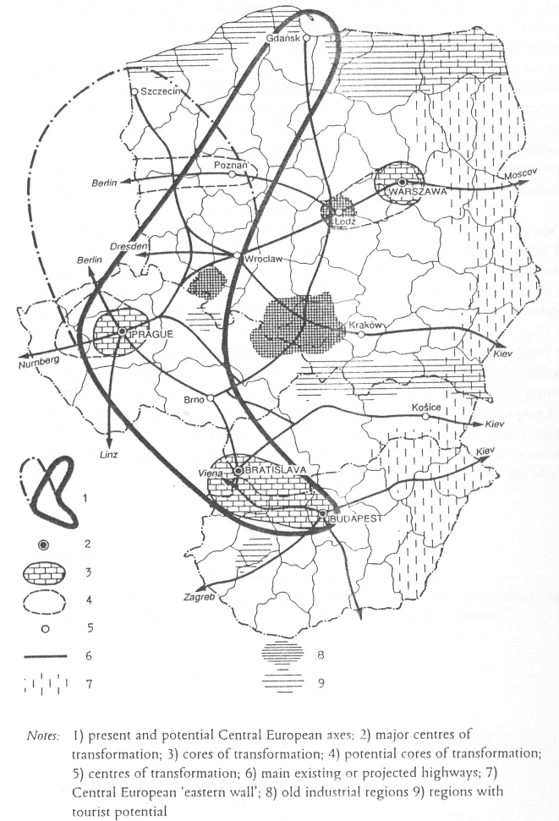

Figure 2.: Space economy of New Europe
(Source: Sokol 2001 p.647)

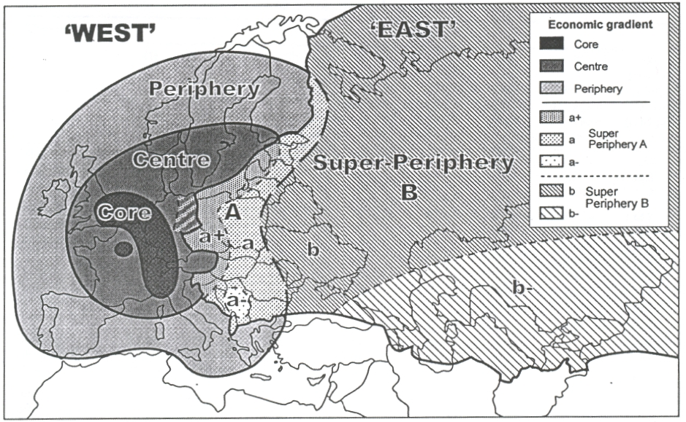

Figure 3: Economic trends of recultivation
(Janossy 1966)

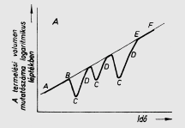

Figure 4: Regional typologies for Poland, Hungary and the Czech Republic over 1990-2000
(Dall’erba and others 2003 p.25.)

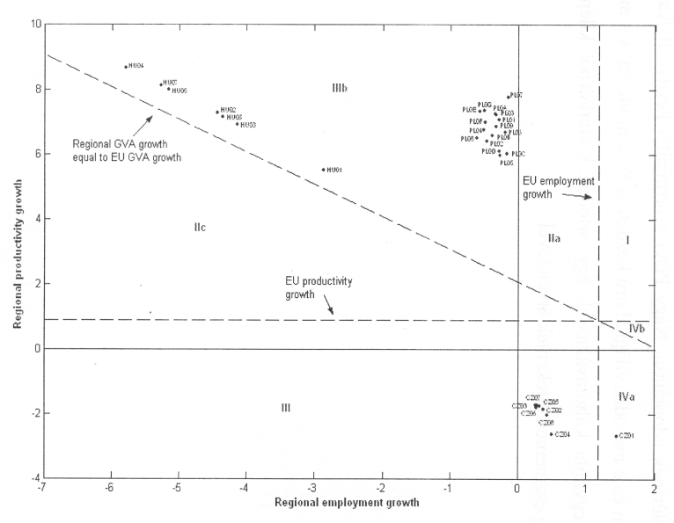

PhD student, Budapest University of Economic Sciences and Public Administration, Department of Economic Geography, Fovam ter 8. 1093-Budapest, Hungary, e-mail: z.balogh@bkae.hu, phone/fax: +36-12176706

