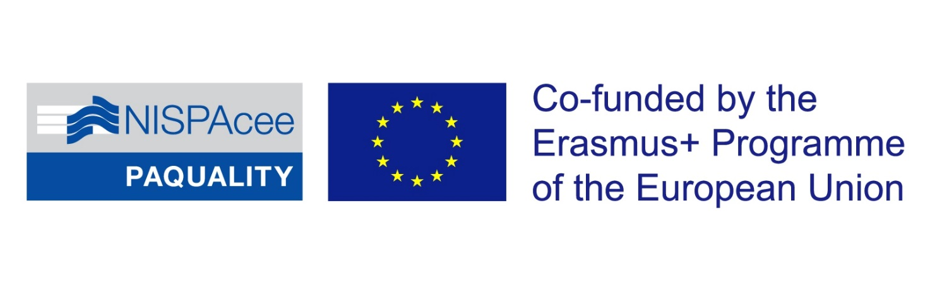

Public Administration Education Quality Enhancement Erasmus+ Strategic Partnership KA203 (PAQUALITY)
No – 2018-1-SK01-KA203-046330, Slovakia, 09/2018-08/2021

Framing the design of PA teaching
Workshop on PA curricula in CEE and development of competencies relevant for practice

PROGRAMME

Term: November 4 - 6, 2020
Format: A virtual event (originally planned to be organized in Varna, Bulgaria)
Platform: Google Meet hosted by Varna Free University

Participating institutions:
Four partners of the PAQUALITY project are responsible for the workshop preparation and implementation:
- Varna Free University, Bulgaria
- University of Ljubljana, Slovenia,
- Masaryk University, Czech Republic
- Babes-Bolyai University, Romania
Other participating institutions:
- University of National and World Economy, Bulgaria
- Municipality of Varna, Bulgaria
- Ministry of Economy, Bulgaria
- Technical University Sofia, Bulgaria
NISPAcee participates as an observer.

Introduction/motivation

Given the E+ KA2 projects' framework (innovations and development), the main beneficiaries of the activities undertaken are us (and, subsequently, our friends from the regional community).

When considering taking the activities, we should keep in mind to extrapolate as much benefit out of it for our purposes, when teaching PA, thus also sharing our knowledge and experience.

The main input for the exercise and framework development are outputs of the already completed IO1, where extensive competence screening was performed over the selected programs of partner institutions.

Expected outputs (during and after the workshop)

Identification and streamlining of competencies needed for practice, i.e. for working in public administration, and the assessment what is not covered by the existing teaching of PA (describing know-do gap).

Identification of common problems/topics/issues plaguing PA functioning.

Identification of most suitable teaching and learning approaches, to bridge the gap between needs of practice and current programs' delivery.

Creation of interdisciplinary courses (or modules), focus on the advancement of teaching of PA through practical experience - class-based learning is targetted, and not field-based learning.

Context

Teaching level focus: Master level PA

Starting point: Interdisciplinarity provides the main focus (intended outcome) of the curriculum. Disciplines generally become a means to this end, and students are not exposed to disciplinary grounding and theoretical depth. Disciplines need to integrate content aimed at mastering interdisciplinary outcomes. We assume the nature and complexity of the problem reflect the need to overcome fragmentation and to construct knowledge in such a way that comprehensive “answers” can be found to the problem.

Assessment: Since one of the common tendencies shown by the analyses conducted within the project is that there is a certain lack of practical teaching and learning experienced in the existing programmes, contributing to »know-do« gap, the endeavor in modification of teaching should follow the logic of experiental learning (EL) in the broadest sense the concept encompasses. EL should be of particular relevance for teaching PA in CEE, as we are experiencing decreasing sizes of classes, so institutionalization and operationalization of EL is easier, as this additional contributes to growing pressures for quality assurance, which EL might contribute to directly. Study programs in our region tend to be diverse, so there is less profound existence of pressures for making strict notion of PA discipline, and so EL can contribute to value of diversity. EL can help HEI's stay relevant to students by providing them with the necessary skills to transition into the workforce. We focus specifically on the classroom-based experiential learning, which emerges in the form of role-playing, games, case studies, problem-based learning, simulations, presentations, and various types of group work.

Activities prior to the workshop

Pre-workshop thinking #1
Think about potential course/courses (at MPA level, but it can be at any other level, if not at MPA), where you extensively utilize EL (PBL, CSM, CPA, simulations etc.) as main or prevailing teaching methods. What is the purpose? During the workshop, you will be asked to share the concept and experience with audience. If applicable, also experience from other trainings/vocational learning can be of great value and thus share.
If also holding practical experience in PA working environment, what is basically needed (i.e. competencies) to work there? What graduates know? What can be elaborated on »know-do« gap?

Pre-workshop short thinking #2
Think about potential topic/problem (it could be at the micro, mezzo or macro-level) that could be articulated within the format of independent MPA course, and the address of this issue of necessitates utilizing inter- and multi-disciplinary perspectives. Derive from your teaching/research/vocational/consulting/practical experiences. If something already exists with you, elaborate also on the experience.

Major points addressed during the workshop

Sharing on the experience on the thinking #1
- Discussion and shaping up the best practices, in the form of conceptual outline.
- Describing PA profession in general, matching needed and actual competencies obtained within MPA programs, identification of the perceived »know-do« gap.

Sharing of the outputs under the thinking #2
- Discussion and agreement on the list of potential topics that could be integrated into course outlines (priority – topics shared and mainly experienced in CEE region).
- Agreement on the sharing of the topics for the finalization among project partners.
- Agreement on the common methodological form for course outlines for the purpose of preparation of samples (results).

Plan for the activities after the workshop

Finalization of modules that enhance experiental learning in PA (content and method).

SCHEDULE:

DAY 1 – Competencies and PA teaching

9.00 – 13.00 Group work (Google Meet)

9.00 – 9.15 – Opening of the workshop, participants presentation, and a note by organizers

9.15 - 9.45 – Session 1 - Presentation of the IO5: Introduction to the methodological framework logic and expected outputs from the workshop in relation to IO5 finalization (UL)

9.45 - 10.45 – Session 2 – Individual presentations and reflections on the findings of IO1 (all partners involved, presentation of the main findings of institutional reports)

11.10 - 13.00 – Group meeting and roundtable 1: Current status of teaching of PA and possibilities for modernization towards EL (reflections and brainstorming on pre-programme »thinking« activities) (UL moderator, partners, attendants)

- Inputs: sharing of the experiences under thinking #1 and #2
- Expected outputs: list of relevant topics/problems, list of approaches to PA teaching

14.00 – 17.30 – Individual work
Selection of specific topic/problem and detailed elaboration on multi-disciplinary issues of the topic. An individual written assignment:
1. Please identify at least three issues/challenges/problems public administration is facing (either at micro, mezzo or macro level). Try to identify the ones particularly relevant for CEE regional context. Briefly decribe each of them in few sentences.
2. If you are involved in PA teaching, please desribe the method of teaching/learning/assessment, at least one (but not limited to), that addresses the improvement of competencies of students that are relevant for PA practice. If applicable, focus on master level teaching by priority. Provide the short description of method(s) and its/their application in your case.

DAY 2 – Competencies and know-do gaps

9.00 – 13.00 Group work (Google Meet)

9.00 – 10.45 – Roundtable 2: Reflections from practice, competencies needed and know-do gaps (VFU, local attendants sharing the practical experience)

11.10 – 13.00 – Group meeting2: PA profession and teaching, matching competencies and know-do gaps (VFU moderating)

- Inputs: the view from practice on relevant knowledge (competencies) needed in practice, missing competencies and know-do gaps
- Expect outputs: know-do gaps identification, disciplinary, multi-disciplinary and intedisciplinary views on these gaps.

14.00 – 17.30 – Individual work
Selection of specific know-do gap, detailed elaboration in the possibilities to bridge this gap in teaching of PA, single-, inter-, and multi-disciplinary perspective. Individual written assignment:
1. Please reflect on the gaps that have been outline during the workshop. How they could be bridged, from topics and techniques perspective in PA teaching, inter- and multi-disciplinary dimensions. Write short report.
2. Considering your expertise, select one of the gap listed, and put additional reflection to it regarding the assignment stated above. If some gap has been missing from the list, please put it down, with brief description. Write short report.

DAY 3 – Framing the design of PA teaching

9.00 – 13.00 Group work (Google Meet)

9.00-10.45 – Roundtable: Reflections and summarization on group meetings on day #1 and day #2 (moderating: MU, BBU)

11.10-12.45 – Workshop: Experiental learning in PA: modules and methods selection; Format for concluding activities fort the IO finalization (moderating: UL)

12.45 – 13.00 – Closing of the workshop

- Inputs: day 1 and day 2 activities
- Expected outputs: defining modules, sharing the responsibility for modules creation, agreeing on the format/structure of modules, deciding on outlines and deadlines fort he finalization of results part of MF.

14.00 – 17.30 – Individual work
The assignment is based on the collecting the materials for the module preparation, i.e. developing on the topics and teaching, relevant for practice, aim being the preliminary draft creation. Individual written assignment is:
1. Reflect on the possible structure of sessions, ex. Intended learning outcomes; what is missing; what is very important to be inside?
2. Reflect on linking relevant and missing competencies for PA teaching with appropriate teaching, learning and assessments methods.

