 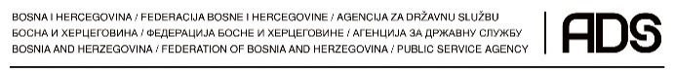

**Manual Part D – Comments on the Public Procurement legislation**

Project: **Effective Project Management in the Water Sector in Bosnia and Herzegovina: Implementation of the EU tendering procedures**  
  
Implementing organisation: **Network of Institutes and Schools of Public Administration in Central and Eastern Europe (NISPAcee)**

Partner: **Civil Service Agency of the Federation of BIH (CSAF BIH), Sarajevo, Bosnia and Herzegovina**  
   
Supported by: **SlovakAid, a Slovak Ministry of Foreign Affairs' Programme**

**Author: Juraj Tkáč**

**Date: March 22,2017**

Copyright © 2017 by NISPAcee

The Network of Institutes and Schools of Public Administration in Central and Eastern Europe

<http://www.nispa.org>

**Effective Project Management in the Water Sector in Bosnia and Herzegovina: Implementation of the EU tendering procedures**

**Manual Part D – Comments on the Public Procurement legislation**

**Responsible author: Juraj Tkáč**

The manual was developed in the frame of the project No. SAMRS/2016/ZB/1/1 „Efektívne riadenie projektov vodného hospodárstva v Bosne a Hercegovine: Implementácia výberových konaní EÚ“ / „Effective Project Management in the Water Sector in Bosnia and Herzegovina: Implementation of the EU tendering procedures“ jointly implemented by NISPAcee (The Network of Institutes and Schools of Public Administration in Central and Eastern Europe) and Civil Service Agency of the Federation of BIH (CSAF BIH), Sarajevo, Bosnia and Herzegovina with the support of Slovak Aid – the Slovak Agency for International Development Cooperation.

The team of contributors participated in the project and development and review of this publication:

Slovakia:

Milan Oleriny, Project Expert

Juraj Tkac, Project Expert

Ludmila Gajdosova, Project Expert

Boris Balog, Project Expert

Elena Zakova, Project Expert / Project Manager

Juraj Sklenar, Project Assistant

Bosnia and Hercegovina:

Alma Imamovic, Project Expert

Amra Ibrahimpasic, Project Expert

Sanja Cubela, Project Expert

Samra Ljuca, Project Coordinator

The opinions of the authors may not necessarily reflect the views of NISPAcee, CSAF BIH and SlovakAid.

Due to a continuously development of local Laws, Decrees as well as Documents of International Financial Institutions, the last version of Documents shall be always taken by Employer into consideration. NISPAcee documents based on a version of EU based TD January 2016 (Version 2016.0). For a last version check in advance related EU web pages:

<http://ec.europa.eu/europeaid/funding/about-funding-and-procedures/procedures-and-practical-guide-prag_en>

<http://ec.europa.eu/europeaid/prag/document.do?isAnnexes=true>

NISPAcee is an international association focused on public administration. Its mission is to promote and strengthen the effective and democratic governance and modernization of public administration and policy throughout the NISPAcee region.

Content

**1.** **General Overview** 3

**2.** **The Cross border procurement** 6

**2.1.** **The plurilateral level – the GPA** 7

**2.2.** **Prevalence of cross-border procurement on the EU market** 8

**2.3.** **Specific procedure for cross border procurement** 9

**2.4.** **Openness of tender procedure to all relevant European entities – economic operators** 11

**3.** **Life cycle costing** 16

**3.1.** **Definition** 16

**3.2.** **Financing Costs** 16

**3.3.** **Costing Methods** 20

**3.4.** **Impact on Budgets** 21

**3.5.** **Life-Cycle Cost Methodology** 22

**4.** **E-procurement** 24

**4.1.** **E-procurement defined** 24

**4.2.** **Procurement as a Function** 24

**4.3.** **E-procurement Tools and Application** 24

**4.4.** **The Benefits of E-Procurement** 25

**5.** **Conflict of interest in public procurement** 28

**5.1.** **Consequences of not recognising the risk of conflicts** 28

**5.2.** **Recognising the risk of conflicts of interest** 29

**5.3.** **Conflicts arising from the design of policy/system** 30

**5.4.** **Corruption, the bane of public procurement** 30

**5.5.** **How to enhance integrity and curb corruption in public procurement** 32

**5.6.** **Integrity** 32

**5.7.** **Transparency** 34

**5.8.** **Stakeholder Participation** 35

**5.9.** **Access to public procurement contracts** 36

**5.10.** **E-procurement** 37

**5.11.** **Oversight and control** 37

**5.12.** **Red flags** 39

**6.** **Innovation Partnerships** 44

**6.1.** **Public procurement of innovative solutions** 44

**6.2.** **What is Public procurement of innovative solutions – PPI?** 45

**6.3.** **What has been done to support public procurement of innovative solutions in Europe?** 47

**6.4.** **How can The European legal framework and EU programmes support public procurement of innovative solution?** 48

**6.5.** **The potential for public procurement of innovative solutions in the European Structural and Investment Funds** 51

**6.6.** **Outlook on PPI support under Horizon 2020** 54

**6.7.** **Innovation Partnership in the new public procurement regime – a shift of focus from procedural to contractual issues?** 55

**6.8.** **Background** 55

**6.9.** **Innovation Partnership** 57

**6.10.** **‘Cherry-picking’ in the Innovation Partnership** 59

**6.11.** **Structure of the innovation partnership** 61

**6.12.** **What is new ?** 63

**6.13.** **Conclusion** 65

**7.** **European single procurement document** 65

**7.1.** **Backround** 65

**7.2.** **Eletronic ESPD service** 66

**7.3.** **Supporting documents** 67

**7.4.** **Reliance on other entities** 68

**7.5.** **Signinig the ESPD** 68

**7.6.** **Structure of the ESPD** 69

**8.** **Small and Medium Enterprises** 72

**8.1.** **What are medium-sized enterprises (SMEs)?** 75

**8.2.** **What is the economic significance of SMEs?** 76

**8.3.** **Ways to help SMEs** 78

# **General Overview**

The first Public Procurement Law (PPL)in Bosnia and Herzegovina was adopted in 2004 (OG BiH 49/04) and was in force in whole BiH. Advantage of the law was certainly fact that was in force in both BiH entities and District Brčko and that all public institutions were obliged to use and respect PPL. Institution responsible for law enforcement is Agency for Public procurement.

During the implementation period, some gained experience and wish to improve procurement process resulted in adoption of the new PPL. New Law on Public procurement was adopted and put into force 2014. year (OG BiH 39/14). Second reason for adoption of the new law was process of harmonizing with EU Directives on public procurement.

The public procurement is one of the most important areas in the overall process of European integration. In this light, the decision stipulated by the new law on public procurement ensure complete application of the rules and requirements of the EU in terms of ensuring free movement of goods, people and capital, enabling the continuity in realizing the principle of the open market, which is in accordance with Article 76 of the Stabilisation and Association Agreement. By signing the Stabilisation and Association Agreement in June 2008 years, Bosnia and Herzegovina has made a commitment of further harmonization with EU legislation.

This new PPL is tremendously aligned with;

* Directive 2004/17 / EC of the European Parliament and of the Council of 31.03.2004, by which procurement methods are being harmonized for subjects in water sector , energy, transport and postal services and Directives and Regulations which amended this Directive
* Directive 2004/18 / EC of the European Parliament and of the Council of 31.03.2004 on the coordination procedure of contracts awarding for public works, goods supply and services and Directives and Rules which amended this Directive
* Directive 2007/66 / EC of the European Parliament and of the Council of 11.12.2007, by which the Directive 89/665 / EEC and 92/13 / EEC were changed and amended regarding enhanced the effectiveness of review procedures concerning the award of public contracts;

The most important features of the new Act are:

* Increased number of articles from 57 in the previous Law to 124 in the new Law , because many issues were not covered by law or by by-laws
* Harmonization with EU Directives
* Improvement application of the basic principles of public procurement : transparency, competitiveness, equality of bidders, economy and effectiveness
* Increased level of social control
* Usage of information technology
* Systematic improvement of capacity and work of all stakeholders of public procurement

The new directives are modernised in order to increase the efficiency of public spending, facilitating in particular the participation of small and medium-sized enterprises (SMEs) in public procurement, to enable procurers to make better use of public procurement in support of common societal goals, to ensure legal certainty and to incorporate certain aspects of related well-established case-law of the Court of Justice of the European Union.

The advantages of this reform set in new public procurement directives can be found in 4 main areas.

Firstly, the main advantage of the new directives is in increasing the efficiency of the sys-tem. The increased use of eProcurement; a new electronic self-declaration for bidders, significantly contributes to the digitalisation of public procurement, which in return will markedly increase the efficiency of the system as well as lead to billions in public savings, allowing EU companies, especially medium-sized enterprises (SMEs), to exploit the full benefits of the Digital Single Market. Moreover, the bidding on public contracts will now be easier for (SMEs), due to the introduction of the option to divide tenders into lots through the “apply or explain” principle and the turnover requirements being limited to a maximum of twice the estimated value of the contract, except in duly justified cases.

The public procurement rules are going to be simplified by first broadening the possibilities for negotiation, and second, by reducing the documentation required; through the compulsory acceptance of self-declarations from bidders (a standardised European Single Prurient Document), only a winning bidder submits formal evidence and the minimum deadlines for tender- submissions are shortened.

Secondly, public services will be modernised and administrative burden slashed. Contracting authorities will obtain better value for money as a result of simpler procedures for contracting authorities which will open up the EU’s public procurement market, prevent “ buy national” policies and promote the free movement of goods and services. Greater flexibility of the new legislation includes also the possibility of choosing the best quality-price ratio as Member States are free to eliminate price as the sole award criterion. Further, contracting authorities can cooperate with a company (selected in a competitive tender procedure) to develop an innovative product, which does not exist on the market, as a way to encourage innovation in public administration. What is more, new rules on concessions will increase competition, allowing Member States to achieve better value for money when mobilising private capital and know-how to complement public resources and enable new investment in public infrastructure.

The first to gain benefit from this will be the local and regional authorities, as they will be enabled to advertise their contracts through less difficult prior-information notice, in place of contract notices. Moreover, they are enabled to agree with the pre-selected bidders on the deadlines in their procurement procedures.

Thirdly, these new directives also address societal challenges. To spur eco-innovation, fresh opportunities have been opened up for public authorities, by using new award criteria in contract notices that place more emphasis on environmental considerations. Furthermore, by using their purchasing power to choose socially responsible goods, public authorities can set a positive example and encourage enterprises to make wider use of social standards in the management, production and provision of services.

Further, the distinction between A services and B services (priority v non-priority) is ab-olished and a brand new regime is used for social, health, cultural and assimilated servic-es - applicable also to services, hotels and restaurants services, catering and canteen services. Water transport, agricultural and forestry services (current B services) will fall under the full set of rules of the Directives, if not listed in the ‘new simplified regime” annex to the Directives). These changes further support the idea of modernisation, flexibility and the supporting of a commercial approach, making the public procurement process faster, less costly, and more effective for business and procurers alike and so encouraging economic growth.

Fourthly, an objective of these directives is to prevent corruption and create a culture o integrity and fair play. A new proper framework for the prior publication of tenders, clear and unbiased technical specifications, equal treatment of bidders in all stages of the process, and objective evaluation of tenders are set by the new directives.

On the whole, this means a deeper and fairer single market, by facilitating cross-border procurement and fostering the free movement of goods and services, combined with more transparency and simplified procedures. More transparency, fair and competitive rules also lead to increased business opportunities, greater competition, makes it easier for SMEs to access public procurement markets, and as a consequence boost jobs, growth and investment.

**The focus of this report is to show that the current law - BiH Law on public procurement - has not yet fully implemented these changes and to suggest why such implementation would be beneficial.** The primary focus, however, is on Directive 2014/24/EU of the European Parliament on public procurement, repealing Directive 2004/18/EC Text with EEA relevance and Directive 2014/25/EU of the European Parliament and of the Council of 26 February 2014 on procurement by entities operating in the water, energy, transport and postal services sectors and repealing Directive 2004/17/EC.

# **The Cross border procurement**

Public procurement often involves cross-border activities in different forms. The nationality of firms and the origin of products are the issues of concern in public procurement rules. In the case of crossborder procurement via foreign firms, geographical residence of the company, its affiliations and owner-ship are usually considered. The distinction between “local” and cross-border procurement via goods or services considers the location of the finishing manufacturing or the manufacturing of some substantial intermediate products. As vertical specialization increases, organizational structures become less geographically concentrated, supply chains and capital more internationalized – few firms qualify as genuinely local. Therefore, the concept of “buying local” is a question of degree of “localness” – particularly for small countries with a high degree of integration with other economies. The same goes for contracts that appear to be international, as manufacturing and services may be executed locally.

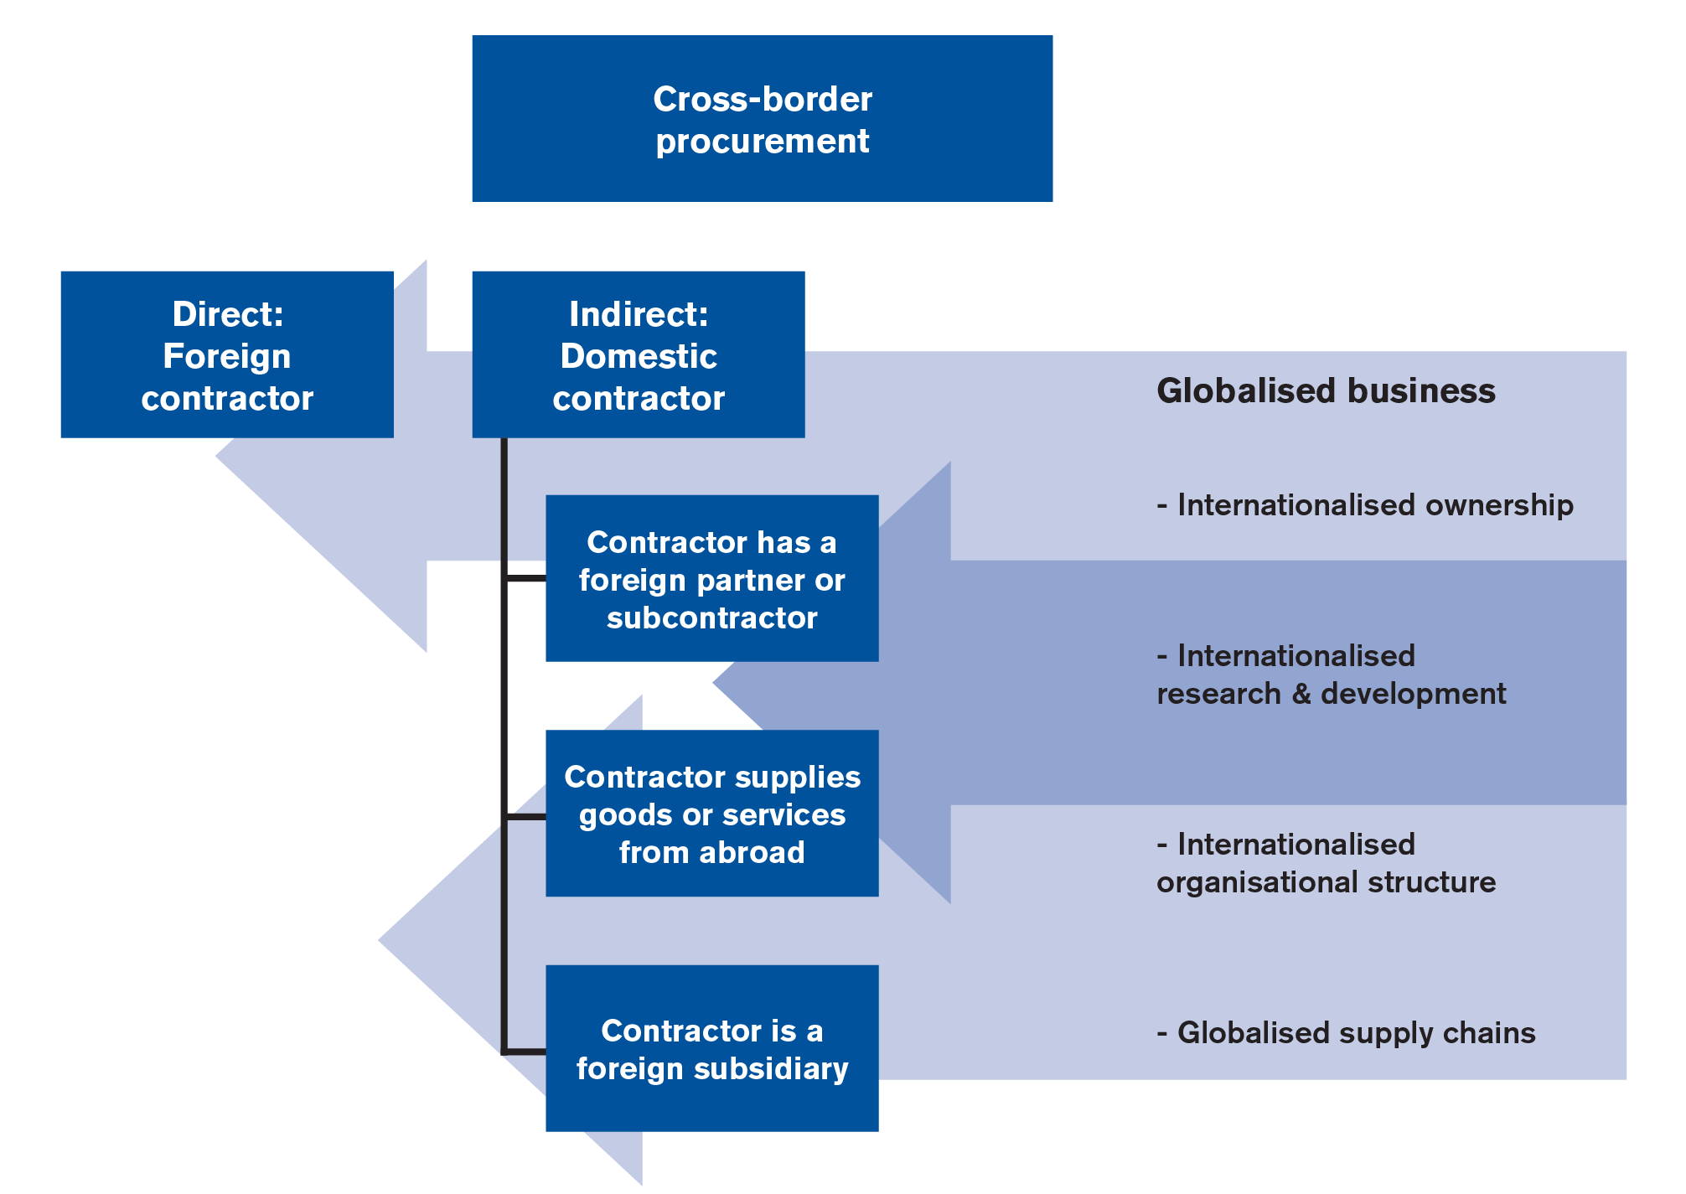

The most straightforward form of cross-border procurement is direct cross-border procurement, which occurs when a foreign contractor (not established in the domestic market) is awarded a public contract. Indirect forms of cross-border procurement are those that occur where the contractor is:

* A locally established subsidiary of a foreign firm (the parent company/headquarters are located abroad, i.e. a foreign firm has submitted a bid through its subsidiary established in the market of the contracting body).
* A domestic firm (prime contractor) having a foreign subcontractor during performance of the contract.
* A domestic firm having a foreign consortium partner.
* A domestic firm importing products to perform the contract (e.g. wholesaler).

**All above mentioned forms of cross border procurement are valid according to new public procurement directives and must be followed when European funds are used.**

# **The plurilateral level – the GPA**

The WTO agreement on government procurement, the GPA, is a plurilateral agreement. Only the EU, its Member States and 14 other WTO members are parties to the agreement. Briefly, the agreement, which is currently being revised, provides for transparent tendering procedures, domestic review procedures and, like other WTO agreements, non-discrimination. The non-discrimination obligation not only applies to imports from the GPA parties, but also to locally established suppliers on the basis of foreign affiliation, ownership and the country of production. As a result of the non-discrimination obligation, the agreement, in principle, prohibits localcontent requirements, price preferences, offsets and similar discriminatory policies. However, the rules apply only to covered procurement. Market access is specified individually for each party in appendices to the agreement. First, only purchases exceeding certain thresholds specified in Special Drawing Rights are covered. Second, only purchases by specified entities are covered. Third, although all goods are, in principle, covered by the agreement, only the services listed (positive list) are covered. Fourth, parties have excluded some purchases (e.g. defence procurement) from coverage and made other general exceptions from coverage (e.g. with regard to SMEs or country-specific derogations). As a result, a substantial share of the GPA parties’ procurement still lies outside the scope of the agreement. For instance, procurement by 13 US states is, at present, not covered by the agreement. This is significant, as procurement by sub-central governments is much larger than procurement by central governments. Like the GATT, the GPA provides for further and periodical negotiations on increased coverage on the basis of mutual reciprocity (cf. Article XXIV (7) (b)) and coverage, i.e. market access, negotiations are ongoing.

As a result of periodic negotiations, coverage of the GPA has increased over time. Services have been included (which was not the case with the Tokyo Round Agreement on Government Procurement), more contracting bodies have been added and thresholds have been lowered. Also, increased membership, mainly through the EU enlargement, has resulted in expanded coverage. There are cur- rently nine WTO members, one of which is China, negotiating accession (although not all actively). The GPA contains a reporting mechanism. Parties are obliged to report annually on covered procurement in terms of type of contracting body, numbers and value of procurement. If available, parties will also provide statistics on the country of origin of purchased goods and services (Article XIX: 5). The statistics would serve as a useful basis for coverage negotiations. Unfortunately, parties do not report regularly or in a similar and comprehensive manner, and there has been little empirical research using the data that has been provided. Studies on the effects of the GPA (looking at crossborder procurement) are inconclusive. Data for the period between 1983 and 1992 suggests that smaller GPA parties made less nationalistic purchasing decisions over time. It also showed that smaller countries purchased more from foreign firms on average than large countries. Moreover, foreign firms’ share of above threshold procurement by covered entities remained virtually unchanged. Two country-specific empirical studies have shown that the GPA did nothing to increase market access for foreign firms in Japan and Korea in the 1990s. Although the findings above are interesting, it should be noted that they mostly relate to the operation of the Tokyo Round Agreement on Government Procurement, whose coverage was considerably less comprehensive than that of the current GPA. There is definitely a need for more up-to-date and comprehensive empirical research on the operation and impact of the GPA, not least in view of the aim to expand the agreement’s coverage.

**Contract authority should always identify if GPA agreement is used. In European funds usage of GPA agreement is obligatory.**

# **Prevalence of cross-border procurement on the EU market**

Several studies have been carried out to measure the somewhat elusive concept of cross-border procurement. Results indicate that direct crossborder procurement seems, in general, to account for a relatively small share of total procurement. For instance, EU tenders awarded to firms from other GPA parties in 2007 can be estimated to account for roughly 3–4 per cent of the value of total above threshold procurement under the GPA.

Another example is that direct above threshold cross-border procurement has recently been estimated to less than 2 per cent of the winning tenders on the EU market. The figure is somewhat striking, as it relates to the internal market and covers both intra- and extra-EU direct cross-border procurement in 2007 to 2009.

Indirect cross-border procurement is more common. In 2007, around 14 per cent of all tenders published in the TED database were awarded to non-EU firms (including subsidiaries of foreign firms). From a legal point of view, these subsidiaries are considered to be EU firms and, consequently, they currently do not face any legal restrictions in participating in EU procurement.

The significance of cross-border procurement varies greatly between EU Member States. As an example, 44 per cent of the aggregated contract value in Swedish procurement was awarded to foreign subsidiaries, 6.7 per cent of total contract value was awarded to foreign firms. In the Netherlands, 13 per cent of the total contract value was awarded either to foreign firms or foreign subsidiaries. These figures cover both intra- and extraEU cross-border procurement.

The import penetration in the public sector is a complementary indicator of indirect cross-border procurement, measuring the degree of international trade in the public sector. Estimates suggest that the total import penetration in the EU Member States’ public sector was 7.5 per cent of total public demand of goods and services in 2005. This is significantly lower than the import penetration in the private sector, which corresponds to 19.1 per cent. The discrepancy in private and public sectors appears to be partly explained by variations in the goods and services demanded. The public sector consumes a higher share of administration and other services that are partly non-tradable and other products that are also less traded in the private sector. One study suggests that, when differences in demand are accounted for, the gap between import penetration in the private and public sectors is 0.9 per cent. Nevertheless, this figure corresponds to approximately 24 billion euros (unexplained) less trade in public consumption in the EU. Naturally, import penetration, too, varies between sectors and countries. As an example, the import penetration in the Swedish public sector in 2005 was 5.7 per cent. In the private sector, the import penetration was 19.2 per cent. In the Netherlands, corresponding figures were 6.8 and 27.9 per cent. Generally, the public sector import penetration in EU Member States is similar to that of non-EU countries.

# **Specific procedure for cross border procurement**

Despite the fact that Directive 2004/18/EC implicitly allowed for cross-border joint public procurement, contracting authorities are still facing considerable legal and practical difficulties in purchasing from central purchasing bodies in other Member States or jointly awarding public contracts. In order to allow contracting authorities to derive maximum benefit from the potential of the internal market in terms of economies of scale and risk-benefit sharing, not least for innovative projects involving a greater amount of risk than reasonably bearable by a single contracting authority, those difficulties are in new public procurement directive remedied. Therefore new rules on cross-border joint procurement are in new public procurement established in order to facilitate cooperation between contracting authorities and enhancing the benefits of the internal market by creating cross-border business opportunities for suppliers and service providers. Those rules are determining the conditions for cross-border utilisation of central purchasing bodies and designate the applicable public procurement legislation, including the applicable legislation on remedies, in cases of cross-border joint procedures, complementing the conflict of law rules of Regulation (EC) No 593/2008 of the European Parliament and the Council In addition, contracting authorities from different Member States should be able to set up joint entities established under national or Union law. Specific rules should be established for such forms of joint procurement.

All this above mentioned features of cross border procurement procedure are set in article 39 of directive 24/2014/ES which states following:

*1. Without prejudice to Article 12, contracting authorities from different Member States may act jointly in the award of public contracts by using one of the means provided for in this Article.*

*Contracting authorities shall not use the means provided in this Article for the purpose of avoiding the application of mandatory public law provisions in conformity with Union law to which they are subject in their Member State.*

*2. A Member State shall not prohibit its contracting authorities from using centralised purchasing activities offered by central purchasing bodies located in another Member State.*

*In respect of centralised purchasing activities offered by a central purchasing body located in another Member State than the contracting authority, Member States may, however, choose to specify that their contracting authorities may only use the centralised purchasing activities as defined in either point (a) or in point (b) of point (14) of Article 2(1).*

*3. The provision of centralised purchasing activities by a central purchasing body located in another Member State shall be conducted in accordance with the national provisions of the Member State where the central purchasing body is located.*

*The national provisions of the Member State where the central purchasing body is located shall also apply to the following:*

*(a) the award of a contract under a dynamic purchasing system;*

*(b) the conduct of a reopening of competition under a framework agreement;*

*(c) the determination pursuant to points (a) or (b) of Article 33(4) of which of the economic operators, party to the framework agreement, shall perform a given task.*

*4. Several contracting authorities from different Member States may jointly award a public contract, conclude a framework agreement or operate a dynamic purchasing system. They may also, to the extent set out in the second subparagraph of Article 33(2), award contracts based on the framework agreement or on the dynamic purchasing system. Unless the necessary elements have been regulated by an international agreement concluded between the Member States concerned, the participating contracting authorities shall conclude an agreement that determines:*

*(a) the responsibilities of the parties and the relevant applicable national provisions;*

*(b) the internal organisation of the procurement procedure, including the management of the procedure, the distribution of the works, supplies or services to be procured, and the conclusion of contracts.*

*A participating contracting authority fulfils its obligations pursuant to this Directive when it purchases works, supplies or services from a contracting authority which is responsible for the procurement procedure. When determining responsibilities and the applicable national law as referred to in point (a), the participating contracting authorities may allocate specific responsibilities among them and determine the applicable provisions of the national laws of any of their respective Member States. The allocation of responsibilities and the applicable national law shall be referred to in the procurement documents for jointly awarded public contracts.*

*5. Where several contracting authorities from different Member States have set up a joint entity, including European Groupings of territorial cooperation under Regulation (EC) No 1082/2006 of the European Parliament and of the Council (30) or other entities established under Union law, the participating contracting authorities shall, by a decision of the competent body of the joint entity, agree on the applicable national procurement rules of one of the following Member States:*

*(a) the national provisions of the Member State where the joint entity has its registered office;*

*(b) the national provisions of the Member State where the joint entity is carrying out its activities.*

*The agreement referred to in the first subparagraph may either apply for an undetermined period, when fixed in the constitutive act of the joint entity, or may be limited to a certain period of time, certain types of contracts or to one or more individual contract awards.*

Based on above mentioned the contract authority should have right to undertake cross border procurement process, what is not possible based on valid state law. Tender documents should set the regime of public procurement procedure (which public procurement state law is applying to cross border procurement procedure, and which state law is applying to contract after its award.)

# **Openness of tender procedure to all relevant European entities – economic operators**

One of the basic freedoms set in Lisbon Agreement and subsequently set in all EU public procurement law is free movement of goods, capital and services. As mentioned above, one part of the cross border is to ability of any to all relevant European entities – economic operators to be part of fair tender procedure and in case they considers tender as interesting to place a bid and in finally to award them a contract. Any selection criteria and technical specification should be non-discriminatory.

Ad/ selection criteria:

It is important for a contracting authority to ensure that it will enter into a contract with an economic operator that has the ability to perform and complete the contract. Thus a contracting authority may want to check, for example, economic operators’ suitability in terms of compliance with basic legal requirements as well as the financial resources, experience, skills and technical resources and exclude from the procurement process those economic operators that do not satisfy such checks. This is known as the selection or qualification process.

The selection of economic operators generally involves two distinct phases. Firstly the contracting authority will establish whether there are grounds for excluding an economic operator from participating. The contracting authority will then go on to consider whether the economic operators which have not been excluded meet the relevant requirements to be selected as tenderers. Those economic operators who are selected will then either be invited to submit tenders, negotiate or participate in dialogue. In the case of the open procedure, the tenders which they have already submitted will be evaluated.

Selection of economic operators means the process of assessing and deciding which economic operators are qualified to perform the contract. This process must be carried out by applying objective, non-discriminatory and transparent selection criteria, which are set by the contracting authority in advance and disclosed to economic operators.

The Directive limits in a significant way a contracting authority’s discretion in this area: it lists the selection criteria that a contracting authority may choose to use, it lays down the evidence or references that a contracting authority may require from economic operators to verify that the set selection criteria are satisfied, and it also lays down general rules concerning the process of selection. The Directive seeks to ensure that the selection process does not provide opportunities for contracting authorities to conceal discrimination and that fair opportunities of participation are given to economic operators. The main objective of is to ensure that intraCommunity trade is not restricted and that the Treaty principles on freedom to provide services and freedom of establishment are respected.

**What selection criteria can be used?**

Only the following selection criteria may be used by a contracting authority to establish whether an economic operator is qualified to perform a specific contract:

* + Personal situation of the economic operator:
* mandatory grounds for exclusion
* optional grounds for exclusion
  + Suitability to pursue the professional activity
  + Economic and financial standing
  + Technical and/or professional ability

**Personal situation of economic operators: Mandatory grounds for exclusion:** A contracting authority is obliged to exclude from participation in a contract award procedure those economic operators that are known to have been convicted by final judgment for one or more of the following criminal activities:

* Participation in a criminal organization
* Corruption
* Fraud
* Money-laundering

Personal situation of economic operators: Optional grounds for exclusion: A contracting authority is permitted but not obliged to exclude from participation in the procurement process those economic operators that:

1. are bankrupt or are under any analogous situation in accordance with national laws or regulations
2. are the subject of proceedings for a declaration of bankruptcy or similar proceedings under national laws and regulations
3. have been convicted by a judgment that has the force of res judicata of an offence relating to their professional conduct, in accordance with the legal provisions of the country concerned;
4. have been guilty of grave professional misconduct proven by any means that the contracting authority can demonstrate;
5. have failed to fulfil obligations relating to the payment of social security contributions in their countries of establishment or that of the contracting authority in accordance with the legal provisions of the country concerned;
6. have failed to fulfil obligations relating to the payment of taxes in their countries of establishment or that of the contracting authority, in accordance with the legal provisions of the country concerned;
7. have been guilty of serious misrepresentation in supplying information required for the purpose of the selection of economic operators or have not supplied such information.

National legislation may make some or all of these grounds mandatory grounds for exclusion.

**What evidence may be requested from economic operators to prove that they do not fall under the mandatory or optional grounds for exclusion?**

In compliance with the principle of transparency, a contracting authority must indicate in the contract notice the grounds for mandatory or optional exclusion that will be applied and the information required from economic operators proving that they do not fall under the cases justifying exclusion.

A contracting authority is obliged to accept as sufficient evidence that an economic operator does not fall under any of the mandatory or optional grounds for exclusion the types of evidence listed in the Directive. In relation to the mandatory grounds, in general terms, this evidence must take the form of an extract from the judicial record or its equivalent or, where a country does not issue such documents, a declaration on oath or solemn declaration. Where appropriate, the contracting authority is to ask the economic operator to supply evidence that it does not fall under any of the mandatory grounds for exclusion In relation to the optional grounds, the types of evidence vary depending on the optional grounds for exclusion concerned. With regard to grave professional misconduct and serious misrepresentation of information, it is for the contracting authority to determine the acceptable types of evidence.

**Economic operators based in other member states**: It may be difficult in practice for a contracting authority to establish the types of documents/evidence that economic operators based in other member states are able to submit in order to prove that they do not fall under any of the mandatory or optional grounds for exclusion and to identify the authorities that are authorised to issue these documents/evidence under their national laws.

**What general requirements apply to the use of selection stage criteria?** In compliance with the principle of transparency, a contracting authority must indicate in the contract notice the selection stage criteria to be applied and the relevant information to be provided.

A contracting authority is permitted but is not obliged to consider the suitability, economic and financial standing and technical/professional ability of economic operators. A contracting authority therefore has discretion as to what it does and does not ask within the limits of the permitted selection criteria.

Criteria must be related and proportionate to the subject matter of the contract. Setting criteria that are not necessary or are inappropriate may attract economic operators that are not qualified or deter efficient economic operators from participation. It is left to the discretion of the contracting authority to fix the minimum capacity levels that economic operators must meet. However, if a contracting authority decides to fix minimum capacity levels they must also be related and proportionate to the *subject matter* of the contract and set out in the contract notice. Under no circumstances may the set selection criteria be changed or waived during the process of selection of economic operators. At this stage, the set selection criteria are to be applied as they stand.

**How do we apply the specified selection criteria?**

**Suitability to pursue the professional activity** A contracting authority may check if economic operators are generally suitable and fit to carry out the professional activity by asking them to prove that they are enrolled on trade or professional registers in their member state of establishment. Where no relevant register exists in these states, economic operators may produce a declaration on oath or a certificate, in accordance with the provisions of their national laws. The registers and corresponding declarations or certificates for each EU Member State are listed in the relevant annexes of the Directive.

A contracting authority may not require an economic operator established in another EU Member State to be enrolled on a trade or professional register in the country of the contracting authority. This requirement would be in breach of both the Directive and the principle of the freedom to provide services.

**Economic and Financial Standing**

A contracting authority may consider the economic and financial standing of economic operators. The specific economic and financial standing criteria must be aimed at assessing whether economic operators have adequate financial resources (throughout the contract period), such as cash in hand, as a credit line or in any other way, to handle and complete the contract to be awarded.

**Evidence that may be requested from economic operators as proof of their economic and financial standing:** The Directive provides a list of the types of evidence that, as a general rule, a contracting authority may request from economic operators as proof of their economic and financial standing. However, this list is only indicative and not exhaustive. Therefore a contracting authority may also require other evidence than that listed in the Directive, subject to compliance basic public procurement principles. The Directive explicitly requires the evidence/information sought from economic operators to be related and proportionate to the subject matter of the contract.

**Technical and/or professional ability**

A contracting authority may consider the technical and/or professional ability of economic operators. The specific technical and/or professional ability criteria must be aimed at assessing whether economic operators have the relevant technical and/or professional ability (skills, equipment, tools, manpower, past experience, etc.) to perform the contract to be awarded.

**Evidence that may be requested from economic operators as proof of their technical and/or professional ability:** The Directive lays down an exhaustive list of evidence that a contracting authority may request from economic operators as proof of their technical and/or professional ability. As the list is exhaustive, a contracting authority may not request any other evidence than that listed. However, a contracting authority is not obliged to request all of the listed evidence but only the evidence that is necessary to assess the technical and/or professional ability of economic operators in relation to the contract to be awarded. This list of evidence is divided according to the subject matter of the contract (i.e. supplies, works or services).

**Conclusion:**

* **State legislation of Bosnia does not reflect the cross boarder procurement procedure, and in fact does not allow to implement cross border EU funded projects.**
* **Each tender should identify if GPA agreement is applied**
* **Each European tender process should be open to all entities from European Market and tender conditions should not make any barrier to be able submit offer by such entities.**

# **Life cycle costing**

# **Definition**

For many years, life cycle costing has been used in the field of maintenance engineering and to evaluate the advantages of using alternative materials in construction or production design. The method has gained wider acceptance and use in the areas of industrial decision-making and the management of physical assets.

By definition, life cycle costs are all the costs which are incurred during the life cycle of a physical asset, from the time its acquisition is first considered, to the time it is taken out of service for disposal or redeployment. The stages which the asset goes through in its life cycle are specification, design, manufacture (or build), install, commission, operate, maintain and disposal.

# **Financing Costs**

In a municipal context, services are provided to benefit tax/rate payers. Acquisition of assets is normally timed in relation to direct needs within the community. At times, economies of scale or technical efficiencies will lead to oversizing an asset to accommodate future growth within the municipality. Over the past few decades, new financing techniques such as development charges have been employed based on the underlying principle of having tax/rate payers who benefit directly from the service paying for that service. Operating costs which reflect the cost of the service for that year are charged directly to all existing tax/rate payers who have received the benefit. Operating costs are normally charged through the tax base or user rates.

Capital expenditures are recouped through several methods; operating budget contributions, development charges, reserves, developer contributions and debentures, being the most common.

New construction related to growth could produce development charges and developer contributions (e.g. works internal to a subdivision which are the responsibility of the developer to construct) to fund a significant portion of projects, where new assets are being acquired to allow growth within the municipality to continue. As well, debentures could be used to fund such works, with the debt charge carrying costs recouped from taxpayers in the future.

However, capital construction to replace existing infrastructure is largely not growthrelated and will therefore not yield development charges or developer contributions to assist in financing these works. Hence, a municipality will be dependent upon debentures, reserves and contributions from the operating budget to fund these works.

Figure 3-2 depicts the costs of an asset from its initial conception through to replacement and then continues to follow the associated costs through to the next replacement.

As referred to earlier, growth-related financing methods such as development charges and developer contributions could be utilized to finance the growth-related component of the new asset. These revenues are collected (indirectly) from the new homeowner who benefits directly from the installation of this asset. Other financing methods may be used as well to finance the non-growth related component of this project; reserves which have been collected from past tax/rate payers, operating budget contributions which are collected from existing tax/rate payers and debenturing which will be carried by future tax/rate payers. Ongoing costs for monitoring, operating and maintaining the asset will be charged annually to the existing tax/rate payer.

When the asset requires replacement, the sources of financing will be limited to reserves, debentures and contributions from the operating budget. At this point, the question is raised; "If the cost of replacement is to be assessed against the tax/rate payer who benefits from the replacement of the asset, should the past tax/rate payer pay for this cost or should future rate payers assume this cost?" If the position is taken that the past user has used up the asset, hence he should pay for the cost of replacement, then a charge should be assessed annually, through the life of the asset to have funds available to replace it when the time comes. If the position is taken that the future tax/rate payer should assume this cost, then debenturing and, possibly, a contribution from the operating budget should be used to fund this work.

Charging for the cost of using up of an asset is the fundamental concept behind depreciation methods utilized by the private sector. This concept allows for expending the asset as it is used up in the production process. The tracking of these costs forms part of the product's selling price and hence end users are charged for the asset's depreciation. The same concept can be applied in a municipal setting to charge existing users for the asset's use and set those funds aside in a reserve to finance the cost of replacing the asset in the future.

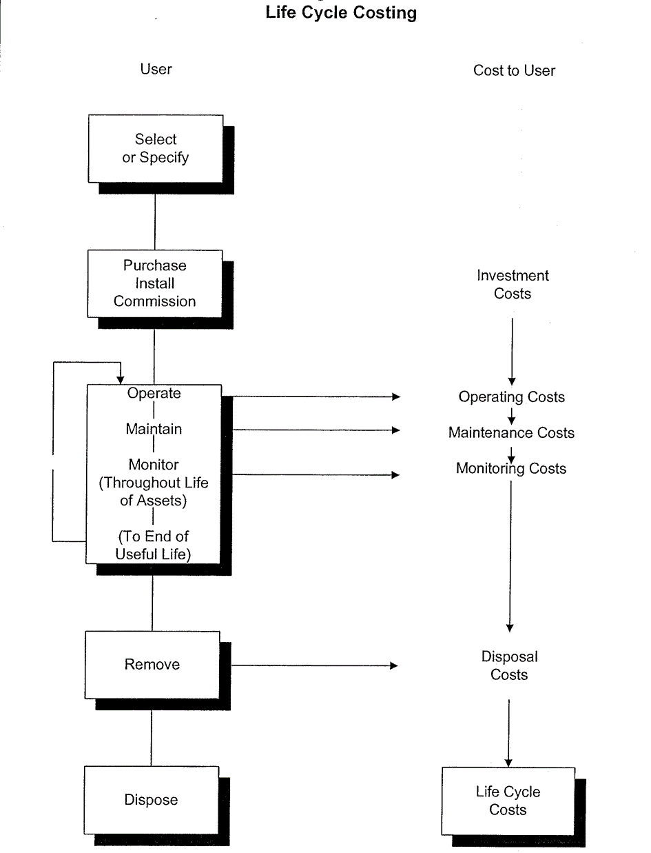

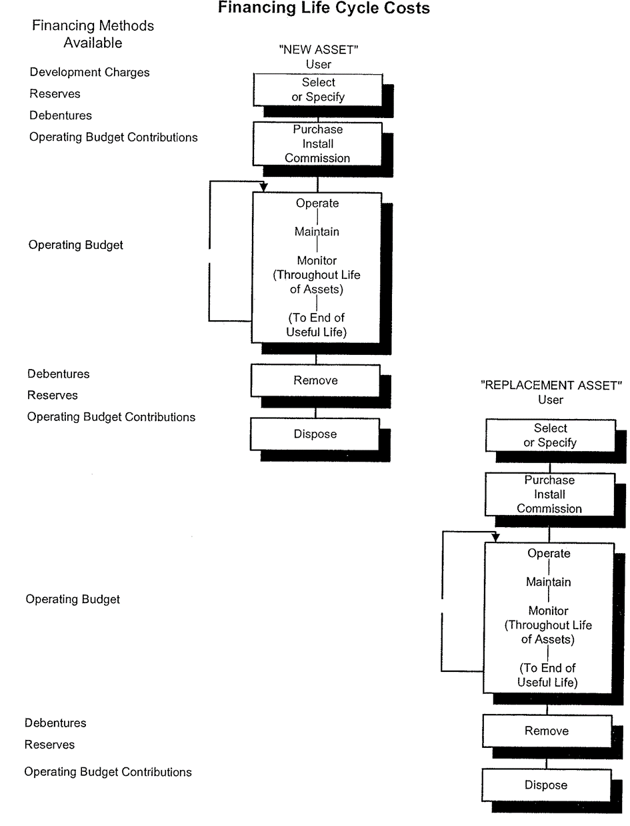

# **Costing Methods**

There are two fundamental methods of calculating the cost of the usage of an asset and for the provision of the revenue required when the time comes to retire and replace it. The first method is the Depreciation Method. This method recognizes the reduction in the value of the asset through wear and tear, and aging. There are two commonly used forms of depreciation: the straight-line method and the reducing balance method.

The straight line method is calculated by taking the original cost of the asset, subtracting its estimated salvage value (estimated value of the asset at the time it is disposed of) and dividing this by the estimated number of years of useful life. The reducing balance method is calculated by utilizing a fixed percentage rate and this rate is applied annually to the undepreciated balance of the asset value.

The second method of life cycle costing is the sinking fund method. This method first estimates the future value of the asset at the time of replacement. This is done by inflating the original cost of the asset at an assumed annual inflation rate. A calculation is then performed to determine annual contributions (equal or otherwise) which, when invested, will grow with interest to equal the future replacement cost.

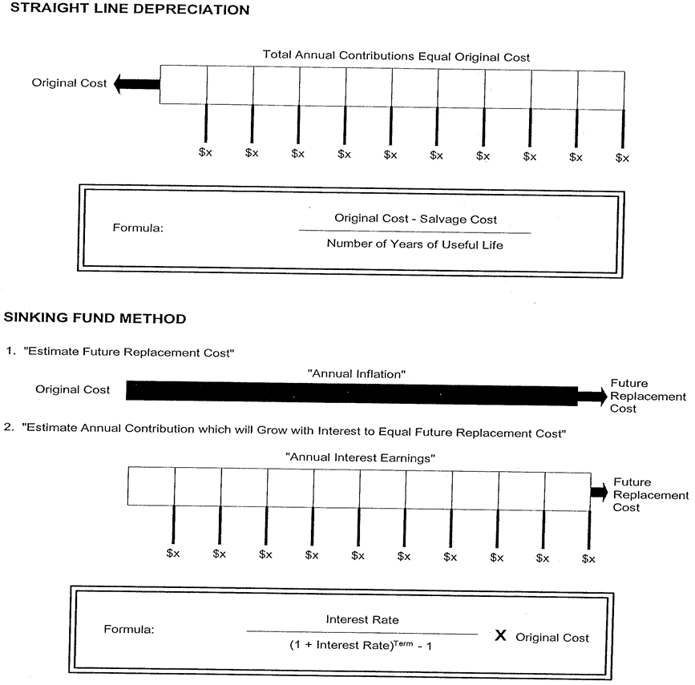

# **Impact on Budgets**

The lifecycle replacement analysis was undertaken for the wastewater infrastructure. Generally, the replacement cost assumptions provide for the removal and replacement of mains, along with repairs to the portion of the road disturbed in this process. A detailed costing is provided for the wastewater infrastructure in Appendix A. The sewer main information is summarized by material type and provides:

• Main Lengths

• Diameter of the mains

• Approximate age

• Estimated useful life

• Estimated replacement timing

• Estimated replacements cost per metre

• Total replacement cost

# **Life-Cycle Cost Methodology**

The LCC of a system is conventionally defined as the present value, at the beginning of operation of the system, of all costs of the system. Symbolically,

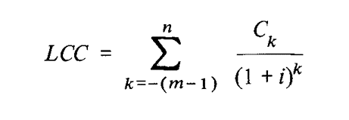

where m is the number of years in the development/acquisition phase, n the operational lifetime, i the interest (discount) rate, and Ck the cost incurred in the kth year. To apply the formula, one must carry out the following key tasks:

• Estimate the useful life of the system.

• Estimate the yearly costs over the life-cycle.

• Choose a discount rate.

Task 1 often turns out to be more significant and difficult than it would appear to be.

Task 2 is the most challenging part of the LCC analyses. The major categories of costs to be estimated are:

1. Research and development, testing and evaluation.

2. Production and/or acquisition.

3. Operation and maintenance.

4. Salvage.

Within these broad areas it is necessary to identify specific cost items to be estimated. For example, the maintenance costs for the Air Force’s Electronically Agile Radar (EAR) system were broken down as follows:

1. Initial and pipeline spares.

2. Replacement spares.

3. On-equipment maintenance.

4. Off-equipment maintenance.

5. Inventory and supply management.

6. Support equipment.

7. Training and training equipment.

8. Management and technical data.

These eight items were found to be comprised of 115 data elements.

Once the appropriate cost items are identified, how should their costs be estimated? Some items, like acquisition prices, are usually easy. Others, like operations and maintenance (O&M), suggest the need for a large and accurate data base, organized so as to be useful for the required analysis. Ideally, such a data base would indicate things like expenditures of labor and materials needed for similar systems (or subsystems).

Since a data base approaching the ideal is seldom available, how can the required estimates be obtained using only partial, inaccurate data obtained from experience with previous systems?

Several approaches are popular, as can be seen from investigation of the literature surveyed in Section VI. One consists of using cost-to-cost estimating relationships based on the idea (or observation) that certain costs can be tied to other related costs in a fixed ratio. This is particularly appealing when good

data are available for a few key cost items. It may even be feasible to relate certain costs to the prices of system components or spares.

Another approach is called non-cost to cost estimating, which attempts to relate the costs to be estimated to appropriate non-cost variables of system components, such as performance or operating characteristics, reliability, size, or complexity. In its ultimate form, this approach seeks to derive a mathematical model (e.g., a regression model) that fits cost items to appropriate variables based on experience with previous systems.

Less ambitious though potentially useful schemes include the use of specific analogies with past systems or components to estimate costs of a new system and, if all else fails, consulting expert opinion (to get an expert guess).

Once the task of estimating yearly costs over system lifetime is accomplished, it may seem as though task 3, choosing a discount rate, would be quite simple. This is perhaps true, because the rate is merely a reflection of the “time value of money” and can be chosen in line with prevailing rates for government borrowing. However, such rates do fluctuate, and the difference in effect between an 8% rate and a 10% rate, say, can be crucial in comparing two alternatives where one involves much higher initial costs and lower recurring costs.

# **E-procurement**

# **E-procurement defined**

In layman’s term, e-procurement is nothing but electronic data transfer to support operational, tactical and strategic procurement. E-procurement has been existence for long time in one form or the other earlier it was done through electronic data interchange. In today’s environment, most of the e-procurement is done through the Internet.

Traditionally, procurement of supplies and material was done through paper, which slowly migrated to usage of an electronic medium for order printing and storing. With the advent of the Internet e-commerce flourished, and procurement was done through email and websites. As the Internet technology evolved e-catalogue came in the forefront thus traditional procurement was getting done through the Internet. In the current market with data security and advanced tools whole process of e-procurement is done through the Internet.

# **Procurement as a Function**

Procurement departments are found in most of the organization. There are responsible for purchase of raw material, office supplies, office equipment, facility maintenance, etc. It is important for them to know and understand the e-procurement concept so that they can add efficiency and effectiveness to the whole process.

Procurement managers must have complete understanding of various e-procurement applications. He must be able to identify processes, which can make procurement effective. He should have understanding of e-procurement benefit. He should understand risk associated with e-procurement implementation.

# **E-procurement Tools and Application**

There are several tools and application which fall under e-procurement some of them are as follows:

* In electronic data interchange system, procurement messages are exchange between computers of two separate organizations. Message is exchange in batch and can be easily transmitted and stored. EDI is mostly used for order transmission, order confirmation, logistic information and order invoicing.
* Enterprise resource planning system have separate module to handle the procurement function.
* Internet based tools and resources help in the process of procurement. Some of the common applications are email, internet based EDI, XML based data exchange via the internet etc. Internet provides tools for e-sourcing, e-tendering, e-auctioning, e-ordering and e-catalogue.
* E-sourcing tool is used to identify potential suppliers during the selection phase. E-tendering tool is used to send out tenders with procurement requirements, supply schedule, contracting terms, etc. E-auctioning tools bring together potential supplier identified during selection phase under one umbrella to undertake auctioning process. E-auctioning tools operate under two separate mechanism, upward price mechanism for selling organization and downward price mechanism for the buying organization. E-ordering tool is used procurement of office supplies and services; it is accessible by all employees within the organization and is mainly used for ad-hoc purchases. A web-based ERP tool is used for product-related purchases, is exclusively used by the procurement department, and falls under a planned process.

A traditional procurement process starts with phase requirement definition, sourcing, solicitation, evaluation, contracting and contract management. In the internet based this steps are replaced by e-sourcing, e-tendering, e-reverse auction, e-ordering and web based ERP.

# **The Benefits of E-Procurement**

There are many benefits to be found from using e-procurement within an organisation, and the following are just some of the key points:

**Reduced Transaction Time**: individual business activities (transactions) can be completed much more quickly; they are not restricted by office hours and may not even need human intervention, thus increasing the capacity to complete transactions on a real-time basis. This means that downstream processes are not constrained by waiting for transactions to be completed.

**Electronic catalogues**: the development of e-catalogues has enabled organisations to market their product offer electronically, this has been a fantastic marketing tool for sellers and for buyers, there is price transparency (you can easily see how much items cost) and buyers can compare offers from various e-catalogue vendors.

**Increased Standardisation**: With the electronic catalogues mentioned, there has been a move by some suppliers to offer a more standardised offer, thus allowing buyers to easily compare the offers from e-catalogues, however care must be exercised in these comparisons as it is difficult to assess the quality of products without samples. If in doubt request samples and take time to make your own assessment.

The great news is that most catalogue sites operate in a very similar way, and they are very easy to set up allowing multiple business users to undertake some of their own procurement…this keeps the business running, sourcing the day-to-day needs of the business and allows procurement people to continue to develop great value-adding relationships.

**Wider Spread Supplier Bases**: Because the virtual e-procurement portals are web-based, buyers can search suppliers worldwide, meaning a wider selection of products and services are available to the organisation meaning that when items are not available locally, it is still possible to source these. It is important to remember the time and cost of shipping goods, but it’s great to know that it is possible to source items from somewhere in the world!

**Simplified Global Procurement:**With the e-procurement applications supporting various languages, currencies, international taxation and financing, shipping regulations and more, it is simple for buyers and suppliers in different countries worldwide to communicate and co-operate.

**Increase Productivity**: As e-procurement automates some of the procurement and wider business processes typically handled by employees, this will free up time for the team to spend on more strategically significant functions and tasks. For example with automated matching of invoices, goods can be ordered, processed and paid in a matter of minutes; the key however is to ensure that the supplier is set up in the buyers systems support as much automation as possible.

**Simple Configuration and Scalability**: E-procurement applications can be configured to suit the individual needs or both the buyer and the supplier, and can grow with the organisation as needs be. It is important to select suppliers for both the current requirement as well as possible future need so gaining an understanding of the technical infrastructure development plans of suppliers will help buyers to select possible longer term partners.

**Creation of Trading Communities**: Because the e-procurement applications are internet based, they allow for both vertical and horizontal trading communities to be developed. This means buyers can consolidate buying power and it also opens up opportunities for new supply chains. The opportunity to consolidate the requirements of smaller buyers via consortia or trading communicates has enabled smaller business to access prices historically reserved for bigger buyers, thus fuelling a fast developing SME sector. Many Chambers of Commerce and other local business organisations operate such buying communities.

**More Cost Efficient**: With the time reductions and increased supplier selection, development of trading communities, more opportunities for purchasing surplus goods and services at below market price, and much more, it isn’t surprising that e-procurement proves to be much more cost efficient than traditional procurement.

**How E-Procurement Affects The Bottom Line**

Among e-procurement’s many benefits, it has a positive impact on the profits of the organisation.

**Savings From Increased Preferred Vendor Purchasing**: E-procurement makes it easier to purchase products and services from preferred vendors. The more you purchase from the same preferred vendor, the more you typically save at a unit cost level as they often apply quantity discounts. In addition you have confidence about your sources of supply, making sure you have the right quality for you needs.

**Consolidation of Preferred Vendors**: Some low-volume vendors may eventually become eradicated from the network of suppliers via e-procurement, resulting in more purchases being directed to preferred vendors and increased discounts becoming available. However specialist suppliers are better able to continue to operate in an e-procurement environment due to lower transaction costs.

**Spot Discounts**: Reduction of excess inventory by suppliers for a limited time can easily be applied with the dynamic nature of online pricing, meaning large organisations can take advantage of significant savings by purchasing at the right time. Key here is to keep close to the market, setting up alerts to highlight significant changes.

**Reduced Time/Cost of Transactions**: Because e-procurement automates a large chunk of the procurement process, it reduces the time and money spent on the purchasing cycle as a whole.

The following table, courtesy of www.materialsmanagement.info, shows the vast time difference between manual and e-procurement throughout the procurement process. Nearly 80% of time and therefore cost is saved by e-procurement:

|  |  |  |  |  |  |  |  |  |  |  |  |  |  |  |  |  |  |  |  |  |  |  |  |  |  |  |  |  |  |  |  |  |  |  |  |  |  |  |  |  |  |  |  |  |  |  |  |  |  |  |  |  |  |  |
| --- | --- | --- | --- | --- | --- | --- | --- | --- | --- | --- | --- | --- | --- | --- | --- | --- | --- | --- | --- | --- | --- | --- | --- | --- | --- | --- | --- | --- | --- | --- | --- | --- | --- | --- | --- | --- | --- | --- | --- | --- | --- | --- | --- | --- | --- | --- | --- | --- | --- | --- | --- | --- | --- | --- |
| |  |  |  | | --- | --- | --- | | **Process Step** | **Manual/EDI (Minutes)** | **eProcurement (Minutes)** | | |  |  |  | | --- | --- | --- | | Product Selection | 3 | 20 | | Availability/Price Check | 10 | 1 | | Requisition Creation | 11 | 2 | | Requisition Approval | 21 | 3 | | PO Generation | 11 | 0 | | PO Approval | 3 | 0 | | Send PO to Vendor | 14 | 0 | | PO Confirmation | 4 | 0 | | Status Check | 11 | 1 | | Receive Shipment | 12 | 2 | | Match Invoice, Receipt, etc | 8 | 5 | | Process Exceptions | 8 | 3 | | Payment Approval | 4 | 3 | | Payment Generation | 8 | 5 | | Process Returns | 5 | 3 | | Total Minutes/Purchasing Cycle |  |  | | | | |

# **Conflict of interest in public procurement**

A conflict of interest is a set of circumstances that creates a risk that an individual’s ability to apply judgement or act in one role is, or could be, impaired or influenced by a secondary interest. It can occur in any situation where an individual or organisation (private or government) can exploit a professional or official role for personal or other benefit. This definition is based on generally accepted standards.

Conflicts can exist if the circumstances create a risk that decisions may be influenced, regardless of whether the individual actually benefits. The perception of competing interests, impaired judgement or undue influence can also be a conflict of interest.

Conflicts might occur if individuals have, for example:

* a direct or indirect financial interest;
* non-financial or personal interests; or
* conflicts of loyalty where decision-makers have competing loyalties between an organisation they owe a primary duty to and some other person or entity.

Conflicts of interest exist on a spectrum of severity. In public services, they can take many forms, for example:

* accepting hospitality or gifts from private sector companies during a procurement exercise;
* providing policy advice to government while also working, or consulting, for industry;
* awarding contracts to suppliers in which the decision-maker has a personal or financial interest; and
* in the delivery of public services, where individuals or organisations assess service needs as well as providing the services.

# **Consequences of not recognising the risk of conflicts**

It is important to manage conflicts of interest. Not only can they bring decision-making into disrepute but often the perception of conflict alone is enough to cause concern. This can lead to reputational damage and undermine public confidence in the integrity of institutions.

A failure to recognise a conflict of interest can give the impression that the organisation or individual is not acting in the public interest. More seriously, if left unresolved, some conflicts can result in criminal action, for example fraud, bribery or corruption through abuse of position.

There is also a potential risk of legal challenge to decisions made by public bodies. If a decision-maker has a conflict of interest then the decision is potentially vulnerable and could be overturned on judicial review.

# **Recognising the risk of conflicts of interest**

Conflicts of interest are a common and unavoidable part of management that can arise in a range of situations and environments. They can result from policy decisions or systems or can occur naturally in certain management situations. It is therefore not reasonable or desirable to completely eliminate the risk of conflicts of interest. It is better to recognise the associated risks and put measures in place to identify and manage conflicts when they do arise. Departments and other bodies should design a proportionate approach that reflects the nature and scale of conflicts that they are exposed to and their risk appetite.

The following sections describe the types of situations where conflicts are more likely to occur. We use case examples to illustrate our points not to form a judgement. At times, the examples highlight allegations reported by the media. We use such examples to show how conflicts are perceived, not with the intent of supporting the allegations or commenting on whether the conflicts were appropriately managed.

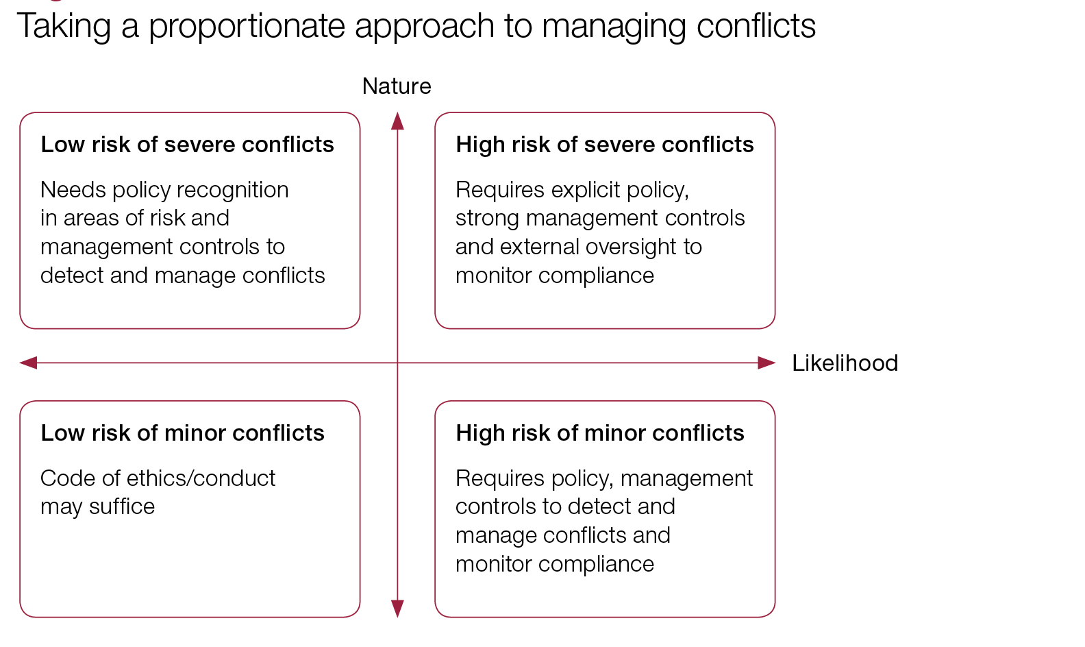

# **Conflicts arising from the design of policy/system**

Conflicts of interest can arise from system or policy design. Changes in public service provision have created devolved delivery models. Private or semi-private organisations assess service needs and then, either directly or indirectly, provide the service. For example, GPs could be both commissioners and providers of services for clinical commissioning groups. They are responsible for selecting providers and deciding on spending, while potentially being involved in delivering some of those services.

Academy trusts and local enterprise partnerships are in a similar position. Members of such groups come from different backgrounds, bringing valuable local, specialist or business expertise. However, there are allegations surrounding the lack of transparency in decision-making and the risk that the private interests of members could influence public spending decisions, for example through related party transactions.

Related party transactions are a type of conflict of interest. The accounting standards define them as “a transfer of resources, services or obligations between a reporting entity and a related party, regardless of whether a price is charged”.2 Most commonly, they take the form of buying goods or services from companies in which the organisation – or individuals within that organisation – has some relationship with. They are not inherently irregular and are permitted.

# **Corruption, the bane of public procurement**

Public procurement is one of the government activities most vulnerable to corruption. In addition to the volume of transactions and the financial interests at stake , corruption risks are exacerbated by the complexity of the process, the close interaction between public officials and businesses, and the multitude of stakeholders.

Various types of corrupt acts may exploit these vulnerabilities, such as embezzlement, undue influence in the needs assessment, bribery of public officials involved in the award process, or fraud in bid evaluations, invoices or contract obligations. In many OECD countries, significant corruption risks arise from conflict of interest in decision-making, which may distort the allocation of resources through public procurement (European Commission, 2014a). Moreover, bid-rigging and cartelism may further undermine the procurement process.

The OECD Foreign Bribery Report (2014) provides additional evidence that public procurement is vulnerable to corruption. Figure shows that more than half of foreign bribery cases occurred to obtain a public procurement contract (OECD, 2014). Almost two-thirds of foreign bribery cases studied occurred in sectors closely associated with contracts or licencing through public procurement: the extractive, construction, transportation and storage, and information and communication sectors

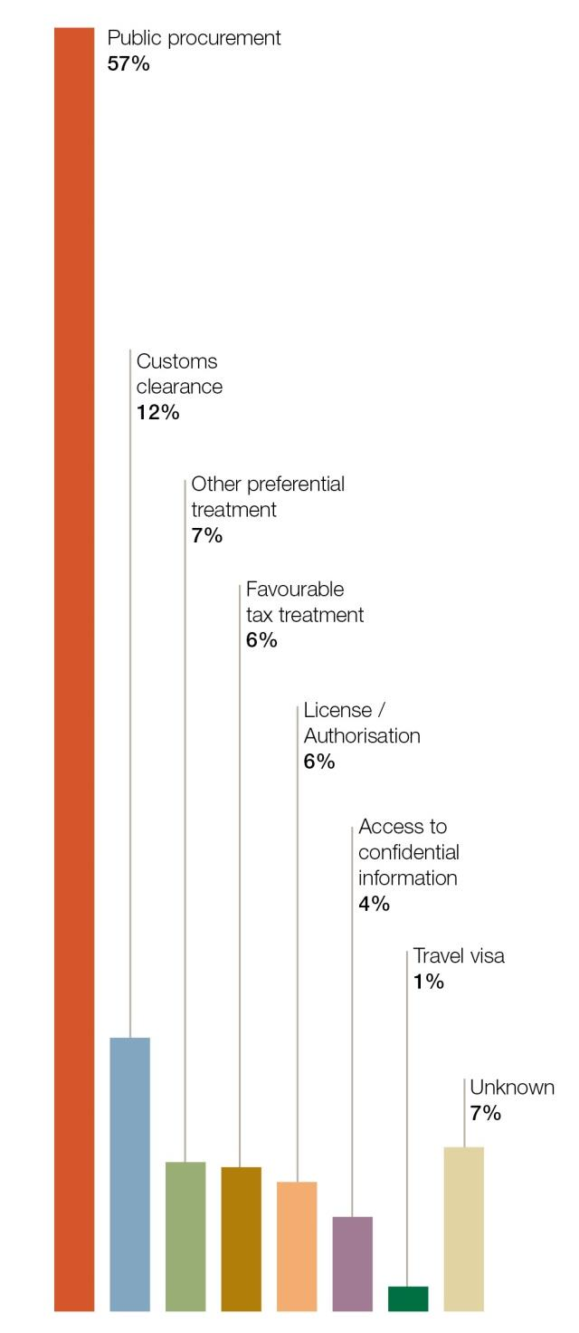

Corruption in public procurement can both occur at the national and subnational levels. On the one hand, decentralisation may narrow the scope for corruption, in line with the assumption that politicians and public officials at subnational levels are more accountable to the citizens they serve. Voters may be better able to discern the quality of their leadership and the results they deliver. Likewise, local politicians and civil servants can be more in touch with specific needs and contexts of their constituencies. On the other hand, however, greater opportunities and fewer obstacles to corruption may play at the subnational level, due to, in some instances, weaker governance capacity (through for example less developed auditing functions, limited legal expertise or low IT capacity) or closer community contacts between public officials and business representatives.

# **How to enhance integrity and curb corruption in public procurement**

As integrity risks exist throughout the public procurement process, a holistic approach for risk mitigation and corruption prevention is needed. Focusing integrity measures solely on one step in the process may increase risks in other stages. Similarly, addressing only one type of risks may give leeway to integrity violations through other mechanisms. For example, administrative compliance measures in the bidding phase do not root out the risk for political interference in the identification of needs. Likewise, asset declarations for procurement officials may not sufficiently protect against bidrigging or petty fraud.

Embodying this holistic approach, the OECD Recommendation on Public Procurement highlights several mutually supportive principles which may, directly or indirectly, prevent corruption and stimulate good governance and accountability in public procurement. These principles include:

* Integrity
* Transparency
* Stakeholder participation
* Accessibility
* E-procurement
* Oversight and control

# **Integrity**

Integrity of actors in the procurement process may significantly reduce corruption risks. Integrity refers to upholding ethical standards and moral values of honesty, professionalism and righteousness, and it is a cornerstone for ensuring fairness, non-discrimination and compliance in the public procurement process. Therefore, safeguarding integrity is at the basis of any effort to curb corruption in public procurement.

Recognising the importance of integrity for good governance and trust in public institutions, countries apply national integrity standards for all public officials, for example through civil service regulation or a generic code of conduct outlining the standards and expectations for good conduct of civil servants. Often, a dedicated government department is responsible for developing, updating and diffusing the code of conduct, and may provide tailored advice, guidance and practical examples supporting the implementation of the code.

In addition to the standards applicable in the whole public service, specific standards for procurement officials may mitigate the specific risks related to the complexity and characteristics of the public procurement process. The standards for procurement officials - in particular specific restrictions and prohibitions - aim to ensure that officials’ private int erests do not improperly influence the performance of their public duties and responsibilities. Most common conflict of interest situations are related to personal, family or business interests and activities, gifts and hospitality, disclosure of confidential information, and future employment. Consequently, the additional standards can include provisions on asset declaration requirements, whistleblowing procedures, and protection measures for whistleblowers. For example, Canada has a specific Code of Conduct for Procurement.

The Code of Conduct for Procurement in Canada provides all those involved in the procurement process – public servants and vendors alike – with a clear statement of mutual expectations to ensure a common basic understanding among all participants in procurement. The Code reflects the policy of the Government of Canada and is framed by the principles set out in the Financial Administration Act and the Federal Accountability Act. It consolidates the federal government's measures on conflict of interest and anticorruption as well as other legislative and policy requirements relating specifically to procurement. This Code is intended to summarize existing law by providing a single point of reference to key responsibilities and obligations for both public servants and vendors. In addition, the Code describes Vendor Complaints and Procedural Safeguards.

Many OECD countries have introduced specific codes of conduct for procurement officials, often together with specific guides and training, to help procurement officials apply these standards in their daily practice. Ethics or integrity training for public officials, and procurement officials in particular, can raise awareness, develop knowledge and commitment, and foster a culture of integrity in public organisations.

The Anti-Corruption Strategy of the Austrian Federal Procurement Agency exemplifies this approach, and also in France specialised training is offered for public procurement officials.

In addition to procurement-related standards, some countries have developed standards to fight particular forms of fraud, as part of a broader corruption prevention framework in the public sector.

With regard to conflict of interest management, all OECD countries surveyed in the 2014 OECD Survey on Managing Conflict of Interest in the Executive Branch and Whistleblower Protection reported having policies, rules and procedures to manage conflicts of interest of public officials. Almost half of them developed specific policies or rules on managing conflicts of interest for procurement officials.

Disclosure of assets, previous employment and paid positions outside the public service may be effective at detecting potential conflict of interests and possible illicit enrichment. The conflict of interest rules need to leave flexibility to relevant authorities to attract competent and experienced employees while ensuring impartiality of the procurement process. Some OECD countries have higher disclosure requirements procurement officials than for civil servants in general.

The public procurement cycle involves multiple actors and therefore integrity is not a requirement for public officials alone. Private companies often have their own integrity system in place , and many countries engage with private sector actors to instil integrity in public procurement. For example, integrity standards applicable to public sector employees may be expanded to private sector stakeholders through integrity pacts. Integrity Pacts are essentially an agreement between the government agency offering a contract and the companies bidding for it that they will abstain from bribery, collusion and other corrupt practices for the extent of the contract. To ensure accountability, Integrity Pacts also include a monitoring system typically led by civil society groups.

# **Transparency**

Transparency in public procurement not only promotes accountability and ensures access to information, it also serves an important role in levelling the playing field for businesses and allowing small and medium enterprises to participate on a more equal footing.

Hence, transparency is central to OECD instruments promoting good governance in the public sector. The OECD Recommendation on Public Procurement (OECD, 2015b) recommends that adhering countries ensure an adequate degree of transparency of the public procurement system in all stages of the procurement cycle. Moreover, the OECD Recommendation on Public Integrity recommends adherents to safeguard integrity and the public interest at all stages of the policy process, in particular through promoting transparency and open government, including actively ensuring full access to information and open data, along with active and timely responses to request for information.

Although transparency in the public service is strongly related with integrity and anti-corruption, the relationship is not automatic. Several conditional factors need to in place for effective accountability. In order for citizens and civil society organizations to fulfil an oversight role, as so-called watchdog, data availability needs to be paired with timeliness, data quality, processing capacity, effective reporting and whistleblower channels.

As a minimum, adequate and timely information may be provided about upcoming contracts as well as contract notices and information about the status of ongoing procurement processes.

Additional information such as the average procurement duration, justification of exceptions and specific overview records by type of bidding procedure may further enable external parties to scrutinize public procurement practice. To provide an appropriate degree of information, governments need to strike a balance between ensuring accountability and competition on the one hand, and on the other hand protecting trade secrets and respecting the confidentiality of information that can be used by interested suppliers to distort competition, in current or future procurement processes. Mexico and Australia both run a comprehensive procurement information system. Mexico also provides for a separate tendering process with respect to hydrocarbons exploration and extraction.

# **Stakeholder Participation**

In order to promote government accountability and foster trust in public institutions, several OECD countries have longstanding practices whereby a large range of stakeholders are involved in the procurement process, including anti-corruption offices, private sector organisations, end-users, civil society, the media and the general public. More recently, some countries have introduced direct social control by involving citizens at critical stages of the procurement process. Open and regular dialogue with suppliers and business associations can reinforce mutual understanding of factors shaping public markets. For example, the Chief Acquisition Officers Council in the United States has institutionalised the dialogue with external stakeholders.

Stakeholders involvement in policy processes is also an important foundation of OECD instruments promoting integrity. The OECD Recommendation of the Council on Public Procurement (OECD, 2015b) recommends that adherents foster transparent and effective stakeholder participation.

Moreover, the OECD Draft Recommendation of the Council on Public Integrity encourages adherents to safeguard integrity and the public interest at all stages of the political and policy process, in particular through granting all stakeholders – civil society organisations, businesses, the media and citizens equitable voice in the development and implementation of public policies ; and enabling a civil society that includes ‘watchdog’ organisations, citizens groups and independent media in order to ensure effective accountability.

Providing opportunities for direct involvement of relevant external stakeholders in the procurement system can increase transparency and integrity while assuring an adequate level of scrutiny, provided that confidentiality, equal treatment and other legal obligations in the procurement process are maintained. Mexico, for example, has established a system of social witnesses for certain ternder procedures.

# **Access to public procurement contracts**

Access to public procurement contracts by potential companies of all sizes is important in order to get the best value for money through fair competition. Participation in public procurement by small and medium enterprises (SMEs) may be facilitated through streamlining tendering procedures and reducing bureaucracy, which can level the playing field among businesses and at the same time cut out opportunities for corruption. In order to ensure fair competition and to sanction corrupt practices, companies with a proven track record of integrity breaches can be excluded from access to public procurement contracts.

Generally speaking, SMEs, accounting for more than 90% of all established businesses worldwide, differ from large companies on public procurement integrity. When faced with excessively complex bureaucracies, SMEs are more likely to make illegal payments in order to secure an advantage as they often lack the time and resources necessary to get informed about complex regulations and requirements, making illegal payments to cover up mistakes or avoid overly bureaucratic procedures more likely. Indeed, as highlighted by the report Corruption Prevention to Foster Small and Medium Sized Enterprises Development (UNIDO & UNODC, 2007), SMEs are more susceptible to bureaucratic corruption than larger companies. According to this study, this is due to a number of factors, including the following: their structure (e.g. a greater degree of informality and fewer accountability mechanisms); a vision and perspective that focus on short term implications of entering into corrupt transactions (as opposed to larger companies, SMEs may be less concerned about reputation and other long-term negative impacts of corruption); limited financial resources; and their inability to wield influence over officials and institutions as they lack bargaining power to oppose requests for illegal payments from public officials.

The OECD Recommendation of the Council on Public Procurement (OECD, 2015b) encourages adherents to facilitate access to procurement opportunities for potential competitors of all sizes.

Many countries have adopted tools to reduce corruption while reinforcing competition and efficiency in procurement procedures. For example in Spain a self-declaration system facilitates participation of SMEs in public procurement. Italy runs a train the trainers programme to empower SMEs in the area of public procurement and Ireland has consultation and review mechanisms in place to tailor the procedures to SME needs.

The European Commission is taking action to minimise administrative burden in public procurement, harmonizing practices across the EU and facilitating the participation of SMEs in public tenders. Measures include one-stop shops, data-sharing and standardisation, common commencement dates for new rules, tailored guidance and trainings for SMEs, and dialogue with SME representatives to ensure that they are fully involved in the public procurement reform process.

Integrity violations of companies may lead to permanent or temporary exclusion from public procurement. In line with the EU legislation, there are mandatory debarment/exclusion rules in place in EU Member States according to which bidders against whom final court convictions for corruption have been handed down are excluded from future tenders (European Commission, 2014a). In many EU Member States, laws contain debarment provisions and contracting authorities have also cross -access to their internal debarment databases.

With the leadership of the World Bank, Multilateral Development Banks have developed an Agreement for Mutual Enforcement of Debarment Decisions and make public the list of companies and individuals ineligible to participate in their tendering process (World Bank, no date). The 2009 OECD Anti-Bribery Recommendation calls on Parties to the OECD Convention of Bribery of Foreign Public Officials in International Business Transactions to: “suspend, to an appropriate degree, from competition for public contracts or other public advantages, including public procurement contracts and contracts funded by official development assistance, enterprises determined to have bribed foreign public officials and, to the extent a Party applies procurement sanctions to enterprises that are determined to have bribed domestic public officials, ensure that such sanctions should be applied equally in case of bribery of foreign public officials”.

# **E-procurement**

E-procurement, which is the use of information and communication technologies in public procurement, can increase transparency, facilitate access to public tenders, reduce direct interaction between procurement officials and companies, increasing outreach and competition, and allow for easier detection of irregularities and corruption, such as bid rigging schemes. The digitalisation of procurement processes strengthens internal anti-corruption controls and detection of integrity breaches, and it provides audit services trails that may facilitate investigation activities. The e-procurement system KONEPS in Korea is an example of an integrated online platform for procurement.

Accordingly, the OECD Recommendation of the Council on Public Procurement (OECD, 2015b) encourages adherents to use digital technologies to support appropriate e-procurement innovation throughout the procurement cycle.

# **Oversight and control**

Oversight and control of the procurement cycle are not only essential in supporting accountability and promoting integrity in the public procurement process, these processes also generate valuable evidence on the performance and efficiency of the procurement cycle. The basis for an adequate oversight and control system is a risk analysis of the government process and its environment in question. In turn, the observations from oversight and control activities may yield insights on new and emerging risks or red flags, allowing updating and refining the oversight and controlling system. Moreover, proportional sanctions following the detection of illicit behaviour through oversight and control activities may act as an effective deterrent to engage into corrupt behaviour.

Oversight and control constitute one of the foundations of OECD instruments promoting the implementation of effective integrity systems in the public sector as a whole and in public procurement in particular. The OECD Recommendation of the Council on Public Procurement (OECD, 2015b) encourages adherents to apply oversight and control mechanisms to support accountability throughout the public procurement cycle, including appropriate processes for complaint handling and sanctions. In addition, the OECD Recommendation of the Council on Public Integrity ask adherents to apply a control and risk management framework to safeguard integrity in public sector organisations, in particular through:

* ensuring a control environment with clear and fair objectives that demonstrate managers’ commitment to integrity and public service values, and that provides a reasonable level of assurance of an organisation’s efficiency, performance and compliance;
* ensuring a strategic approach to risk management;
* ensuring that control mechanisms are coherent and include effective and clear procedures for responding to credible suspicions of violations of laws and regulations, and facilitate reporting to the competent authorities without fear of reprisals.

Effective internal controls are designed to ensure the efficient fulfilment of a public procurement process while safeguarding integrity-related goals and objectives. Internal controls in procurement verify whether legal, administrative and financial procedures are followed and include financial controls, internal audit and management controls. Moreover, harmonised internal control practices ensure consistency in the application of procurement rules and standards across th e public sector. The Federal Procurement Agency in the Ministry of the Interior in Germany for examples monitors workflows electronically, enabling more efficient controls. In Brazil the Public Spending Observatory works with a system of red flags indicating specific risks.

Internal controls are designed according to a comprehensive assessment of integrity risks. Conducting a proper risk assessment exercise will require d efining the integrity risks associated with public procurement procedures, identifying the controls that are already in place to mitigate these risks, and prioritizing the implementation of additional controls that are necessary to address any existing gap s.

In addition, risk assessment can be carried out on a rolling basis, to adapt to the constantly evolving factors that may influence or affect public procurement processes. For instance, Argentina, Brazil, France, and Korea have been taking a “looking forward approach” by mapping out regularly risk factors and integrity vulnerabilities related to public procurement. As another example, South Africa recently appointed a Chief Procurement Officer to review and modernize the legal framework, public procurement information systems and improve governance, compliance and accountability of public procurement.

In order to build bidders’ confidence in the integrity and fairness of the procurement system, efficient appeal and complaints procedures are important. Accessibility, user-friendliness, timely processing, independent review, and effective follow-up are key features of sound appeal and complaints procedures. Appeal options can be made available before the signature of the contract , to ensure that the bidders who may challenge the decision of relevant authorities maintain a chance of being awarded the contract. Several countries have introduced a mandatory standstill period to secure a reasonable opportunity for other bidders to be reinstated in the procurement procedure if circumstances warrant. In EU countries, reforms of public procurement laws have been carried out in compliance with the 2007/66/EC Directive on remedies. In Japan, the Office for Government Procurement Challenge System operates a complaints handing system and Canada has established a ombuds-office specifically for public procurement complaints.

# **Red flags**

**What are red flags and how are they used?**

A red flag is an indicator of possible fraud or corruption. It is an element or a set of elements that are unusual by nature or vary from the normal activity. It is a signal that something is out of the ordinary and needs to be examined further.

A variety of red flags may appear in public procurements. They can show anomalies in

* bidding documents, e.g. bids from supposedly different bidders that are faxed from the same telephone number;
* financial records, e.g. invoices paid in amounts that exceed the contract value;
* the behaviour of project staff, e.g. putting pressure on the evaluation committee to select a given contractor.

The presence of red flags should make staff and managers more vigilant: they should take the necessary action to confirm or deny that there is a risk of conflict of interests. It is extremely important to react to them. It is the responsibility, first, of the contracting authorities, and, secondly, of the managing authorities, to remove any doubts that the red flag has raised.

The existence of a red flag does not mean that fraud has occurred or may occur, but that the situation needs to be checked and monitored with due diligence.

**Red flags in public procurement procedure**

This section discusses typical cases of suspected fraud concerning conflicts of interests in different phases of the procedure with examples of what happens in practice.

Some of these red flags may appear commonplace; they can apply to lots of situations, not just conflicts of interests. It is important to keep in mind that the red flags are indicators aiming at carrying out first level checks to waive the doubts or confirm the likelihood of occurrence of a fraud or irregularity. The following red flags should lead to checks dedicated to waive or confirm the possibility of occurrence of a conflict of interests.

**Preparation and launch of the procedure**

The issue of conflicts of interests must be raised right from the preparation stage of the procedure. When the tender documents are being drafted, the contracting authority may need some outside studies or request opinions from outside sources. To some extent, they may base the documents for the tender procedure on reports drafted by outside experts. The contracting authority must also decide on the type of procedure and draft contract notices, contract documents, specifications and a draft contract.

The contracting authority should take the necessary measures to prevent conflicts of interests right from the very first stage of preparation of the documents.

**Risks linked to a conflict of interests**

Someone who takes part in drafting the documents may directly or indirectly try to influence the tender procedure to allow, say, a relative, friend, or commercial or financial partner, to take part.

**Red Flags**

* The person in charge of drafting the tender documents / a senior official insists on hiring an outside firm to help draft the documents although it is not necessary.
* Two or more preparatory studies are requested on the same subject from external firms and someone puts pressure on staff to use one of these studies in drafting the tender documents.
* The person in charge of drafting the documents organises the procedure in such a way that there is no time to revise the documents carefully before the tender procedure is launched.
* Two or more contracts for identical items are issued over a short period of time for no apparent reason, resulting in a less competitive procurement method being used.
* A negotiated procedure is chosen, even though an open procedure is possible.
* There are unjustified selection or award criteria that favour a particular firm or bid.
* The rules on providing goods or services are too strict, allowing only one firm to bid.
* An employee of the contracting authority has relatives who work for a firm which may bid.
* An employee of the contracting authority worked for a firm which may bid, just before joining the contracting authority.

**Example:** One of the tenderers takes part in the preparation procedure and gains some additional information before the procedure is launched. This denies other bidders a fair chance of winning the tender, and is a conflict of interests.

**Risks linked to a conflict of interests**

Information on the tendering procedure may be leaked.

**Red Flags**

* Unusual behavior of an employee insisting on getting information on the tendering procedure although he is not in charge of this procedure.
* An employee of the contracting authority has relatives who work for a firm which may bid.
* An employee of the contracting authority worked for a firm which may bid, just before joining the contracting authority.

**Example:** A member of staff takes part in drafting or correcting the public procurement documents, then resigns and joins a company which submits a bid soon afterwards.

**SUGGESTIONS**:

* Review bidding documents for red flags.
* Ensure that audit rights and contractual remedies are included, as appropriate.

**The call procedure, the evaluation of the tenders and the final decision**

After the deadline for the receipt of tenders, the contracting authority checks the tenders submitted for compliance and evaluates them. Where appropriate, the contracting authority asks tenderers to remedy deficiencies or supply specific information or further explanation. The contracting entity decides which final tenders are valid, based on the criteria given in the notice. The evaluation committee makes a written assessment and recommendation. The decision to award the contract is taken by the decision-maker appointed within the contracting authority.

**Risks linked to a conflict of interests**

The bids received may be tampered with to conceal a bidder’s failure to meet the deadline or to provide all the documentation required.

A member of the evaluation committee may try to mislead or put pressure on the other members to influence the final decision, for example by giving a wrong interpretation of the rules.

**Red flags**

* The official documents and/or certificates of receipt of the documents have obviously been changed (e.g. crossing-out).
* The evaluation committee members do not have the necessary technical expertise to evaluate the submitted bids and are dominated by one individual.
* Subjective elements are overrepresented in the criteria system.
* Some obligatory information from the winning bidder is missing.
* Some information provided by the winning bidder relates to contracting authority staff (e.g. an employee’s address)
* The winning bidder’s address is incomplete, e.g. there is only a PO box address, no telephone number, and no street address (might be shell companies).
* The specifications are very similar to the winning bidder’s product or services, especially if the specifications include a set of very specific requirements that very few bidders could meet.
* Few of the companies that bought the bidding documents submit bids, especially if more than half of them drop out.
* Unknown companies with no track record win the contract.

**SUGGESTIONS:**

* Ensure that committee members are selected in accordance with the established project implementation manual.
* Ensure the project procurement officer is available to the evaluation committee to answer any procedural questions.
* Confirm that the evaluation committee has the necessary technical expertise to evaluate the bids.
* Check that committee members sign a declaration stating that they do not have a conflict of interests in performing their duty, such as any current or past affiliation with any of the bidders.

**Performance, amendment and modification of public contracts**

Any contract awarded under a public procurement procedure must be implemented in full accordance with the requirements laid down in the call for tender and the technical specifications and within the time frame set in the call. Parties may be authorised to amend part of the contract slightly, if they are able to prove that the amendment was not originally foreseeable and ensure reasonable sustaining and economic balance.

**Risks linked to a conflict of interests**

The contract is not drafted according to the rules and/or the technical specifications and tender documents.

The contract is poorly executed.

The contract is poorly monitored.

False certificates are accepted.

**Red flags**

* Standard contract clauses (audit, remedies, damages, etc.) are changed.
* The methodology and work plan are not attached to the contract.
* The name and legal status of the firm is changed and the desk officer in charge does not question this.
* Numerous or questionable change orders for a specific contractor are made, and approved by the same project official.
* In international projects, there is a long, unexplained delay between the announcement of the winning bidder and the signing of a contract (this may indicate that the contractor is refusing to pay or is negotiating on a demand for a bribe).
* Substantial changes are made to technical specifications or to the Terms of Reference.
* The quantity of items to be delivered is reduced, without a commensurate reduction in payment.
* Labour hours are increased, with no corresponding increases in the materials used.
* The contract is missing or the documentation supporting a purchase is inadequate.
* A contracting employee’s behaviour when dealing with the file is unusual: he/she is reluctant to answer management questions about unexplained delays and missing documents.
* There are many administrative reviews and cancelled procurement procedures.
* There are any changes to the quality, quantity or specification of goods and services in the contract that deviate from the bidding document (terms of reference, technical specifications, etc.)

**SUGGESTIONS:**

* Evaluate any requests for change order, check their legitimacy and ask for supporting documents, as appropriate, before agreeing to the change order.
* On monitoring missions to high-risk projects, ask clients to inform the bank of any change orders issued to any of the signed contracts, for any amount.
* Use supervision missions by the task team to check that key goods, works, and services outputs actually exist. Reviews can confirm that the progress of the work is consistent with the completion certificates issued, that supporting documentation is adequate, that officers are correctly certifying that goods and services have been received on time.
* Require independent annual technical, financial, and procurement audits of highrisk projects.
* Include site visits by technical experts in supervision missions.
* Introduce contract management training for project officials.
* As part of a procurement and financial management review, specifically check the supervision of contract management — payment listings by contract or contractor, checks for duplicate payment, and certification of goods and services received.
* Introduce strict complaints-handling procedures and publicise them.

# **Innovation Partnerships**

# **Public procurement of innovative solutions**

Public procurement is the process whereby public authorities – including all levels of government and public agencies – buy goods and services or commission work.

The resulting contracts make up a very significant proportion of the European Union market, accounting for about 19 % of its gross domestic product (GDP) or almost € 2.400 billion a year.

Public contracts above certain value thresholds must be published in national government or European Union Official Journal. This is to ensure greater competition in the context of the European internal market. Public procurement plays a central role in the delivery of public services, such as health and education, and involves all government departments, local authorities, agencies and other public bodies.

In the last decade, more and more considerations have been given to link public procurement and political objectives like innovation and sustainability.

# **What is Public procurement of innovative solutions – PPI?**

Horizon 2020, the new EU Framework Programme for Research and Innovation, includes a useful legal definition of public procurement of innovative solutions (PPI) as a basis for the eligibility of procurement actions for EU cofinancing:

**It stipulates that Public Procurement of Innovative solutions (PPI)** is procurement where contracting authorities act as a launch customer for innovative goods or services which are not yet available on a largescale commercial basis, and may include conformance testing. Public procurement of innovative solutions does not include the procurement of R&D services, which is known as ‘pre-commercial procurement’ (PCP).

Pre-commercial procurement (PCP) means procurement of research and development services involving risk-benefit sharing under market conditions, and competitive development in phases, where there is a separation of the research and development phase from the deployment of commercial volumes of end-products. PCP is excluded from the procurement directives, and the European Commission developed a specific guidance to Member States in 2007 presenting how to develop PCP procedures.

As outlined in the introduction, this guidance is about PPI. PCP is only mentioned in this guide for the sake of putting PPI in its overall policy and economic context. Where reference is made to both instruments, PPI and PCP, the wording “innovation procurement” is used.

Innovation procurement: what are PCP and PPI?

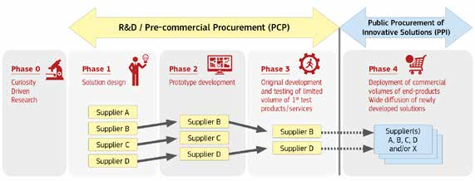

Public procurement of innovative solutions (PPI) plays a key role in improving the efficiency and quality of public services while addressing major societal challenges. It contributes to achieving best value for public money as well as wider economic, environmental and societal benefits in terms of generating new ideas, translating them into innovative products and services and thus promoting sustainable economic growth, to the benefit of European enterprises and SMEs.

Public procurement of innovative solutions (PPI) is particularly useful in **certain areas (e.g. mobility, health, construction, egovernment, waste management, recycling), where the public sector accounts for a big part of demand and can use procurement as a means to address key societal challenges such as sustainable transport, resource-efficiency or health and ageing.**

Public procurement of innovative solutions (PPI) provides an early ‘reality check’ of concrete specific public purchasing needs against feasible solutions. Suppliers can better anticipate demand for new solutions and shorten time-to-market. Procurers can compare competing solutions and get a better price for an innovative solution that is more fit for purpose. Public authorities may be able to steer the supply of innovative solutions from the demand side and leverage additional investment in R&D and innovation.

By driving innovation from the demand side and steering the development and first application of innovative solutions corresponding to public-market needs public procurement of innovative solutions (PPI) can enable procurers to avoid the costs of unnecessary features, prevent supplier ‘lock-ins’ and take account of longer-term public sector requirements.

When procurers represent a critical mass, they can create new lead markets by acting from the demand side so that entire sectors switch from proprietary to open standardised solutions and provide more flexible solution designs. In certain sectors, the public-sector ‘demand pull’ is the most important factor in developing new markets for innovative solutions. In spite of the potential benefits of public procurement of innovative solutions (PPI) for both the efficiency of public services and new solutions to societal needs, public authorities generally tend to adopt a risk-averse approach to purchasing innovation. Public procurers still write terms of reference and prefer to go for the lowest bids or lowest price as the main criterion when assessing the offers received. Certain barriers need to be overcome for using public procurement more strategically.

From the business point of view, as regularly confirmed by Innobarometer surveys since 2009, very few European companies (7 % of the respondents) have had the opportunity to sell innovative solutions to public procurers.

The Innobarometer surveys conclusions on opportunities for companies to sell innovative solutions to public purchasers are supported by other studies that show the **difficulties for innovative SMEs to get access to public procurement contracts**. Overall, this hampers public authorities’ access to the innovative potential of SMEs.

# **What has been done to support public procurement of innovative solutions in Europe?**

Considering the potential of innovation procurement – including both PPI and PCP – to stimulate growth and job creations, some Member States (e.g. the United Kingdom, the Netherlands, Sweden, Italy, Spain, Austria, Germany, France, Poland and Finland) have been supporting and carrying out PPI – and PCP – for ten to fifteen years, with specific policy actions often developed via national, and in some cases regional, innovation agencies (e.g. BIS (UK), the Agency (NL), VINNOVA (SE), TEKES (FI) and IWT (Flanders region, BE)).

Often driven by quantitative objectives for the share of public procurement of innovative solutions in the procurement volume (e.g. Netherlands 2.5 %, France 2 %, Spain 3 %), these programmes have encouraged procurers to feed ‘innovation’ considerations and approaches into their regular procurement activity. In the past few years, almost all Member States have developed PPI-related policy actions.

More recently, European regions have taken targeted measures to support their public procurers in contracting innovative solutions and services. Flanders (BE) and Lombardy (IT) have been pioneers in this respect.

On the EU level, the European Commission has provided significant and increasing support for PPI since 2009. The support from the European Commission can be differentiated in three categories:

* First, direct support measures to reduce the financial risks of public procurement of innovative solutions (PPI). This includes both financial support to the establishment of cross-border procurer networks and a financial contribution to the purchase of innovative solutions, a so-called ‘topping-up’.
* Second, indirect support measures to improve the skills of procurement officers, such as a web platform to exchange best practices and experiences with regard to public procurement of innovative solutions (PPI); guidance for the public procurement of innovative solutions in specific areas (e.g. sustainable construction, healthcare).
* Third, accompanying measures to improve the evidence base, such as measuring public procurement of innovative solutions (PPI) and pre-commercial procurement (PCP) and benchmark Member States’ actions to support public procurement of innovative solutions (PPI).

In 2013, € 94.5 million was allocated in the Competitiveness and Innovation Framework Programme and the 7th Framework Programme for Research and Development to innovation procurement – including both PPI and PCP –.

In the light of the European R&D&I programme Horizon 2020, the European Commission intends to develop new opportunities for funding and promote innovation procurement – including both PPI and PCP – in the coming years .

Also, the Procurement of Innovation Platform is a new system that aims to make public procurement – of innovative solutions a widespread reality in Europe. It has been developed to help public authorities, procurers, policy-makers, researchers and other stakeholders harness the power of PPI.

# **How can The European legal framework and EU programmes support public procurement of innovative solution?**

There are two main ways to support European public procurers to purchase more innovative solutions: first, in having a more innovation friendly legal framework and second, in developing policy support actions to the benefit of public procurers and supporting organisations. These two potential routes for action are set out in the following pages.

**The legal framework: New EU procurement directives**

Public procurement is currently subject to the Public Procurement Directives – 2004/17/EC (procurement in the water, energy, transport and postal services sectors), 2004/18/EC (public works, supply and service contracts) and 2009/81/EC (defence and sensitive security procurement). The new Public Procurement Directives 2014/24/EU and 2014/25/EU replacing Directives 2004/17/EC and 2004/18/EC came into force on 17 April 2014. **The new directives will encourage companies to develop their capacity for innovation, while main-taining the basic requirements of competition, transparency and equal treatment. The Member States have now to transpose them into national law, at the latest by April 2016.**

The new competitive procedure with negotiation replaces the current negotiated procedure with prior publication of a contract notice. To ensure fairness, transparency and efficiency, this new procedure is clearly structured and ensures equal exchange of information between the contracting authority and tenderers. It focusses on the improvement and adaptation of the tenders and provides contracting authorities with effective instruments to obtain the best possible procurement outcome in the negotiations.

Secondly, the **competitive dialogue** has been simplified for particularly technically and financially complex projects.

These procedures give contracting authorities more flexibility, greater options and new routes to procurement. They have much greater freedom to choose the type and design ofprocedure best suited to their needs. Contracting authorities can effectively use such procedures in all situations where negotiations are required (e.g. for contracts which include an element of design or innovation, or if technical specifications cannot be sufficiently defined). Procurers will thus have greater flexibility in the choice of procedure to meet their needs and to evaluate a range of solutions.

The new rules also introduce a new procedure called innovation partnership18 to enable public procurers to have an innovative solution developed tailored to their requirements. The innovation partnership foresees the funding of R&D for an innovative solution in the same procedure as the procurement of the solution. It is therefore not relevant for PPI financed under Horizon 2020.

Beyond the above new and revised procedures available to contracting authorities, the 2014 Public Procurement Directives further facilitate procurement approaches which have been found to be ‘innovation friendly.’ The possibility to conduct preliminary market consultations is underlined. The ability to take environmental and social considerations into account at various stages of the procurement process, and the use of life-cycle costing at award stage, are given a stronger legal basis. By allowing buyers to focus on criteria beyond the initial purchase costs, environmental and social criteria and life-cycle costing can promote innovative solutions which may be awarded more points in the light of their long-term financial benefits. Similarly the use of functional or performance-based specifications can allow more scope for innovative proposals.

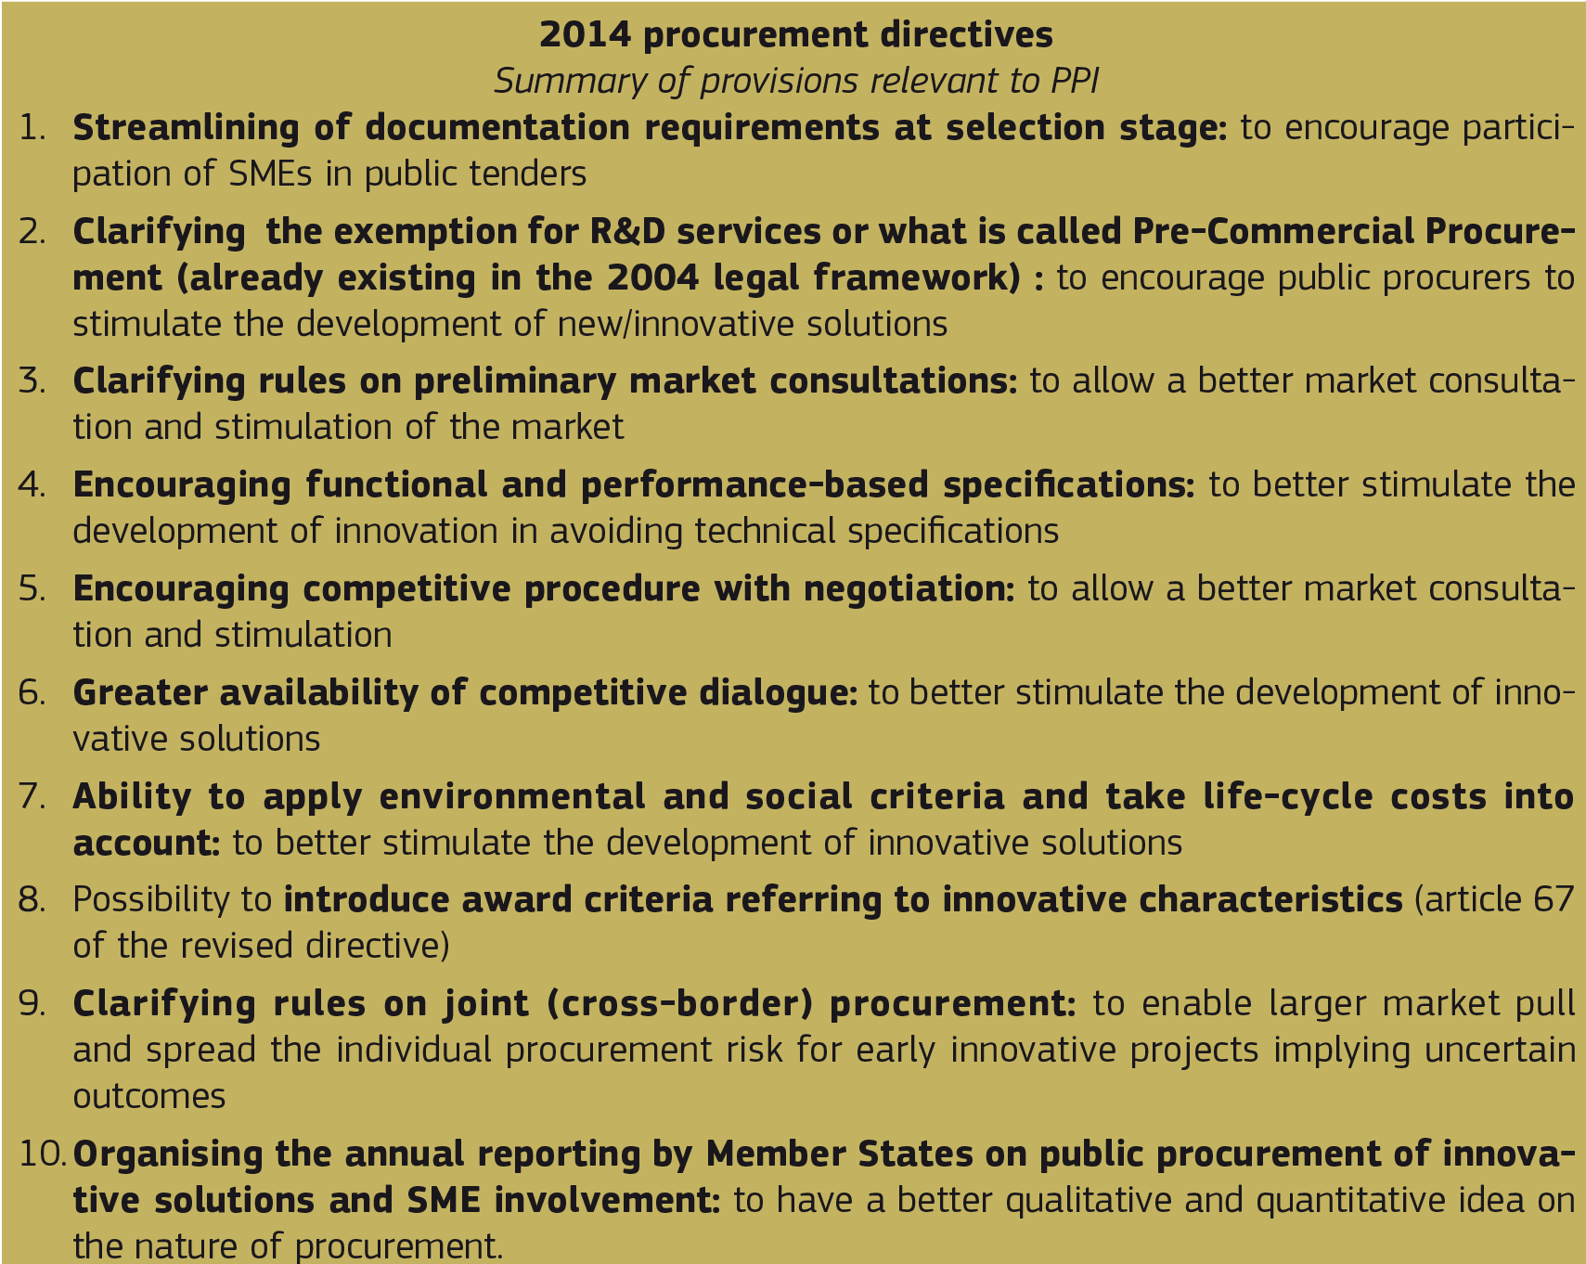

Finally, a number of changes to selection procedures and documentation requirements are also aimed at ensuring SMEs – many of which are highly innovative – have better access to public procurement procedures. New rules on cross-border joint procurement will enable buyers from various Member States to make joint purchases. Aggregating demand from various Member States can encourage risk and benefit-sharing for innovative projects and the pooling of demand.

Last but not least, and perhaps most importantly, the implementation of the new directives by Member States offers them an opportunity to assess public procurement from a strategic perspective as well as to identify how innovation and other objectives can best be delivered. The forthcoming years will see many organisations adopting new approaches to achieve better procurement outcomes. Meanwhile, this process should be assisted by greater reliance on electronic systems with the current mainstreaming of e-procurement, following the European Commission strategy to make the use of e-procurement the rule in the European Union by mid-2016. This development of e-administration has to be seen also as a unique opportunity to encourage innovation in public procurement.

# **The potential for public procurement of innovative solutions in the European Structural and Investment Funds**

European Structural and Investment Funds (ESIF) support massive investments, mostly via public procurement – see precise data below –, in infrastructure providing basic services to citizens in the areas of energy, environment, transport and ICT, and social, health, research, innovation, business and educational infrastructure. They also direct these investments in the development of endogenous potential of EU industries, including increasingly **research and innovation, support services, clusters and networks**.

The percentage dedicated to innovation increased from 6 % in the pre-2000 operational programmes to around 25 % in the 2007-2013 programmes, including under the “European Territorial Cooperation objective” of the European Regional Development Fund (commonly known as “INTERREG”). This is further enhanced through the thematic concentration of the post 2013 European Regional Development Fund (ERDF) on research, innovation, ICT, SME competitiveness and low-carbon economy investments that is expected to earmark around € 110 billion for these themes. Alongside this, also the European Social Fund (ESF), the European Agricultural Fund for Rural Development (EAFRD) and the European Maritime and Fisheries Fund (EMFF) actively support innovation and the Cohesion Fund holds potential for the purchase of innovative solutions in the fields of transport and energy. These five funds are the so-called “European Structural and Investment Funds” (ESIF) and are governed by separate regulations, but held together via a Common Provisions Regulation.

**Regarding the last cohesion policy funding period (2007-2013), the 2012 European Parliament study *Public procurement and cohesion policy* draws interesting conclusions on the use of these funds and their relationship with public procurement.**

**Firstly, it showed that many European projects receiving regional policy support involved large-scale public procurement procedures. Major construction works relating to infrastructure investment account for the biggest proportion of these.**

**Overall, such procurement accounted for 46 % of the total Cohesion Policy budget – some € 159 billion – at European level in 2007-13 (this includes only procurement exercises over the EU publication threshold). Therefore, using public procurement to stimulate innovative solutions could exert significant leverage.**

The EP report indicates that **large-scale public procurement** as part of infrastructure investment (46 % of the total Cohesion Policy budget) concerns the following sectors:

* Transport (24 %)
* Environment (direct investments, 15 %); and
* Energy, ICT infrastructure, urban development (rehabilitation, regeneration, housing), health, research and education infrastructure:

Large-scale public procurement accounts for

1. € 144 billion in less developed regions (‘convergence’ objective) or 80 % of the total Cohesion Policy budget; 52 % of the budget for these regions goes into large infrastructure; and
2. € 14.5 billion in more developed regions (‘competitiveness’ objective) or 21 % of their overall budget.

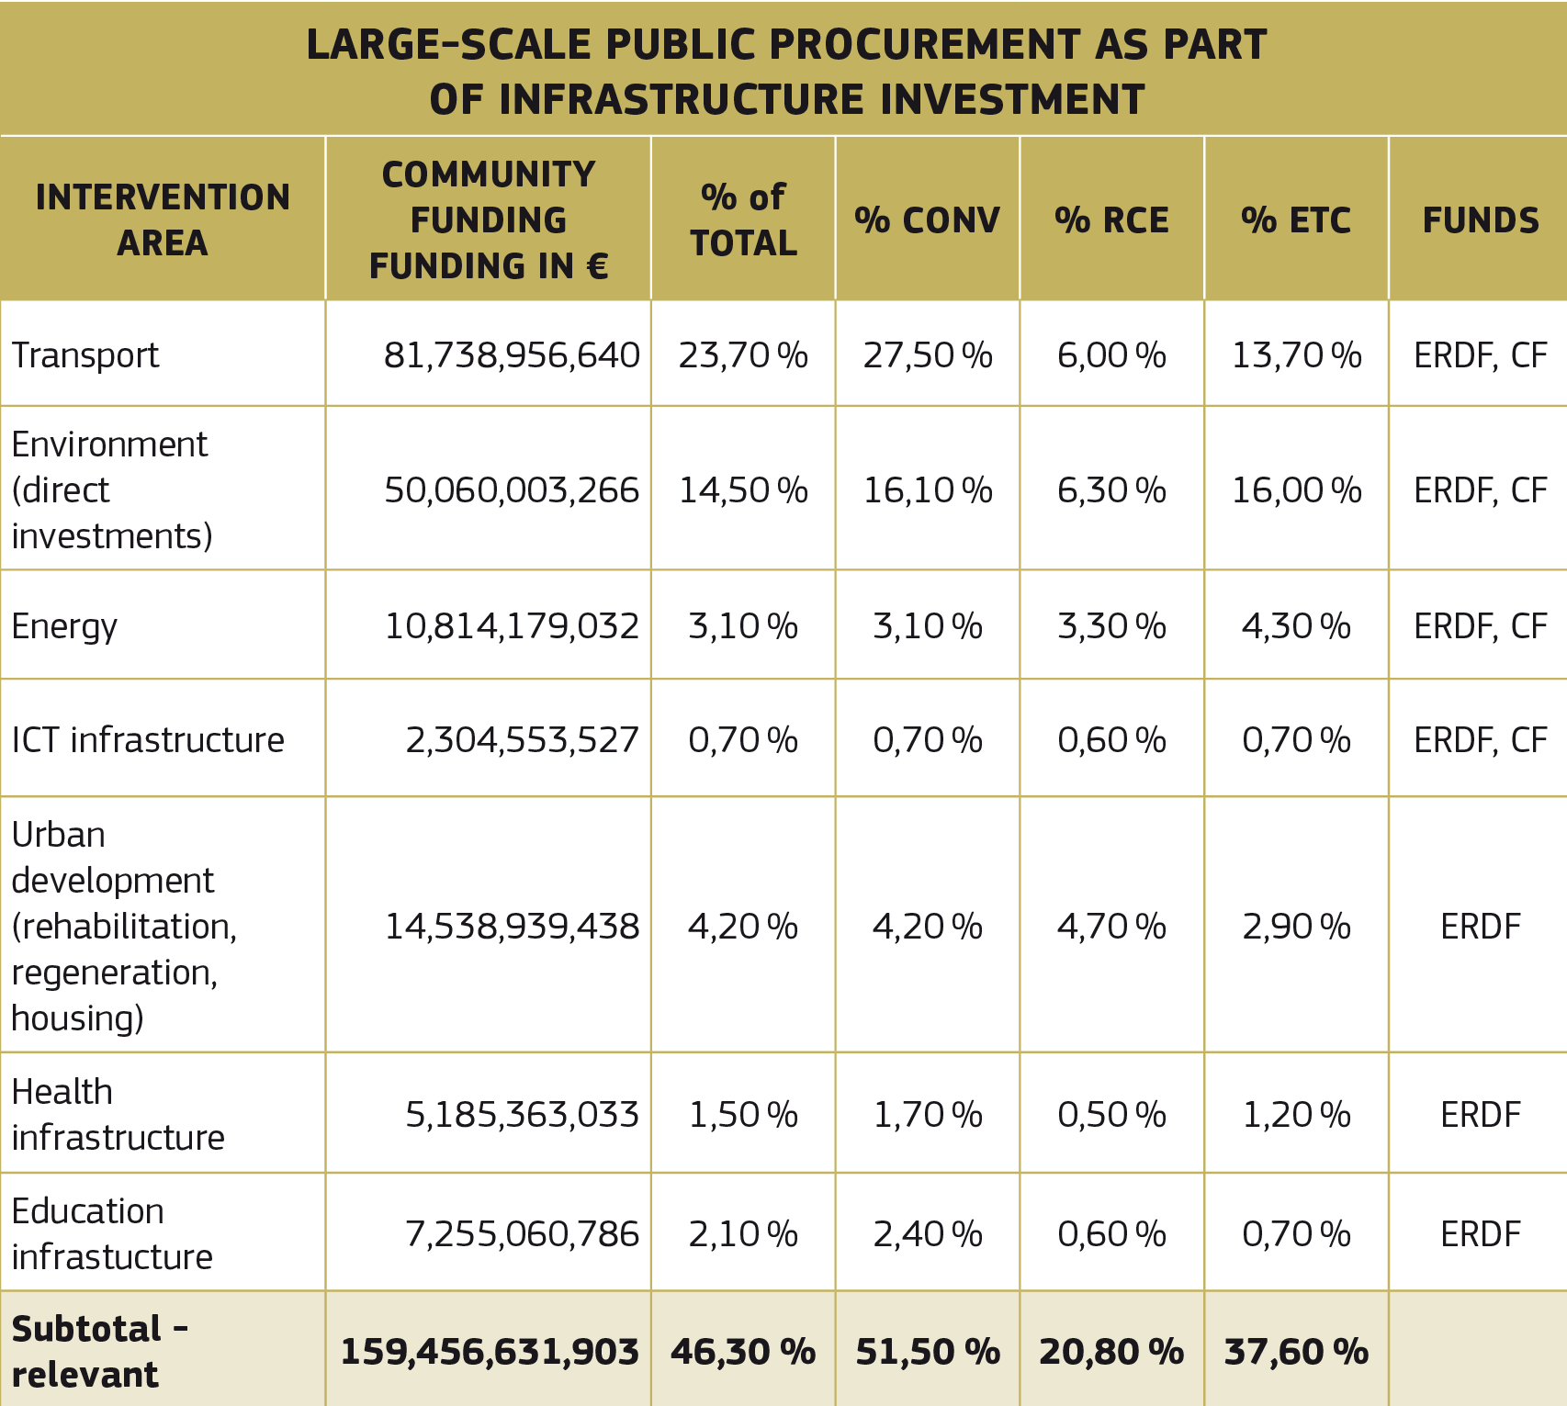

Secondly, the report also shows the use of cohesion funds funding in the light of smaller scale procurements, smaller contracts and purchases of goods and services, in particular with regards to the acquisition of:

* Private and public purchase of ICT products and services;
* Machines, equipment and small infrastructure;
* SME support services;
* Education and training services for RTDI human capital, employment and social inclusion.

These data show the enormous potential in terms of the budgets and economic sectors concerned. The sectors are employment-intensive, have a great need for innovation and are areas in which European industries are world leaders.

**As from 2014 onwards, the new ESIF investment rules show a strengthened emphasis on the need to address new areas, new types of actions and new priorities. It is worth noting in particular the following:**

* **The emphasis for regions to develop ‘cooperative partnerships’** between: research, education and innovation actors;
* **The opportunity to ‘invest’** in areas such as eco-innovation, social innovation, public service applications;
* **The possibility to use the ‘demand stimulation’ for**: innovations, networking, clusters, early product validation, advanced manufacturing capabilities and first production, in particular in key enabling technologies and diffusion of general purpose technologies.
* **The development and take-up of** e-government, e- learning, e-inclusion, e-culture and e-health solutions, enhancing institutional capacity and efficiency of public administration, supporting the shift towards a low-carbon economy, climate change adaptation, risk prevention and management, preserving and protecting the environment and promoting resource efficiency, promoting sustainable transport and removing bottlenecks in key network infrastructures, promoting sustainable and quality employment and supporting labour mobility count among the investment priorities. This holds a substantial potential for **creating more demand for innovative products and services through public procurement of innovative solutions (PPI)**

Whether this potential of the European Structural and Investment Funds will be a reality depends largely on the Managing Authorities, i.e. national and regional authorities, and the priorities and implementation modalities they choose for the forthcoming ESIF programmes. It is not necessary to expressly mention PPI in the ESIF programmes in order to be allowed to use it, however, it would be welcomed to mention PPI as a type or example of actions to be supported or as guiding principle for the selection of operations under the relevant priority axis.

As the identification of **‘investment priorities’** is a key element of the ESIF Programmes, it should be noted that practically all of the **11 investment priorities of ESIF** allow for PPI use. However, in order to avoid an incorrect classification of actions – for instance to comply with “thematic concentration obligations” –, a direct link between the use of PPI under the investment priority needs to be insured. It has to be noticed that since direct beneficiaries of PPI actions are always public bodies

(bodies subject to the procurement Directives), therefore it cannot be used under investment priorities 3 a-d (enhancing the competitiveness of SMEs) to directly support SMEs, except public infrastructure or services are procured that specifically support SMEs (e.g. an incubation centre, equipment for a FabLab, etc.). Nonetheless, **PPI actions can indirectly help innovative SMEs by giving them an opportunity to find a lead customer and thus bring their innovations faster to the market and obtain faster return on investments**.

# **Outlook on PPI support under Horizon 2020**

Horizon 2020 is the financial instrument implementing the Innovation Union 28 – a Europe 2020 flagship initiative aimed at securing Europe’s global competitiveness. It aims at:

* Boosting excellence in science;
* Strengthening industrial leadership;
* And addressing societal challenges.

Under Horizon2020, public procurement of innovative solutions (PPI) has been recognised as new innovation support form. Horizon 2020 foresees three types of support to public procurement of innovative solutions carried out by procurers from Member States and Associated Countries by awarding a grant:

* For networking public procurers in a specific area of public interest (Coordination and Support Action – CSA); For these type of actions the Horizon 2020 co-financing rate is 100 % ; These actions typically also include activities for preparation of a joint or coordinated PPI, management and follow-up, such as activities for awareness raising, networking, training, evaluation, validation and dissemination of results);
* For co-financing the price of a joint or coordinated procurement of innovative solutions (Co-fund Action – CA). For this type of actions the Horizon 2020 co-financing rate is 20 %. The eligible costs include the price of the purchase as well as related coordination and networking costs to prepare, manage and follow-up the call for tender;
* For a third channel is foreseen with Horizon 2020 for supporting PPI carried out by the EU (or relevant funding body) on its own behalf or jointly with contracting authorities from Member States and Associated Countries (Procurement Action).

Inviting public procurers and support organisation to Team up with other procurers in the framework of a Horizon 2020 project can help not only with the identification of the state-of-the-art technology and performance levels, but also with the correct handling of procurement procedures in line with the Directives and the risk management of PPI projects. Teaming up can also bring down the cost for the innovative solution, thanks to economies of scale due to the greater procurement volume. Such Horizon 2020 projects can also facilitate the procurement of additional quantities of the innovative solutions through ESIF.

To obtain support under Horizon 2020, these groups of public procurers have to respect certain administrative rules, in-line with the Horizon 2020 rules for participation. For example a consortium has to include participants from at least 3 different countries, of which minimum 2 public procurers from 2 different countries with common procurement needs. In addition, other procurers – e.g. private, NGO procurers – that are providing services of public interest and other entities that are assisting the procurers can participate in a consortium. PPI actions are likely to be mainly used under the three Horizon 2020 priorities: “Excellent Science”, “Industrial Leadership” and “Societal Challenges” (health, demographic change and wellbeing, food security, sustainable agriculture and forestry, marine and maritime, inland water research, security, clean and efficient energy, smart, green and integrated transport, climate action, environment, resource efficiency and raw materials).

# **Innovation Partnership in the new public procurement regime – a shift of focus from procedural to contractual issues?**

At the beginning of 2014, the European Parliament and the Council adopted the new directive on public procurement (Directive 2014/24/EU; hereafter the Directive). Inter alia, the newDirective introduces a new procedure called the innovation partnership. The availability of the new provisions maybe valuable particularly from the perspective of complex contracts, which are characterised as mixed contracts. This is because the innovation partnership has a potential to enable a contracting authority to procure complex contracts with more than one type of subject matter regarding development of innovation and its delivery.

On the one hand, the innovation partnership has a potential to overcome the primary challenge and uncertainty regarding the usage of a two-stage procedure divided into pre-commercial and commercial procurement, relating to the unfair competition and the conflict of interest that may occur based on cooperation within the pre-commercial phase. On the other hand, the establishment of an innovation partnership may be seen not only as an answer to existing challenges, but also as a new way of realising the objective of a smart, sustainable and inclusive growth that characterises the Europe 2020 strategy. However, at the same time the application of the innovation partnership provisions may pose certain challenges. The aim of this article is to identify and discuss these challenges.

To achieve this aim firstly, the scene for the discussion will be set by a presentation of background information. Secondly, three methods of procuring innovation will be discussed: first, the pre-commercial procurement; secondly, delivery of innovation throughout the competitive dialogue procedure; and, finally, the newly introduced innovation partnership. Thirdly, particular attention will be given to the innovation partnership provision in the Directive. Focus will be given to the proposed procedure and structure of the partnership. Fourthly, the article will consider what new solutions the new procedure introduces. Finally, the last section will conclude the discussion.

# **Background**

The EU, like any other region, is faced with important societal challenges such as ensuring high quality and accessible health care, the fight against climate change and improvement of energy efficiency. Addressing these challenges often requires new and better solutions. As research and innovation play a central role in the Europe 2020 strategy for a smart, sustainable and inclusive growth , the procurement of innovation is of high value. However, delivery of innovation brings specific legal challenges which need to be considered. One of the challenges is how innovation should be understood. Until now there has not been any legal definition of innovation in EU public procurement law, and this could potentially cause uncertainties. Among others it was unclear how to procure a contract including innovation and how to classify such a contract, especially since it is often difficult to specify the subject matter of an innovation contract.

With the introduction of anew procedure – the innovation partnership the Directive also introduces a legal definition of an innovation in Article 2(22) stating:

*“'innovation' means the implementation of a new or significantly improved product, service or process, including but not limited to production, building or construction processes, a new marketing method, or a new organisational method in business practices, workplace organisation or external relations inter alia with the purpose of helping to solve societal challenges or to support the Europe 2020 strategy for smart, sustainable and inclusive growth;”*

There are several problems of this definition - in particular, the question of how we should understand the concept of ‘significantly improved’. In this respect, Recital 47 of the Directive states that innovation should improve efficiency and quality; and that it should contribute to achieving best value for public money as well as wider economic, environmental and societal benefits. Therefore, it seems that the requirement for significant improvement should refer to these elements. The innovation should allow a contracting authority to deliver better public contracts in terms of quality, life-cycle cost, and enable the contracting authority to incorporate better environmental and societal considerations and standards .In addition, other elements of the definition can be criticised. Firstly, it is unclear why the legislator would establish a definition which will become outdated, as the definition refers to the Europe 2020 strategy.

Secondly, the definition is too complex. It might be better to refer simply to implementation of a new or significantly improved product, service or process, including but not limited to production, building or construction processes.

There are several ways in which the contracting authority can encourage the introduction of innovation in the procurement procedure. Among others are variants, design contests and a functional description of the subject matter. Nevertheless, these options may increase risks and confusion as to how to make sure that the contracting authority is not comparing apples with oranges. Also, when these tools are used in open or restricted procedures they are not traditional innovation processes, as dialogue between contracting authorities and bidders is not allowed.

Until recently the procurement of innovation could also be carried out in the following two ways. Firstly, the procurement of innovation could be carried out in a two-stage process, starting with a precommercial procurement where a Research and Development (R&D) service contract is awarded, and followed by a procurement procedure of the already developed innovative solution (construction, services, goods) on a commercial market. Secondly, the whole process, including the pre-commercial and the commercial procurement, could be combined into one procedure and the subject matter procured – depending on the circumstances of the contract - through the competitive dialogue procedure or, negotiated procedure with a notice (changed and renamed in the Directive to the competitive procedure with negotiation.) The new Directive has added one more option, whereby the innovation may be developed and delivered through the newly introduced innovative partnership.

# **Innovation Partnership**

The innovation partnership must aim at the development of an innovative product, service or works and the subsequent purchase of the resulting supplies, services or works. On the one hand, the innovation partnership combines both a pre-commercial and a commercial stage of procurement, as its subject matter is both: an innovation development (pre-commercial stage) and a subsequent purchase of the innovation (commercial stage). The latter is under the condition that the innovation corresponds to the performance levels and maximum costs agreed between the contracting authorities and the bidders. Thus, it could be argued that the major challenge of the above mentioned innovation procurement methods such as risk of the conflict of interest or unequal treatment is overcome. On the other hand, the establishment of the innovation partnership may be seen not only as an answer to existing challenges, but also as a new way of realising the objective of a smart, sustainable and inclusive growth that characterises the Europe 2020 strategy.

According to Recital 49 of the Directive, the innovation partnership may be applied if the authority has a need to procure an innovative product, service or work that does not exist on the market and consequently requires research and a long-term partnership for its development. Unfortunately, the wording of Article 31 regarding the innovation partnership is vague and uncertain posing some challenges. One of these is the challenge in assessing which projects may be considered sufficiently innovative. Art.2(22) of the new Directive states that the project must result in a ‘new or significantly improved’ product, service, method etc - rather vague wording. Nevertheless addition of the legal definition of innovation to the Directive is an improvement on the proposal as to some degree it limits possibilities of abuse of the innovation partnership procedure. In particular, the rules prevent the use of the innovation partnership when innovation is purely incidental. Nevertheless, the risk of abuse of the innovation partnership is quite small in practice, because of the detail of regulation of the stages after the conclusion of the procurement agreement and the fact that applicable rules are quite costly, timeconsuming and extensive.

There are differences between the original proposal for the new procurement Directive and the Directive in itself, particularly in regard to guidance on how the innovation partnership shall be awarded. The proposal for the Directive was limited to stating that: any bidder may submit a request to participatein response to a contract notice with a view to establishing the innovation partnership, to be awarded in accordance with the rules for a competitive procedure with negotiations. In accordance with the latter, only invited bidders could submit offers, and the award of the innovation partnership contract was to be based solely on the most economically advantageous tender.

The Directive elaborates more on the procedure, and includes more details regarding exactly how such a process should be concluded. In the procurement documents, the contracting authority shall identify the need for an innovative product, service or works that cannot be met by purchasing products, services or works already available on the market. It shall indicate which elements of this description define the minimum requirements to be met by all tenders. These minimum requirements are those conditions and characteristics (particularly physical, functional and legal) that any tender should meet or possess in order to allow the contracting authority to award the contract in accordance with the chosen award criteria. The information provided in the procurement documents shall be sufficiently precise to enable bidders to identify the nature and scope of the required solution and decide wh ether to request to participate in the procedure. It needs to be acknowledged that, unless the needs of the contracting authority are defined broadly enough, there could be a risk of material change to the terms of the contract once entered into, giving rise to a risk of a procurement challenge. Therefore, the first challenge for the contracting authority is to define its needs broadly enough for the procurement process not to be challenged but precisely enough for the potential bidder to make an informed decision on particpation.

Another new addition to the adopted form of the Directive is that the contracting authority may decide to set up the innovation partnership with one partner or with several partners conducting separate research and development activities. Also, in the original proposal, Member States were given the choice of whether to implement the innovation partnership procedure in national law, whereas now it is mandatory. As well as, the wording of the award criteria is changed from ‘most economically advantageous tender’ to ‘the best price-quality ratio’ (the terminology used in the 2014 directive for awards that include non-price elements).

The innovation partnership procedure has two stages: the selection of participants and the bidding phase. In selecting bidders, contracting authorities shall pay particular attention to criteria concerning the bidders’ capacity in the field of research and development, and developing innovative solutions. Requirements of the selection criteria may potentially pose some challenges, as they need to be read in conjunction with Article 58(c) (4) of the Directive regarding technical and professional ability. As the objective of an innovation partnership is an innovation, it is difficult to prove definitively that the bidder poses ‘necessary human and technical recourses and experience.’ This can only be proved on the basis of similar projects, and if the innovation is ground-breaking, there is a chance that similar projects were not undertaken in the past. To deal with this issue, the experience of the bidder in different innovation processes should be taken into consideration.

It seems appropriate to state that to a large extent, an innovation partnership will need to be established on the basis of very general criteria. At the same time, it is important to add that besides innovative research and development experience, the bidder should also possess the ability to produce and deliver the developed goods / services/ works.

# **‘Cherry-picking’ in the Innovation Partnership**

The introduction of changes to the technical specification and other procurement documentations after a round of negotiation, during the bidding stage of an innovation partnership, signals a possibility of ‘cherry-picking’ (a possibility first referred to by the Commission in proposing Directive 2004/18/EC introducing the competitive dialogue procedure). ‘Cherry-picking’ is a practice of selecting all or some of the aspects of various candidades’ solutions and including them as the basis for the final tender of other candidates.

From the contracting authority’s perspective, ‘cherry-picking’ from the proposed solutions could be the most beneficial in developing an innovation. Therefore, the limited confidentiality of the dialogue stage of the competitive dialogue procedure was proposed, by allowing the contracting authority to define its technical specifications for the tender phase, either by including one of the solutions presented by one of the bidders in it, or by combining the presented solutions and asking all the bidders to submit their final tenders on this basis. This proposal was met with strong objections from the private market as this threatned protection of confidential information as well as the bidder’s competitive advantage in proposing an innovative solution. Thus Directive 2004/18/EC limited ‘cherry-picking’ by requiring agreement from participating in tender bidders for such a practice. Nevertheless, since the introduction of the competitive dialogue in 2004 it was identified that in practice this procedure was concluded in different ways, which could be grouped in four models. Authors have identified that in some of these models ‘cherry- picking’ occurs, where the participants share their solutions and try to influence as much as possible on what will be included in the technical specification. That is due to the fact that in such a way these bidders will have a larger chance of winning the tender.

How is this issue treated in the new Directive and particularly in the context of innovation partnerships?

Article 31 states that during negotiation, the contracting authority may discuss all aspects (with the exception of the minimum requirements) of the innovation partnership contract with the bidders. However, throughout this discussion, the contracting authority is obliged to treat all participants equally and in particular may not provide information in a discriminatory manner. For example, the contracting authority is not allowed to provide information to one bidder and not others, and it is prohibited from informing selected bidders about certain tender requirements ahead of time. As well as this, the contracting authority cannot reveal to the other participants confidential information communicated by a bidder participating in the negotiations without its agreement. Such an agreement shall not take the form of a general waiver, but shall be given with reference to the intended communication of specific information. At first glance it seems that the situation regarding ‘cherry-picking’ in the innovation partnership looks very similar to before - prohibited unless given approval by the bidder.

However, in the previous Directive 2004/18/EC besides the confidential information it was prohibited to share the proposed solution with others. This rule needed to be read in conjunction with the old Article 29(6) of the Directive 2004/18/EC, which implied that the contracting authority must ask bidders tosubmit their final tenders on the basis of the solution or solutions that were developed during the dialogue stage.

In the current provisions on the innovation partnership it states that in the case of an innovation partnership with several partners, the contracting authority shall not, in accordance with Article 21, reveal to the other partners solutions proposed or other confidential information communicated by a partner in the ‘framework of the partnership’ without that partner's agreement. This part of the provision is placed in the second part of Article 31 which regulates the structure of the innovation partnership not the bidding process per se. The question may be posed should that provision be read in the context of the bidding stage or the implementation stage of the innovation partnership. If the latter interpretation is correct, potentially some scope for ‘cherry-picking’ without the agreement of the relevant bidders would be allowed during the bidding stage. This argument is supported by the fact that it is allowed for the contracting authority to change the technical specification as well as other procurement documents after a round of negotiations. In addition, the contracting authority is required to give an adequate amount of time to bidders to allow them to be able to modify and re-submit amended tenders. Also, the provision in Article 31(4) of the Directive prohibits sharing confidential information, but not the solutions proposed in the tender. There is no reference similar to the those in the competitive dialogue procedure requiring bidders to submit their final tenders on the basis of the solutions presented in the dialogue. Therefore, it could be argued that bidders are allowed to submit their final tenders on the basis of the solution identified and developed during the round of negotiations.

Contrary to the above view, it could be argued that the bidder in such a case would try to classify all aspects of his solution as confidential information, sharing of which he does not agree to. Therefore, it could be argued that it is only permitted to use parts of solutions which are not classified as confidential information, or which the bidders agree to share, and on which basis the technical specifications or other procurement documents are changed.

A different interpretation would be that all paragraphs need to be read in conjunction with each other and the prohibition on sharing solutions without agreement of the relevant bidders, which cannot be provided in the form of a general waiver, is applicable to the whole process, including bidding. The way that the wording in the Directive was tightened from 2004 to 2014 indicates that this is probably the correct interpretation. This may be supported by the fact that both paragraphs four and six of Article 31 refer to the requirement of the confidentiality established in Article 21. Additionaly it is worth noting that contracting authorities will face a difficult task of redesigning the procurement documents and being able to include changes, as they will need to ensure that the confidentiality of specific information is granted and respected.

One way for the contracting authority to share solutions or information could be to include the promise of reimbursement for sharing of the bidders’ knowledge in the tender process. This option is clarified in the competitive dialogue procedure where it is possible to specify prices and payments in return for the participants’ consent. In addition,, in the innovation partnership procurement documents the contracting authority must define the arrangements applicable to IP rights where it could be argued the reinbursment could be included. The price should reflect the time invested in the procedure and the factthat a bidder is willing to share his ‘know-how’ (and all its future consequences) in the competition for a specific contract.

Until recently it was debated whether, alternatively, the contracting authority could simply set a requirement of information sharing in the contract notice. The new Directive states expressly in Article 31(4), a prohibition on revealing to the other participants confidential information communicated by a candidate or tenderer without its agreement, which cannot be provided in the form of a general waver – this seems to imply that a waiver cannot be either general, nor automatic, since agreement must be given for each item of information. Consequently it seems that under the Directive an establishment of a general entry condition of information sharing is most probably not permitted. It is worth considering what alrernatives (if any) would be possible under new regime. Would it be possible to set as an entry requirement for sharing of a specific information that way to escape the prohibition of general character of a waiver? If so what legal qualification would such a requirement have?.

Some authors have argued that an entry condition of sharing information is to be classified as a selection criterion and therefore is not permitted as this type of selection criterion is not contemplated in the Directive. According to Rubach-Larsen, if the acceptance of any type of ‘cherry-picking’ assumes a different legal character than that of a condition for participation in the tender, it would be difficult to argue its validity and consequently that the contracting authority would have any means to enforce such a condition.

However, it could be argued that the requirement of specific information sharing is not a selection criterion, but simply a procedural rule for participation akin to rules on, for example, the required formats of bids. This line of argumentation may be supported by the ruling in the Beentjes case, which strongly suggests that a tender which is noncompliant with the stated requirements may be rejected. However, whether such an approach is allowed under new tightened regime is unclear. What is more then certain is that requiring information sharing of any kind general or specific might deter bidders from participating.

# **Structure of the innovation partnership**

The innovation partnership is a new type of procurement in that it deals not only with the award procedure but also the structure of the innovation partnership and the position after conclusion of the contract.

The innovation partnership must be structured in consecutive stages, following the research process and possibly but not necessarily up to the manufacturing of the supply or the provision of the work or services, involving intermediate targets to be achieved by the partner and providing for payments in appropriate parts. Based on those targets, the contracting authority may after each phase decide toterminate the innovation partnership or, in the case of an innovation partnership with several partners, to reduce the number of partners by terminating individual contracts, provided that the contracting authority has indicated in the procurement documents those possibilities and the conditions for their use in the procurement documents. However, in the Directive there is lack of definition or guidance on how certain used terms should be understood. Firstly, there is lack of explanation of what a ‘research process’ is. As Apostol correctly points out, it is unclear, whether the consecutive stages of the innovation partnerships correspond to the stages of pre-commercial procurement, i.e. solution exploration, prototyping and field testing. It seems as if this matter is left open.

The structure of the innovation partnership requires the contracting authority to a) define the arrangements applicable to intellectual property rights; and b) have the right to terminate the innovation partnership after each of the agreed stages, provided that the possibility and conditions for such termination have been specified in the procurement documents. In regards to the IP rights it is not specified by the Directive who should own the resulting IP rights. If the supplier should own the IP rights it could be argued that he would be paid twice - firstly, for development of innovation and secondly, by keeping the IP rights in the end. Herefore such a situation may triggers state aid issues. However, there are high stakes when considering the option of contracting authority ownership of the IP rights (allowing the authority to appoint another partner to supply the outcome of the innovation), as the authority may not be an expert in development, and may risk being liable for issues about which it knows little. Another option in practice is for the contracting authority and the supplier to have a share ownership of the IP rights that way they could share all the risks and benefits.

Lastly, in regards to the structure of the innovation partnership the Directive requires that the partnership agreement should include information on how long the contract will last, the scope of the financial remuneration for the private partner and a description of how the progress should be documented. It can be noted that already some authors had identified that the wording of the provision in the original proposal for the new Directive was poorly drafted, especially in regard to price and subsequent purchase of the developed goods/works/services. It seems that the adobted version of the Directive did not resolve these issues.

In Article 31(7) itstates:

*“The estimated value of supplies, services or works shall not be disproportionate in relation to the investment required for their development.”*

It is not clear why the costs of development should necessarily affect the price of the purchasing contract. These seem to be incorporated into an earlier stage of the innovation partnership. Indeed, Art. 31(2) of the Directive states:

*“The innovation partnership shall set intermediate targets to be attained by the partners and provide for payment of the remuneration in appropriate instalments.”*

To argue otherwise one would need to acknowledge that bidders may be unwilling to take part in the innovation partnership, if there is a risk of being excluded from later stages without being proportionally remunerated for the incurred costs. However, Arrowsmith argues that the contracting authority enjoys a discretion in deciding what and when should be paid. She argues that the directive does not necessary require all the development work to be renumerated directly at full market rates, but that it gives the contracting authority flexibility to renumerate the supplier for the development through later purchuases, if the contracting authority will find it most beneficial. It seems that as long as principles of transparency and equal treatment are respected it should not matter if the private partner would be renumerated at the stage of the development or during the purchuasing stage. What is crucial in practice, however, is not to underestimate the costs of the development for big innovation projects. These may be a lot bigger then the actual supply order for one single supplier.

The practical challenge for the contracting authority will be to ensure that it uses the innovation partnership in compliance with competition rules. Thus it must ensure that the contracting authority is purchasing commercial quantities of innovation, the value of which is not disproportionate to the acquired investment for its development, rather then crossing the border into purchasing innovation that is already commercialised (that is, no longer operating as a ‘first customer’ and motivating innovative solurions). Such a practice would violate the rule that contracting authorities must not use the innovation partnerships in such a way as to prevent, restrict or distort competition.

Another challenge in the innovation partnership may arise, when the research is truly novel and innovative and, during the course of the research the parties working in a partnership will potentially discover that the successful bidder is lacking certain expertise to more fully develop or deliver the service that he has promised. In such a issues may arise concerning the change in the identity of the winning bidder. Procurement law permits change in consortium members or changes in key sub-contractors but only within strict parameters. To escape this risk it could be argued that it would be beneficial to conclude the innovation partnership with several partners, so that another partner could step in and take over the development of the innovation in this scenario, However, the principle of confidentiality may preclude the contracting authority from providing the ‘stepping-in’ partner with the information that he needs. Further, it is not in any case clear that procurement law allows this kind of ‘stepping-in’ when due to a lack of certain expertise of the primary chosen bidder. It could be argued that the scope of the service provision awarded to this partner is extended without opening competition, given that this partner was chosen to deliver a ‘different’ part of the innovation development. Thus it may be necessary to conduct a new procurement procedure.

# **What is new ?**

Looking at the innovation partnership provisions it may be noticed that for a first time a procurement directive regulates post-procurement, contractual issues relating to a structure of a partnership. However, in regards to the procedural rules for conducting the award process these are similar to negotiated procedure with prior notice from Directive 2004/18/EC and competitive procedure with negotiations in the new Directive. Therefore, the question is whether there was any necessity to establish a whole new procedure.

To answer this question it is worth considering how the procurement of innovation partnership would look under the previous regime of Directive 2004/18/EC. The procurement rules would often apply. Firstly, they would apply to the procurement of exclusive development of innovation. Secondly, if the development were to be non-exclusive the classification of the contract would be based on rules applicable to mixed contracts: the contract would include both elements covered by Directive 2004/18/EU (that is, works, supplies and services) and elements not covered by that Directive (that is, establishment of institutionalised partnerships in the a form of semi public company). Consequently, one of the available procedures of Directive 2004/18 may need to be applied to that award. It seems that the procedures available here would be, as previously mentioned competitive dialogue – on the basis of complexity of the contract – and the negotiated procedure with prior notice – in case of services, on the overall pricing grounds or the ground that no specification can be set.

As was pointed out in previous sections the appropriateness of the competitive dialogue procedure is doubtful or at least its use would post some challenges. However, as Arrowsmith has argued, it seems that if available, negotiated procedure with a prior notice would allow enough flexibility and discretion for the contracting authority to establish a successful innovation partnership and facilitate innovation. Therefore, as Arrowsmith has again argued, it can be contended that from the outset of the procedure everything that can be done under innovation partnership could be done using the negotiated procedure with a prior notice under the Directive 2004/18/EC. However, according to the Commission, the negotiated procedure with prior notice was an exceptional procedure to be applied only in specific and limited circumstances. Consequently, the question may be posed if to these exceptional cases included could be all innovative procurements of the type falling under the new innovation partnership procedure, given that the type for which the innovation partnreship is used are very rare in pract ice. It seems reasonable to argue that yes they would, particularly under governance of old article 30(1)(b) which points out that negotiated procedure could be used when the nature of the works, supplies, or services or the risks attaching thereto do not permit prior overall pricing. Having in mind the subject matter of the innovation partnership, it can be seen that the pricing will be dependeant from the level of achived technocological development. In the research and development process there are no guarantees if the innovation goal will be achived or if it will be achived to the level e xpected by the contracting authority. Therefore, it could be impossible or at least extremly difficult to predict the overall pricing of the contract .

Consequently, if the outset as well as grounds of use of the innovation partnership could be achived under negotiated procedure with prior notice it is debatable if it was necessary to introduce a whole new procedure. Particularly that availability of competetive procedure with negotaiation (sucessor of the negotiated procedure with prior notice) has been extended in the new Directive.

# **Conclusion**

The introduction of the innovation partnership is an interesting addition to the Directive, as it is the first procedure to regulate both the procurement process and the contractual structure of the agreement.

A substantial downside of the innovation partnership is that it is not suitable for bodies seeking new services in a short timeframe, as the process has many stages and will require investment of time and money. Also the wording of the innovation partnership provision is defective in places, introducing uncertainty and confusion. Finally, it is complex, as the contracting authority carries an extensive ‘burden of contractual awareness’. The authority needs to establish intermediate targets and regulate IP rights, and this may be a difficult task especially for small contracting authorities with limited capacity or experience. These extensive contractual requirements and the potential availability of a limited version of ‘cherry-picking’ may be an obstacle hindering the development of the innovation partnerships. Perhaps a better approach would be to leave the structure of the innovation partnership open, to be decided by the parties, and (as Arrowsmith has argued) rather then having three similar procedures (competitive dialogue, innovation partnership and competitive procedure with negotiations) focus on establishing one flexible procedure allowing among others procurement of innovation projects. Such an approach would add more flexibility to the development of innovation, and at the same time safeguard procurement principles. Further guidance from the Commission would be welcomed to ensure an appropriate application, understanding and development of the innovation partnership.

# **European single procurement document**

# **Backround**

The European Single Procurement Document (ESPD) is a self-declaration by economic operators providing preliminary evidence replacing the certificates issued by public authorities or third parties. It replaces the standard Pre-Qualification Questionnaires (PQQ’s) previously in use.

As provided in Article 59 of Directive 2014/24/EU, it is a formal statement by the economic operator that it is not in one of the situations in which economic operators shall or may be excluded; that it meets the relevant selection criteria and that, where applicable, it fulfils the objective rules and criteria that have been set out for the purpose of limiting the number of otherwise qualified candidates to be invited to participate.

Its objective is to reduce the administrative burden arising from the requirement to produce a substantial number of certificates or other documents related to exclusion and selection criteria.

The ESPD is a generic document, used across all EU Member States; this means that the questions in the ESPD cannot be amended and new questions cannot be added. However, not all questions may need to be answered for every tender. The contract notice and/or the tender documents will contain instructions on which criteria and therefore which sections of the ESPD will be reviewed as part of the selection process.

Economic operators may, if applicable, need to include in their ESPD information on subcontractors on whose capacities the economic operator does or does not rely.

The ESPD is intended for use by economic operators from varying jurisdictions and for that reason we have opted to keep the references to Directives and other EU instruments instead of the Gibraltar Law (E.g. Part III, Section A refers to Council Framework Decision 2008/841/JHA instead of the relevant Criminal Offences Act for the definition of participation in a criminal organisation).

Economic operators may be excluded from the procurement procedure or be subject to prosecution under national law in cases of serious misrepresentation in filling in the ESPD or, generally, in supplying the information required for the verification of the absence of grounds for exclusion or the fulfilment of the selection criteria, or where such information is withheld or the economic operators are unable to submit the supporting documents.

Economic operators may reuse the information that has been provided in an ESPD which has already been used in a previous procurement procedure as long as the information remains correct and continues to be pertinent.

# **Eletronic ESPD service**

By 2018 HM Government of Gibraltar should have an electronic ESPD service which will allow economic operators to prepare, store and submit, as part of HM Government of Gibraltar’s e-tendering strategy, their ESPD.

Once adopted procurement procedures, in which a call for competition has been published in the Official Journal of the European Union, will have the information required under Part I automatically retrieved, provided that the above-mentioned electronic ESPD-service is used to generate and fill in the ESPD.

Until then, and if there is no call for competition in the OJEU, then the contracting authority or contracting entity must fill in the information allowing the procurement procedure to be unequivocally identified. All other information in all sections of the ESPD will need to be filled in by the economic operator.

# **Supporting documents**

As mentioned earlier, the ESPD consists of a formal statement by the economic operator that the relevant grounds for exclusion do not apply, that the relevant selection criteria are fulfilled and that it will provide the relevant information as required by the contracting authority or contracting entity.

Tenders in open procedures and requests for participation in restricted procedures, competitive procedures with negotiations, competitive dialogues or innovation partnerships, must be accompanied by the ESPD, which economic operators have completed in order to deliver the required information. Except in relation to certain contracts based on framework agreements, the tenderer to whom it is intended to award the contract will have to provide up to date certificates and supporting documents.

The contracting authority or contracting entity may ask any tenderer at any moment during the procedure to submit all or part of the required certificates and supporting documents where this is necessary to ensure the proper conduct of the procedure.

Similarly, it may make mention of official lists of approved economic operators or equivalent certificates might not be established or issued in a given Member State, or to specify which references and information must be given to enable contracting authorities or contracting entities to retrieve a given certificate electronically.

Where procurements are divided into lots and selection criteria vary from lot to lot, an ESPD should be filled in for each lot (or group of lots with the same selection criteria).

The ESPD further identifies the public authority or third party responsible for establishing the supporting documents and contains a formal statement to the effect that the economic operator will be able, upon request and without delay, to provide those supporting documents.

Contracting authorities or contracting entities may choose, or may be required by Member States, to limit the information required by economic operators on selection criteria to a single question asking all economic operators, with a yes or no answer in Part IV a – Global Indication for all Selection Criteria, whether they meet all the required selection criteria under.

The obligations for the contracting authorities and contracting entities to obtain the documentation concerned directly by accessing a national database in any Member State that is available free of charge also applies where the information initially requested on selection criteria has been limited to a yes or no answer.

If such electronic documentation is requested, economic operators will provide the contracting authority or contracting entity with the information needed to obtain the documentation concerned when the selection criteria are being checked rather than directly in the ESPD.

Where an extract from the relevant register, for example judicial records, is available electronically to the contracting authority or contracting entity, the economic operator can state where the information can be found (i.e. the name of the repository, internet address, identification of the file or record etc.) so that the contracting authority or contracting entity may retrieve this information.

By indicating this information, the economic operator agrees that the contracting authority or contracting entity may retrieve the relevant documentation subject to the national rules implementing Directive 95/46/EC on the processing of personal data, and in particular of special categories of data such as on offences, criminal convictions or security measures.

In accordance with Article 64 of Directive 2014/24/EU of the European Parliament and of the Council, economic operators which are registered on official lists of approved economic operators or possess a relevant certification by bodies established under public or private law may, in respect of the information required under Parts III to V, submit to the contracting authority or contracting entity the certificate of registration issued by the competent authority or the certificate issued by the competent certification body.

# **Reliance on other entities**

An economic operator participating on its own and which does not rely on the capacities of other entities in order to meet the selection criteria must fill out one ESPD. An economic operator participating on its own but relying on the capacities of one or more other entities must ensure that the contracting authority or contracting entity receives its own ESPD together with a separate ESPD setting out the relevant information for each of the entities it relies on.

Finally, where groups of economic operators, including temporary associations, participate together in the procurement procedure, a separate ESPD setting out the information required under Parts II to V must be given for each of the participating economic operators. In all cases where more than one person is member of the administrative, management or supervisory body of an economic operator or has powers of representation, decision or control therein, each may have to sign the same ESPD, depending on national rules, including those governing data protection.

# **Signinig the ESPD**

Concerning the signature(s) of the ESPD, please note that a signature on the ESPD might not be necessary where the ESPD is transmitted as part of a set of documents, whose authenticity and integrity is ensured through the required signature(s) of the means of transmission .

# **Structure of the ESPD**

The ESPD includes the following Parts and Sections: —

**Part I. Information concerning the procurement procedure and the contracting authority or contracting entity (Applicable to all procurement procedures)**

It will include references to the contract notice’s publication in the OJEU or, if applicable, national publication and details on who is purchasing and what is being purchased.

If the ESPD is available from an electronic ESPD service the information in this Part will be automatically populated by that system.

**Part II. Information Concerning the Economic Operator (Applicable to all procurement procedures)**

**A. Information about the Procurement Procedure**

General information about the economic operator e.g. contact information, classification, inclusion in official list(s), role (if participating with others) and identification of lot(s), if applicable, the economic operator wishes to tender for.

**B. Information about Representatives if the Economic Operator**

Identification of 3rd parties authorised by the economic operator to represent him for the purpose of the procedure, including identification and contact details together with details of the representation (form, extent, purpose…).

**C. Information about Reliance on the Capacities of other Entities**

Confirmation by the economic operator whether they will be relying on the capacities of others in order to meet the selection criteria set out in Part IV and V respectively. Including instructions should the answer be yes.

**D. Information concerning subcontractors on whose capacity the Economic Operator does not rely.**

The identification of subcontractors, if applicable, to be engaged by the economic operator. The Contracting Authority or Contracting Entity may request Sections A, and B of this Part and Part III for each of the subcontractors concerned.

**Part III. Exclusion Grounds (Applicable to all procurement procedures)**

**Exclusion criteria: — A:**

**Grounds relating to criminal convictions**

The application of these exclusion criteria is mandatory and pursuant to Article 57(1) of Directive 2014/24/EU. Their application is also mandatory for contracting authorities pursuant to the second subparagraph of Article 80(1) of Directive 2014/25/EU, whereas contracting entities other than contracting authorities may decide to apply these exclusion criteria).

**Exclusion criteria: — B:**

**Grounds relating to the payment of taxes or social security contributions**

The application of these exclusion criteria is mandatory and pursuant Article 57(2) of Directive 2014/24/EU in case of a final and binding decision. Under the same conditions, their application is also mandatory for contracting authorities pursuant to the second subparagraph of Article 80(1) of Directive 2014/25/EU, whereas contracting entities other than contracting authorities may decide to apply these exclusion grounds. Please note that national legislation of certain Member States may render exclusion obligatory also where the decision is not final and binding.

**Exclusion criteria: — C:**

**Grounds relating to insolvency, conflicts of interests or professional misconduct**

Exclusions based on Article 57(4) of Directive 2014/24/EU in which economic operators may be excluded by contracting authorities following their statutory obligations required by their Member States. Pursuant to Article 80(1) of Directive 2014/25/EU all contracting entities, whether or not they are contracting authorities, may decide to apply these exclusion grounds or be required by their Member State to do so.

**Exclusion criteria: — D:**

**Other exclusion grounds that may be foreseen in the national legislation of the contracting authority's or contracting entity's Member State.**

This Part is mandatory for all procurement procedures.

**Part IV. Selection criteria: (Applicable as indicated in the Contract Notice or Procurement Documents)**

**α: Global indication for all selection criteria:**

Yes or No statement from the economic operator confirming that it meets all the selection criteria (section A to D below) set out in the contract notice or procurement documents.

**A: Suitability.**

Questions relating to the economic operators inclusion in mandatory professional and or trade registers or membership of other such organisations required in the country of establishment.

**B: Economic and financial standing.**

Questions relating to the economic operator’s:

* Turnover
* Financial ratios (e.g. ratio between assets and liabilities)
* Professional risk indemnity insurance
* Other economic or economic or financial requirements specified in the contract notice or procurement documents

**C: Technical and professional ability.**

Information on the economic operator’s capacity and capability to deliver the requirements included in the contract notice or procurement documents including:

* Experience, limited to 5 years, in the satisfactory execution of works of a type specified in the contract notice or procurement documents and details thereof
* Experience, limited to 3 years in the satisfactory delivery of goods and/or services of the type specified in the contract notice or procurement documents and details thereof
* Details of technicians or technical bodies who the economic operator relies upon for quality control or, in the case of public works contracts, to carry out the work.
* Details of technical facilities and measures for ensuring quality as well as study and research facilities.
* Details of supply chain and tracking system to be used in the performance of the contract.
* Confirmation that the economic operator will allow checks to be conducted on their production capacities or technical capacity.
* Details on the educational and/or professional qualifications held by either the economic operator or its managerial staff.
* Details of environmental management measures the economic operator will be able to provide when performing the contract
* Details of the economic operator’s average annual manpower and number of managerial staff; limited to 3 years.
* Details of tools, plant or technical equipment held by or available to the economic operator for the performance of the contract
* Details, including proportion (percentage) of the contract which the economic operator intends to subcontract.
* For supply contracts; confirmation that the economic operator will provide samples, descriptions or photographs of products to be supplied and/or certificated of authenticity and/or certificates drawn up by official quality control institutes.

**D: Quality assurance schemes and environmental management standards.**

The economic operator’s quality assurance and/or environmental management systems and standards; certified by independent bodies including accessibility to disabled persons.

**Part V. Reduction of the number of qualified candidates (Not applicable for open procedures)**

Except for open procedures, confirmation that the economic operator meets all the objective and non-discriminatory criteria or rules applied to limit number of candidates and certificates and documentary evidence requested.

**Part VI. Concluding statements (Applicable to all procurement procedures)**

Declaration by the economic operator towards the accuracy and veracity of the information provided in the ESPD and commitment to provide certificates or other forms of documentary evidence requested. Where the documentary evidence is available, free of charge, electronically, the economic operators consent to the contracting authority or contracting entity’s access of the same.

# **Small and Medium Enterprises**

Since 18 April 2016, three directives on public procurement and concessions adopted in 2014 have profoundly changed the way Member States and public authorities spend a substantial part of the €1.9 trillion used on European public procurement every year. In light of these changed and an extensive analysis of the Law on public procurement, it seems that this statute is not in compliance with the new EU directives.

In contrast with the former public procurement rules adopted pursuant to Directive 2004/17/EC of the European Parliament and of the Council and Directive 2004/18/EC of the European Parliament and of the Council, the new directives are modernised in order to increase the efficiency of public spending, facilitating in particular the participation of small and medium-sized enterprises (SMEs) in public procurement, to enable procurers to make better use of public procurement in support of common societal goals, to ensure legal certainty and to incorporate certain aspects of related well-established case-law of the Court of Justice of the European Union.

The advantages of this reform can be found in 4 main areas.

Firstly, the main advantage of the new directives is in increasing the efficiency of the sys-tem. The increased use of eProcurement; a new electronic self-declaration for bidders, significantly contributes to the digitalisation of public procurement, which in return will markedly increase the efficiency of the system as well as lead to billions in public sav-ings, allowing EU companies, especially medium-sized enterprises (SMEs), to exploit the full benefits of the Digital Single Market. Moreover, the bidding on public contracts will now be easier for (SMEs), due to the introduction of the option to divide tenders into lots through the “apply or explain” principle and the turnover requirements being limited to a maximum of twice the estimated value of the contract, except in duly justified cases.

The public procurement rules are going to be simplified by first broadening the possibili-ties for negotiation, and second, by reducing the documentation required; through the compulsory acceptance of self-declarations from bidders (a standardised European Sin-gle Prurient Document), only a winning bidder submits formal evidence and the minimum deadlines for tender- submissions are shortened.

Secondly, public services will be modernised and administrative burden slashed. Con-tracting authorities will obtain better value for money as a result of simpler procedures for contracting authorities which will open up the EU’s public procurement market, prevent “ buy national” policies and promote the free movement of goods and services. Greater flexibility of the new legislation includes also the possibility of choosing the best quality-price ratio as Member States are free to eliminate price as the sole award criterion. Fur-ther, contracting authorities can cooperate with a company (selected in a competitive ten-der procedure) to develop an innovative product, which does not exist on the market, as a way to encourage innovation in public administration. What is more, new rules on con-cessions will increase competition, allowing Member States to achieve better value for money when mobilising private capital and know-how to complement public resources and enable new investment in public infrastructure.

The first to gain benefit from this will be the local and regional authorities, as they will be enabled to advertise their contracts through less difficult prior-information notice, in place of contract notices. Moreover, they are enabled to agree with the pre-selected bidders on the deadlines in their procurement procedures.

Thirdly, these new directives also address societal challenges. To spur eco-innovation, fresh opportunities have been opened up for public authorities, by using new award crite-ria in contract notices that place more emphasis on environmental considerations. Fur-thermore, by using their purchasing power to choose socially responsible goods, public authorities can set a positive example and encourage enterprises to make wider use of social standards in the management, production and provision of services.

Further, the distinction between A services and B services (priority v non-priority) is abol-ished and a brand new regime is used for social, health, cultural and assimilated services - applicable also to services, hotels and restaurants services, catering and canteen ser-vices. Water transport, agricultural and forestry services (current B services) will fall under the full set of rules of the Directives, if not listed in the ‘new simplified regime” annex to the Directives). These changes further support the idea of modernisation, flexibility and the supporting of a commercial approach, making the public procurement process faster, less costly, and more effective for business and procurers alike and so encourag-ing economic growth.

Fourthly, an objective of these directives is to prevent corruption and create a culture o integrity and fair play. A new proper framework for the prior publication of tenders, clear and unbiased technical specifications, equal treatment of bidders in all stages of the pro-cess, and objective evaluation of tenders are set by the new directives.

On the whole, this means a deeper and fairer single market, by facilitating cross-border procurement and fostering the free movement of goods and services, combined with more transparency and simplified procedures. More transparency, fair and competitive rules also lead to increased business opportunities, greater competition, makes it easier for SMEs to access public procurement markets, and as a consequence boost jobs, growth and investment.

The focus of this report is to show that the current law - BiH Law on public procurement - has not yet fully implemented these changes and to suggest why such implementation would be beneficial. The primary focus, however, is on Di-rective 2014/24/EU of the European Parliament on public procurement, repealing Directive 2004/18/EC Text with EEA relevance and Directive 2014/25/EU of the European Parliament and of the Council of 26 February 2014 on procurement by entities operating in the water, energy, transport and postal services sectors and repealing Directive 2004/17/EC.

From old to new:

The first Public Procurement Law (PPL) in Bosnia and Herzegovina was adopted in 2004 (OG BiH 49/04). The main advantage of this law was the fact that it was in force in both BiH entities and District Brčko. A further advantage was the fact that all public institutions were obliged to use and respect the PPL (enforced by the Agency for Public procure-ment).

The new Law on Public procurement was adopted and put into force in 2014 (OG BiH 39/14). One of the reason for the adoption of this new law was the process of harmonisa-tion with the EU Directives on public procurement. The decision stipulated by the new law on public procurement ensures full application of the rules and requirements made by the EU in terms of ensuring free movement of goods, people and capital, enabling continuity in realising the principle of the open market, which is in accordance with Arti-cle 76 of the Stabilisation and Association Agreement. By signing the Stabilisation and Association Agreement in June 2008, Bosnia and Herzegovina has made a commitment to further harmonisation with the EU legislation.

This new PPL is aligned with;

− Directive 2004/17 / EC of the European Parliament and of the Council of 31.03.2004, by which procurement methods are being harmonised for subjects in water sector , energy, transport and postal services and Directives and Regulations which amended this Directive

− Directive 2004/18 / EC of the European Parliament and of the Council of 31.03.2004 on the coordination procedure of contracts awarding for public works, goods supply and services and Directives and Rules which amended this Directive

− Directive 2007/66 / EC of the European Parliament and of the Council of 11.12.2007, by which the Directive 89/665 / EEC and 92/13 / EEC were changed and amended regarding enhanced the effectiveness of review procedures con-cerning the award of public contracts;

The most important features of the new Act are:

• Increased number of articles from 57 in the previous Law to 124 in the new Law , because many issues were not covered by law or by by-laws

• Harmonisation with EU Directives

• Improvement application of the basic principles of public procurement : transpar-ency, competitiveness, equality of bidders, economy and effectiveness

• Increased level of social control

• Usage of information technology

• Systematic improvement of capacity and work of all stakeholders of public pro-curement

# **What are medium-sized enterprises (SMEs)?**

Small and medium-sized enterprises (SMEs) are non-subsidiary, independent firms which employ fewer than a given number of employees.

Table1: Definition of Small and Medium Enterprises with European Union standards

| enterprise category | headcount: annual work unit (AWU) | Annual turnover | Annual balance sheet total |
| --- | --- | --- | --- |
| medium-sized | < 250 | ≤ € 50 million | ≤ € 43 million |
| small | < 50 | ≤ € 10 million | ≤ € 10 million |
| micro | < 10 | ≤ € 2 million | ≤ € 2 million |

The number of employees changes according to a statistical system used. While some countries set the upper limit as low as 200 and the US sets it to as high as 500 employees, the most frequent upper limit tends to be 250 employees (European Union - table 1).

In addition to the staff headcount ceiling, an enterprise qualifies as an SME if it meets either the turnover ceiling or the balance sheet ceiling, but not necessarily both.

However, these are not the only factors that are taken into account. As a matter of fact, an enterprise can be very small in these terms, but if it has access to significant additional resources (e.g. because it is owned by, linked to or partnered with a larger enterprise) it might not be eligible for SME status. For such enterprises (with a more complex structure), a case-by-case analysis may therefore be required to ensure that only those enterprises that fall within the ‘spirit’ of the SME recommendation are considered to be SMEs.

# **What is the economic significance of SMEs?**

SMEs represent 99% of all business in the EU and account for around 60% employment and 2/3 economic activity in most EU countries. As larger firms downsize and outsource more functions, the weight of SMEs in the economy is increasing. Moreover, productivity growth and economic growth are significantly influenced by the competition inherent in the birth and death, entry and exit of smaller firms. This process involves high job turnover rates – and churning in labour markets – which is an important part of the competitive process and structural change.

Smaller firms are found especially in wholesale and retail trade, the hotel and restaurant business, communications + business services, construction and are increasingly present in technology-intensive industries such as information and communications technology (ICT) and bio-technology. SMEs predominate in the important strategic business services sub-sector, including services relating to computer software and information processing, research and development, marketing, business organisation and human resource development. Increased outsourcing by major manufacturing firms, combined with new technologies that have allowed SMEs to win market niches, has led to 10% annual growth in these knowledge-based services in recent years. The fact that the average firm size in strategic business services is a fraction of the average size of firms in manufacturing or in the economy as a whole is an indication of the importance of SMEs in this field.

However, less than 50% of small start-ups survive more than five years, while only a fraction develop into the core group of high - performance firms ,which drive industrial innovation and performance. This underscores the need for governments to reform policies and framework conditions that have a bearing on firm creation and expansion, with a view to optimising the contributions that these firms can make to growth.

SME benefits to the public sector

Without doubt, SMEs provide public bodies with more competition – helping to drive down costs. They have smaller administrative overheads and management costs than larger firms and they can bring innovation through, for example, the early exploitation of new technology, and provide products or services in new or underdeveloped markets. Invariably SMEs have short management chains and approval routes, so they can respond quickly to changing requirements and are more willing to tailor a product or service to meet specific customer needs.

Being a large customer of a small business it is more than likely that your organisation’s business is extremely important to them. This can result in better and often more personal levels of service and in a better relationship with the supplier. And many SMEs supply specialist products or services that larger suppliers find unattractive, for example because of limited demand.

The Global market

Usually, it is viewed that trade as an economic activity only favours larger companies. Certainly it is undeniable that trading internationally is often much more costly and difficult for micro, small and medium- sized enterprises (SMEs). The smaller the business, the bigger the barriers can seem. In developed countries, on average, firms with fewer than 250 employees account for 78 per cent of exporters but only 34 per cent of exports. Therefore, to date, SMEs have been largely absent from the broad trade debate.

The lower productivity of SMEs is often attributed to their inability to take advantage of economies of scale, the difficulties they face in getting access to credit or investment, the lack of appropriate skills, and their informality.This situation may be changing, however. Technological progress, through the expansion of e-commerce and the evolution of global value chains, is opening up new trading opportunities for SMEs. Regional agreements increasingly include SME provisions.

Governments around the world are interested in facilitating the participation of SMEs in trade. This is because there is a strong belief that this may raise productivity, helping to stimulate employment and growth, and reduce poverty. Participation in trade can raise productivity in a variety of ways. Internationalisation helps SMEs learn, evolve and exploit economies of scale, reinforcing growth and employment. Internationalisation also increases the probability of SMEs’ survival by diversifying their markets.

E-commerce and participation in global value chains are two ways in which SMEs can partially overcome these barriers and improve their participation in global trade. E-commerce allows SMEs to reach customers at much lower costs. Global value chains give SMEs a way to access foreign distribution networks and exploit economies of scale.

The contribution of SMEs to industry dynamics (the process of entry and exit) can have positive aggregate effects on productivity, not only because successful entrants have productivity growth rates that are usually higher than those of incumbents, but also because their entry can foster increased innovation by market incumbents.

# **Ways to help SMEs**

SMEs are the backbone of the European economy, being primarily responsible for wealth and economic growth and playing a key role in innovation and R&D. It is estimated that 99% of all EU businesses meet the definition of Small to Medium-sized Enterprise.

In light of this, central to the revised Directives is an attempt to help small and medium - sized enterprises (SMEs) to bid for and win public sector contracts, with wide-ranging changes to the rules now in place to encourage small firms.

1. Less red tape

Previously, authorities required organisations to provide three years’ worth of audited accounts and extensive supporting documentation before being eligible to submit their interest. However, the new Directives will change the system so that businesses only need to support their application once their tender is successful.

The bidding procedure for companies will be simpler, with a standard ‘European Single Procurement Document’ (replacing the various different forms used in the past by EU countries) based on self-declarations, allowing the bidder to demonstrate that they meet the pre-qualification criteria for the contract, that they do not satisfy any of the grounds for exclusion, and that they fulfil the economic or technical selection criteria (e.g. they have paid taxes and have sufficient financial standing). Only the winning bidder will have to provide original documentation, which should reduce the administrative burden on companies by an estimated 80%.

Table2: Overview of burden reduction measures:

|  | Old rule | new rules |
| --- | --- | --- |
| at the start  of a procurement  procedure | all bidders: full documentary evidence  overall burden: HIGH | all bidders: European Single procurement document (standard self-declaration form)  overall burden: low |
| at the end  of a procurement procedure | - - - | winning bidder: full documentary evidence or link to national databases  overall burden: low |

(2) Minimum turnover cap

In the past, smaller bidders were often excluded from procurement procedures because the contracting authorities required high annual turnover figures. This was the case even for contracts of low monetary value. In the future, the required annual turnover should normally not be higher than twice the contract value. As contracting authorities will be required to accept all bidders with adequate financial status for the contract, this measure will help SMEs. This will allow start-ups to enter the process regardless of their size or how long they have been in business.

(3) Timeframes

The new Directives include the shortening of timeframes, which should cut procurement costs and introduce less onerous PQQ requirements.

(4) Splitting contracts into lots

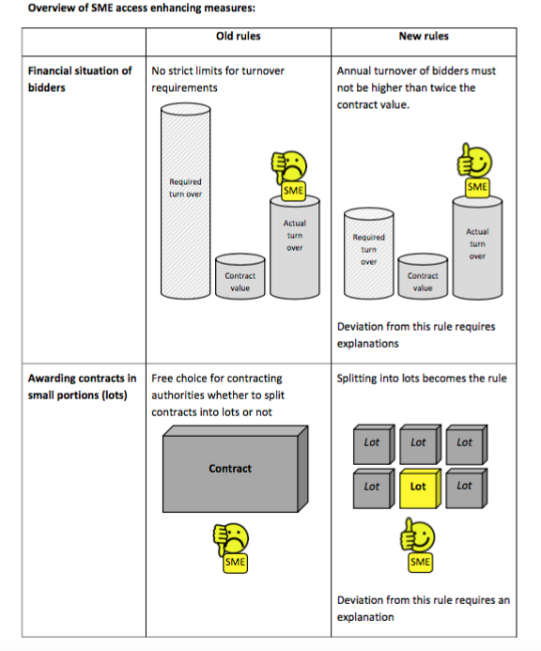Authorities are being encouraged to think about SMEs from the outset in their tender processes and to consider whether contracts can be divided into smaller lots to furthersupport SME participation.

*“To that end and to enhance competition, contracting authorities should in particular be encouraged to divide large contracts into lots …*

*Where the contracting authority decides that it would not be appropriate to divide the contract into lots, the individual report or the procurement documents should contain an indication of the main reasons for the contracting authority’s choice.*

*Member States should remain free to go further in their efforts to facilitate the involvement of SMEs in the public procurement market, by extending the scope of the obligation to consider the appropriateness of dividing contracts into lots to smaller contracts, by requiring contracting authorities to provide a justification for a decision not to divide contracts into lots or by rendering a division into lots obligatory under certain conditions”. (EU Procurement Directive)*

In its simplicity it reads that contracting authority may split into lots or explain why not. According to the old rules, contracting authorities still had the choice that they “may split into lots”. The biggest difference here is that if the contracting authority does not to split into lots they have to explain their decision.

Suppliers are advised to contact the contracting authority and question why they chose not to split into lots. This will raise awareness among contracting authorities about this rule and increase the chance of them considering splitting into lots in the future.

It is not defined what the reason for not splitting a contract into lots should be. As a matter of fact it can be argued that it does not even read that the contracting authority has to go into details as it only states that they have to indicate the main reasons. This leaves it open for debate and what an acceptable reason could be.

Nevertheless, as a principle - splitting contracts into lots - will reduce over-reliance on one or a small number of suppliers and increase competition.

Other suggestions:

(I) Administrative burden + health safety protection

Europe’s small and medium-sized enterprises (SMEs) create most jobs in the private sector, but are less able to cope with administrative burdens or to get bank loans than big ones.

The draft resolution by Zdzisław Krasnodębski (ECR, PL) calls on the EU Commission and member states to consider the often disproportionate impact of administrative requirements on SMEs and systematically reduce it to a minimum, while ensuring that employees have proper health and safety protection.

(II) funding + taxation

It is also suggested that SMEs should get favourable tax treatment, to offset the advantages of large multinationals. In addition, EU-funded programmes for enterprises should pay more attention to less developed, poorer and isolated regions.

[Othmar Karas](http://www.europarl.europa.eu/meps/en/4246/OTHMAR_KARAS_home.html) (EPP, AT) focuses on SMEs’ access to finance in the EU Capital Markets Union arguing that conditions for obtaining loans should be clearer, information on banks and investors publicly available and taxation system transparent and effective to attract investments.